Home learning
Art
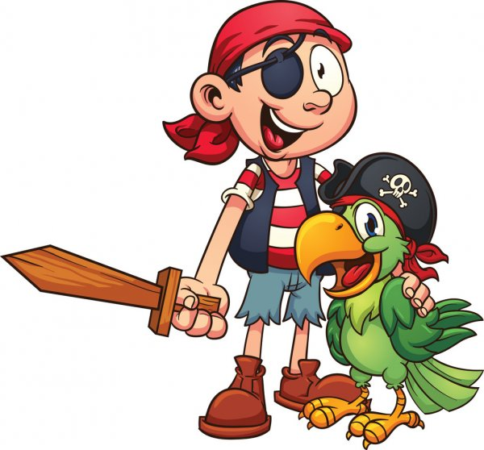
Hello Squirrels
This week in art we are going to be making our own pirate treasure maps.
To begin with, we are going to make our paper look old by staining it with tea.
PLEASE MAKE SURE YOU HAVE AN ADULT WITH YOU!
Follow the instructions on the link below for tips on how to best do this.
https://www.youtube.com/watch?v=Amz7z96gF7I

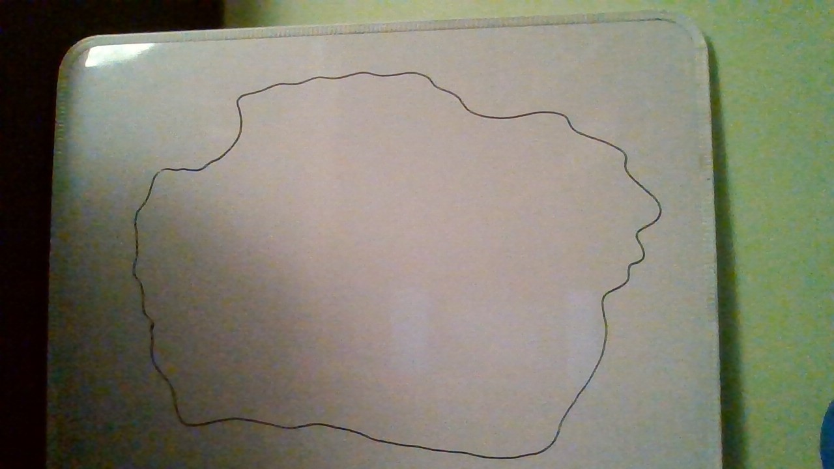
Once your paper has dried, we can start.
I started my treasure map with the island shape.

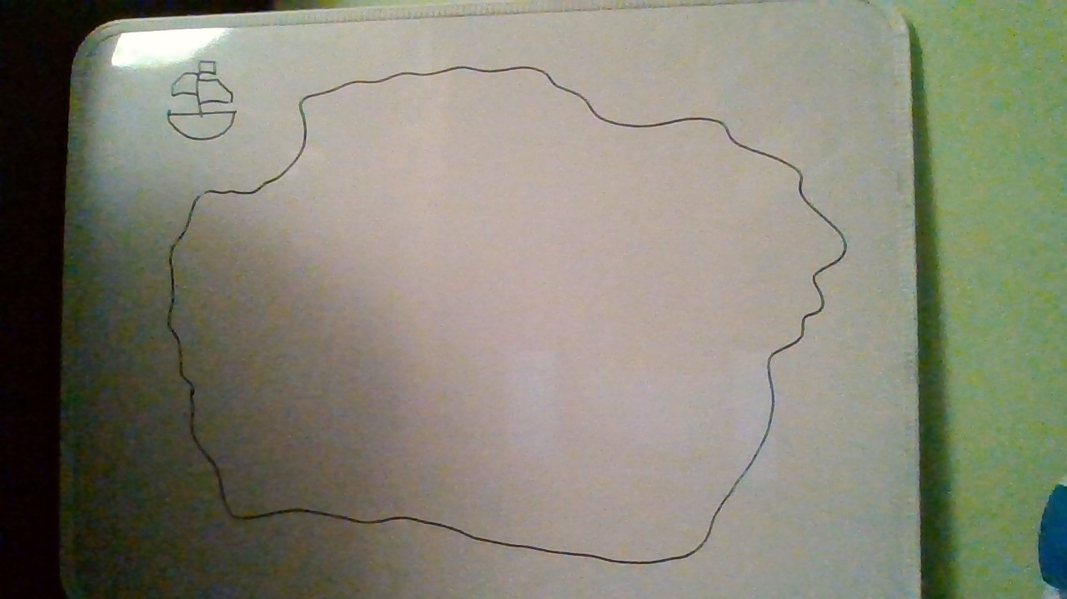
Then I added the boat.
Hint: Remember how we learnt to draw a pirate boat in topic!

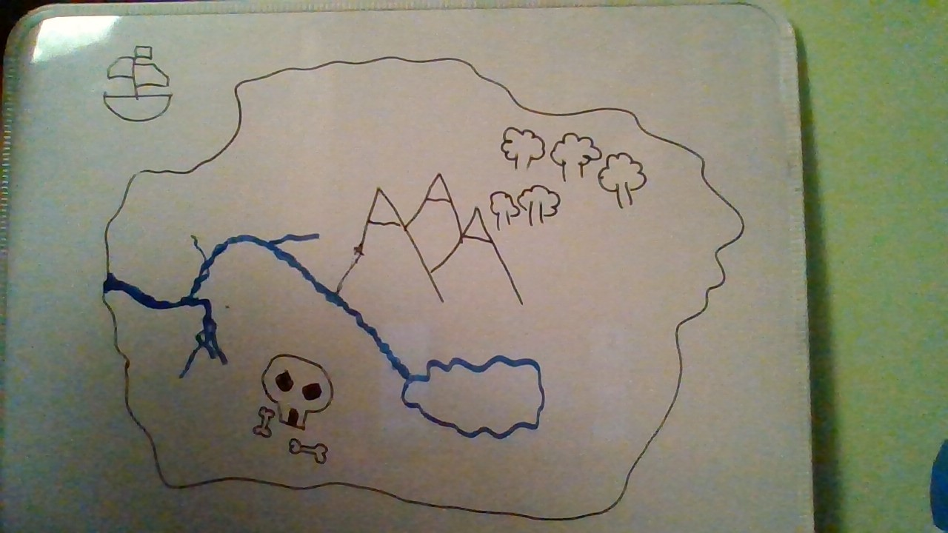
Then I added the details I wanted on my island.
I decided I wanted some mountains, a forest, a river and a lake. I also wanted a scary looking cave with some bones outside.
But you can add your own obstacles for the pirates.

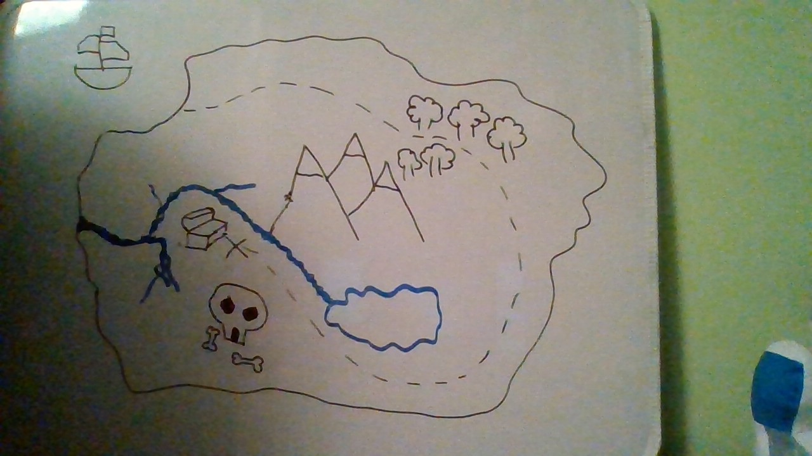
Next, I added the treasure and the path the pirates will need to use to get from the boat to the treasure.
You can do this with a dotted line.

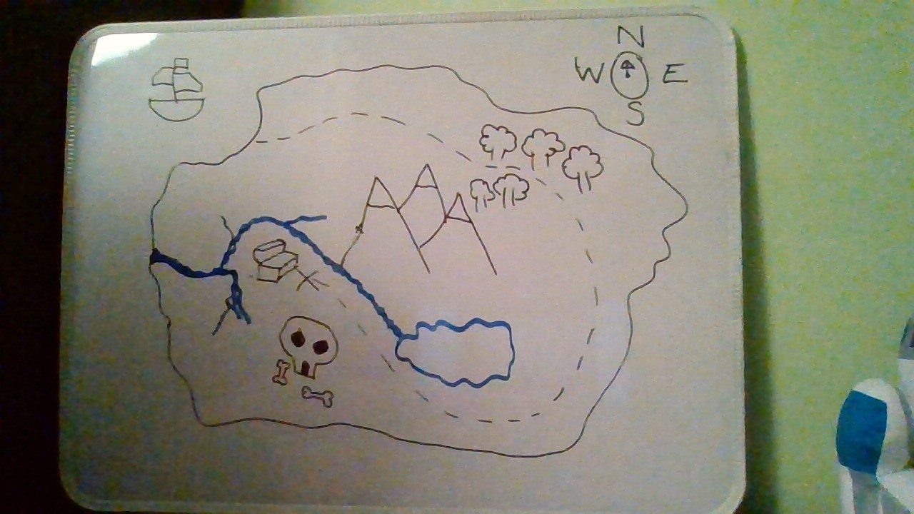
Finally, I added a compass in the top corner to help the pirates find their way.

