Home learning.
Art
Year 1 and 2.
So far this term we have designed and built our own pirate ships, flown our flag from our pirate ships and created a treasure map to find the buried treasure.
After all these weeks of searching, using the maps we made last week, we have finally found the treasure!
You have two activities to chose from this week. Or for you great artists, you can do both.
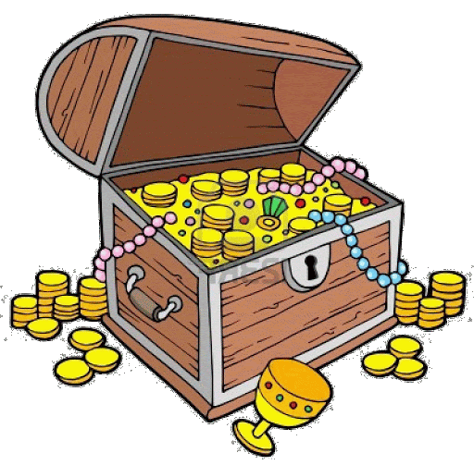
Activity 1:
Make a model treasure chest using the instructions and the plan on the next few pages.

Activity 2:
Draw a picture of what you would put in your treasure chest to keep it safe. Can be your favourite toys, items, or even food! You can draw your own chest or use the one provided.

