Home Learning
Art
Hello Squirrels! Today we are going to be using ICT to create a piece of art. Please log onto ‘Purple Mash’ by following this link:
Please then complete the activities shown when you click on the ‘To Do’ icon.
Your activity is to label the trees according to their season and use the colours available to show what happens to the trees in each season.

Please watch this video to recap the seasons. These can help you draw the seasons: https://www.bbc.co.uk/bitesize/topics/zkvv4wx/articles/zcx3gk7

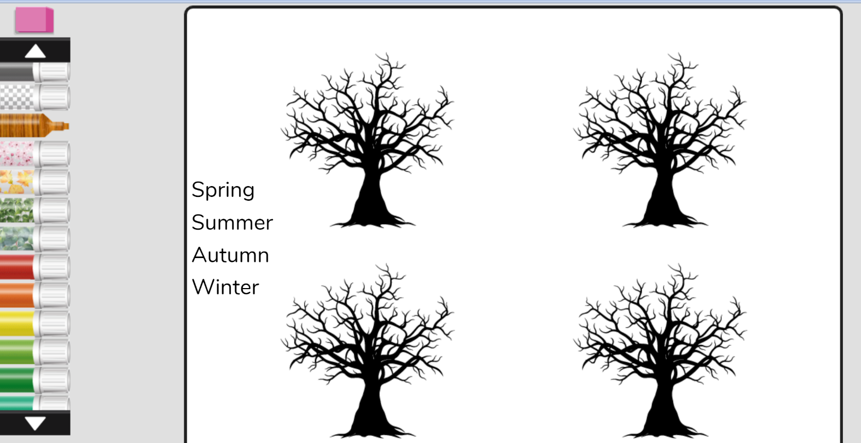
It will look something like:
If you are unable to access purple mash, please send me an email and I will send you a log in.

