Home Learning
English
Year 1 and 2:
Today we are going to be reading a new pirate story called ‘Port Side Pirates.’ This is a sing along book.
Please watch the video to walk you through the story: https://www.youtube.com/watch?v=_qAngsMJD3I

Using the video, have a think about what adventures the boy went on. Can you write down what happened on his journey?
Hint: When the next verse starts, it introduces the next part of his adventure.
Please write your ideas below:
- ___________________________________________

- ___________________________________________

- ___________________________________________

- ___________________________________________

- ___________________________________________

- ___________________________________________

- ___________________________________________

- ___________________________________________

- ___________________________________________

- ___________________________________________

Activity 2:
Have a look at the picture below. This is where the ‘Pirates’ went on their first adventure.
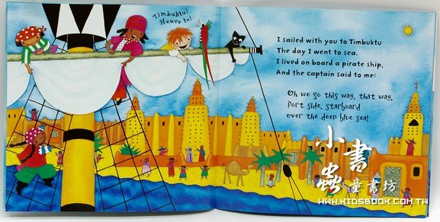
They went to Timbuktu.

Year 1 – Can you write 3 sentences describing this setting.
Year 2 – Please write a paragraph (5 sentences or more) describing this setting.

