Home Learning
English
Year 1 and 2:
Today we are going to be writing a job description for a place on the Squirrels Pirate Ship.
First, please read through the different job descriptions below and pick one that you want to write your job description for:
Sailing Master:
As Sailing Master, you need to navigate and steer the ship.
You need to be organised and be able to read a map.
Captain:
As Captain, you run the ship and organise missions.
You need to be a leader and a decision maker.

Cabin Boy:
As a Cabin Boy, you need to serve the others on the ship.
You must be organised, hard-working and able to work for long hours.

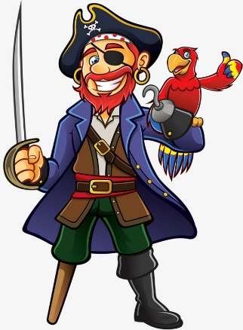
Master Gunner:
As Master Gunner, you need to look after the ships cuns and ammunition, and stop the cannons getting rusty, You also need to teach the crew how to use them.
You must be trustworthy.
Carpenter:
As a Carpenter, you are responsible for the wood on board. This means checking for leaks in the ship.
You must be skilled using tools for carpentry.

Job Application:
Use the sentence starters to structure your job application. There is a word bank below to help you.
Remember: You are trying to persuade Captain MacMillan to accept your application.

Name: _____________________________________________

What job are you applying for?
I am applying for the job of ______________________________
___________________________________________________

Why are you applying for this job?
I am applying for this job because _________________________
___________________________________________________

Why would you be good at this job?
I would be good at this job because ________________________
___________________________________________________

Signed: _____________________________________________
because | hard- working | punctual | experience | reference
reliable | friendly | organised | confident | trustworthy

