Home Learning
English
Today we are going to be doing a reading comprehension. Please have a go at reading through this story with your adult.
Remember: If you are stuck, do some ‘Fred Talk’ to work out the words.
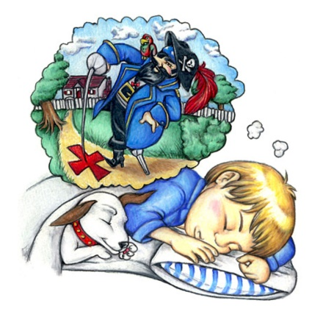
“Ten steps from the porch and twenty steps from the rose bushes,” growled Bluebeard in Jimmy’s dream one night. “There be treasure there! Aawrgh.”
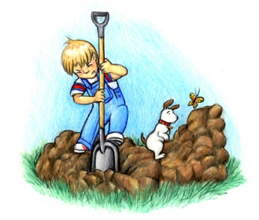
So, the next day, Jimmy began to dig. He dug until the hole was deep and the dirt pile was high.
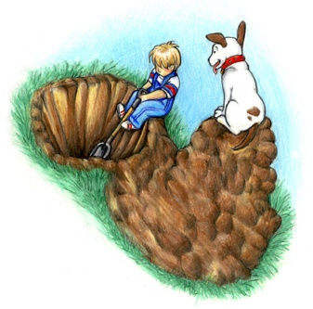
He kept digging. The hole got deeper and the dirt pile got higher. He dug until the hole was deepest and the dirt pile was at its highest. He sighed. “I’m too tired. I can’t dig anymore.”
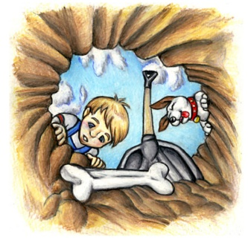
Then he spied something…
… but it was only one of Woofy’s bones. Instead of treasure, all Jimmy had was a dog bone, a hole, and a big pile of dirt to fill it in with. He thought “That pirate lied to me!”
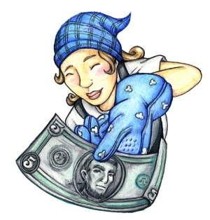
But when Jimmy’s mother saw what he had done, she closed her hands and smiled a smile from here to Sunday. “Oh, thank you, Jimmy. I always wanted a Rhododendron bush planted just there. Here’s £5 for digging that hole.

Year 1:
1. Who told Jimmy where to start digging for treasure?
Jimmy was told to start digging by ____________________________
_______________________________________________________

2. Why did Jimmy want to dig?
Jimmy wanted to dig because ________________________________
_______________________________________________________

3. Why did he stop digging?
Jimmy stopped digging because _______________________________
_______________________________________________________

4. What did Jimmy see in the hole? – Circle the correct option.
a) Treasure
b) Woofy’s bone
c) Gold Coins

5. Why was mum happy that Jimmy had dug the hole?
She wanted to plant a ______________________________________
_______________________________________________________

Year 2:
1. Who told Jimmy where to start digging for treasure?
_______________________________________________________
_______________________________________________________

2. Why did Jimmy want to dig?
_______________________________________________________
_______________________________________________________

3. Why did he stop digging?
_______________________________________________________
_______________________________________________________

4. What did Jimmy see in the hole? – Circle the correct option.
a) Treasure
b) Woofy’s bone
c) Gold Coins

5. Why was mum happy that Jimmy had dug the hole?
_______________________________________________________
_______________________________________________________

6. Did Captain Bluebeard lie to Jimmy in the dream? Can you give a reason?
______________________________________________________________________________________________________________

