Home Learning
English
Year 1 and 2:
Well done for a great week of work Squirrels. Below, there are two activities to finish off the week.
Activity 1:
Please unjumble the sentences below.
Remember: Capital letters are at the beginning of the sentence and full stops are at the end. Look out for those to help you start unjumbling your sentence, they re read the sentence until the order makes sense.

1. pirate The sailed sea. the
_______________________________________________________

2. Tom Captain used compass a to treasure. find
_______________________________________________________

3. parrot beautiful. is very The
_______________________________________________________

4. crew scrubbed The the decks.
_______________________________________________________

Activity 2:
Below there is a treasure chest. Imagine that you are a Pirate and you are making a treasure chest of your most important treasures. Draw them into the treasure chest and write what your items are and why you chose them.
Year 1: Please draw 3 items and write 3 sentences.
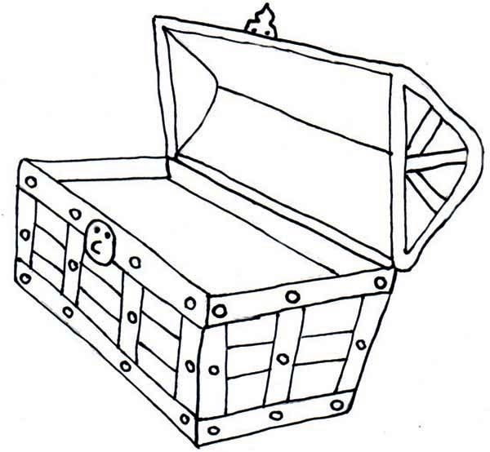
Year 2: Please draw 5 items and write 5 sentences.
________________________________________________________________________________________________________________________________________________________________________________________________________________________________________________________________________________________________________________________________________________________________________________________________________________________________________________________

