Home Learning
English
Year 1 and 2:
Today we are going to be learning about ‘Imperative Verbs.’ We can also call them Bossy Verbs.
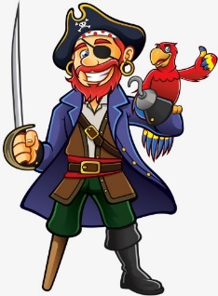
Please watch the first video on this link: https://www.bbc.co.uk/bitesize/topics/zrqqtfr/articles/z8strwx#:~:text=Command%20sentences%20are%20used%20when,tell%20someone%20to%20do%20something.
Activity 1:
Please look at the pictures below and see if you can match the ‘Commands’ to the correct picture. Then please highlight or write down the ‘Bossy Verbs’ in each command.
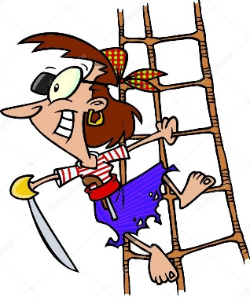

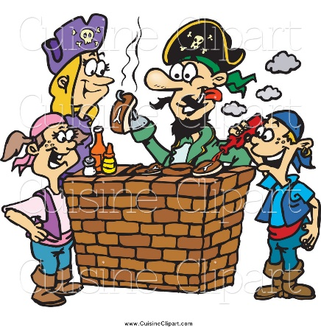
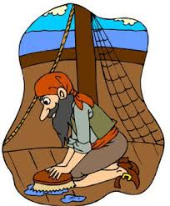

Scrub the decks.
Cook the food.
Climb the rigging.
Find the treasure.

Activity 2:
Well done for finding the bossy verbs. Now it is your turn to write some instructions to get the pirate to collect some objects. Please use a different bossy verb for each instruction as well as a positional word.
Bossy Verb
For example,
Positional Word
Crawl 2 steps up.
You need to collect:
Steps
- The map.
- The sword.
- The hook.
- The treasure.

Make sure you avoid the other objects.

Word Bank:
Positional Language: | Bossy Verbs:
Up  Right  Left  Down | Hop  Walk  Run  Skip  Crawl  Jump

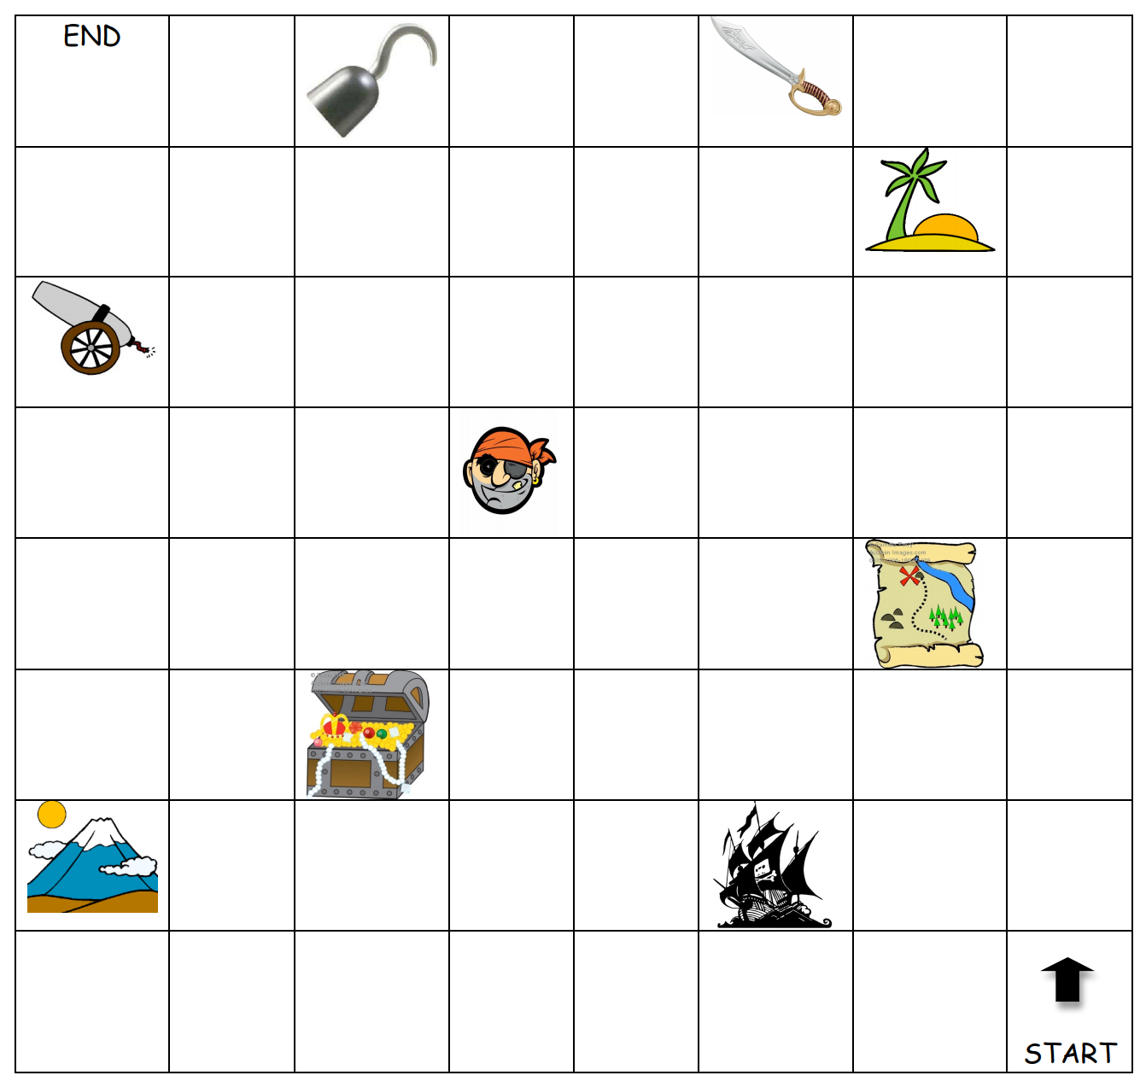
Instructions:
- _______________________________________________

- _______________________________________________

- _______________________________________________

- _______________________________________________

- _______________________________________________

