Home Learning
English
We are going to lay out English slightly differently. Instead of having a Year 1 and a Year 2 activity, there will be ‘Star’ choices.
How it works:
First, you will be given an overall activity to complete. After this activity, you can choose between the choices below:
Easy
Tricky
Hard

Overall Activity – All children need to complete this activity.
Following on with the theme of Snow, I would like you to think about lots of adjectives about snow and Winter. Please use the pictures below to help you and have a look outside to gather more ideas.
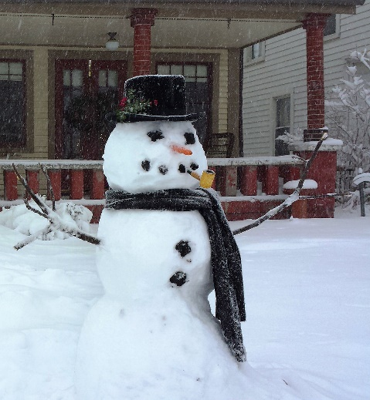
Please write your adjectives on some paper.
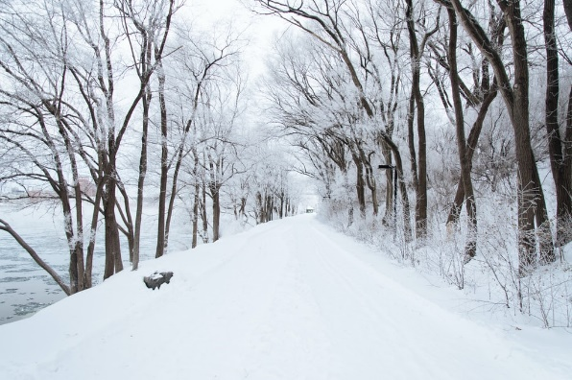

Now it is your choice. There are 3 activities. Please choose to complete one of them.

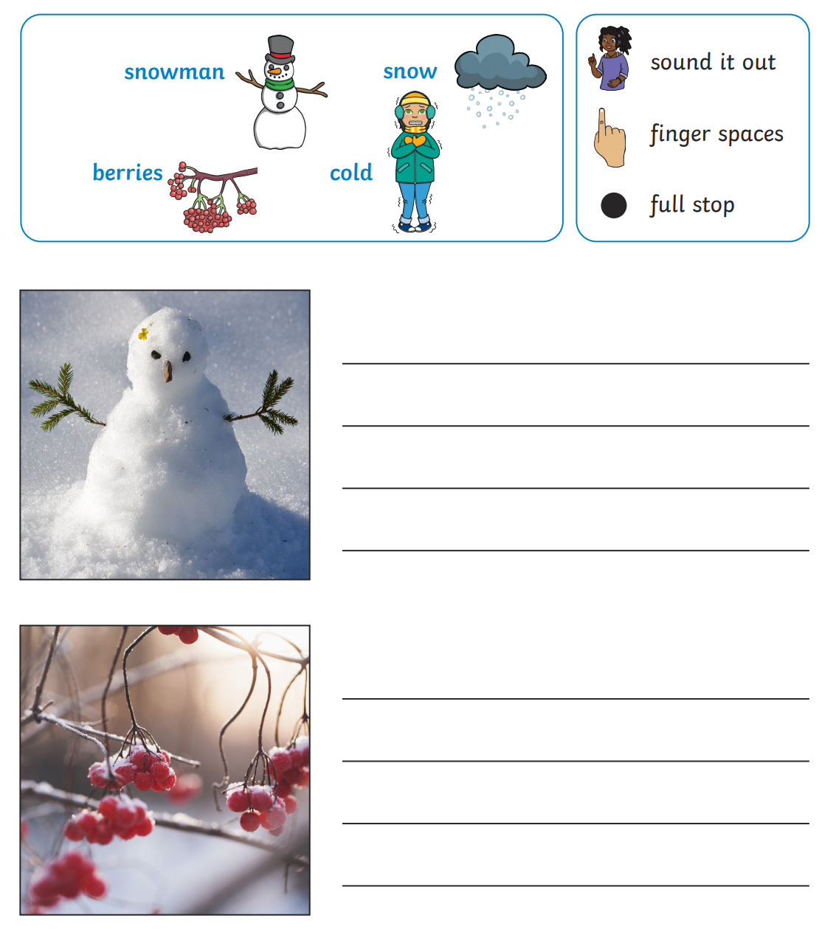
Please look below at the pictures. There are some words to help you. Your activity is to write a sentence about each picture using the word banks to help you:
Please look at the picture below. Have a go at writing 5 or more sentences about the picture. Try and include some of the adjectives that you collected in your sentences.
Adjective
Example: ‘The boy has a fluffy hat.’

________________________________________________________________________________________________________________________________________________________________________________________________________________________________________________________________________________________________________________________________________________________________________________________________________________________________________________________
In this activity, you are going to use the adjectives that you
collected to write an acrostic poem. Your word is going to be:

W_____________________________________________
I________________________________________________
N______________________________________________
T_______________________________________________
E_______________________________________________
R_______________________________________________

