**Home Learning**

**English**

Today we are going to be exploring the beginning of a new story called ‘Jim and the Beanstalk.’ This is the start of our Topic, ‘My secret garden.’

I have put the first page of the story below. Please read through this page with an adult and then choose from the star options below to complete your activity. You are going to be writing some predictions about the story. I have put an example on the next page.

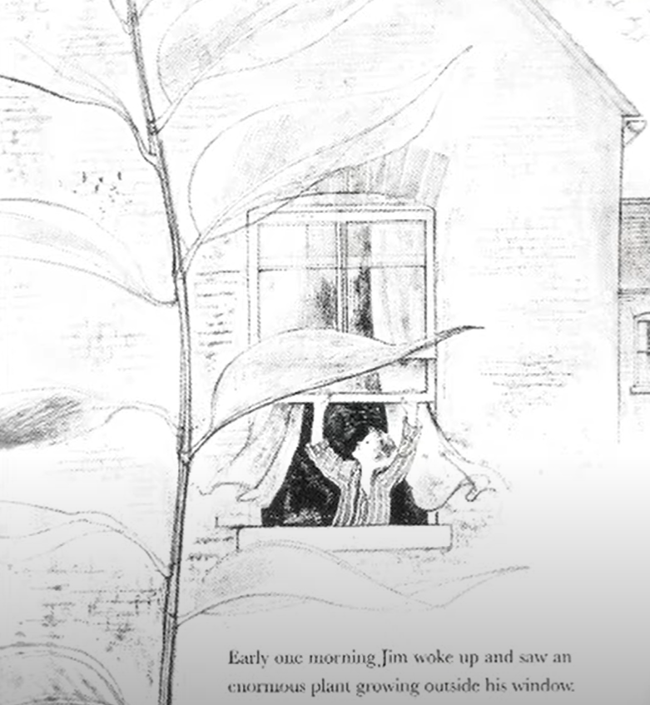Please be as creative with this writing as you like.

**Examples:**

I predict that Jim will find a fairy kingdom at the top of the beanstalk. It will be glistening with beautiful fairies flying happily in the clouds.



**Activities:**

Write a sentence about what you think Jim will see at the top of the beanstalk. Please use the sentence starter below to help you get started:

I predict that Jim will find ____________________________________________

_________________________________________________________________

at the top of the beanstalk.

Please write 3 or more sentences about what you think will be at the top of the beanstalk and use adjectives to describe what Jim sees.

Please write a paragraph about what you think will be at the top of the beanstalk.

You must include:

Expanded Noun Phrases

Adjectives

Adverbs