Home Learning
English
Today we are going to carry on with the story of ‘Jim and the Beanstalk.’
Please watch this video to see what the story is about: https://www.youtube.com/watch?v=dMaMNpod3Es

Activities: Please choose between the activities below.
Please think of 3 adjectives to describe each character using the box below. Then write 1 sentence about each character using one of your chosen adjectives. (Please use the sentence starters below to help you).

The giant is _______________________________________.

Jim is _____________________________________________.
The Giant | Jim
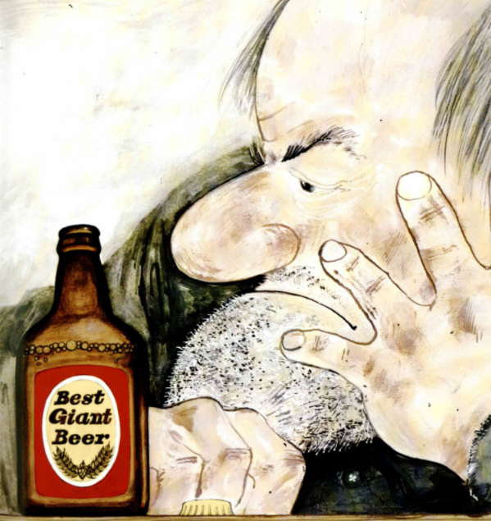  - ______________________  - ______________________  - ______________________ | 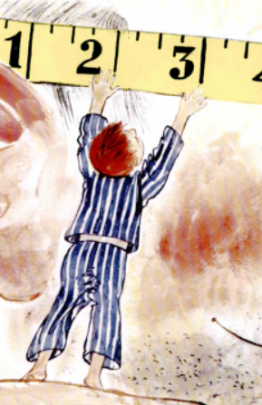  - ______________________  - ______________________  - ______________________

Please think of 3 adjectives to describe each character using the box below. Then write 2 sentences about each character using the adjectives you have chosen. Have a go at using ‘because’ in your writing to give a reason for your adjective.

The Giant | Jim
- ______________________  - ______________________  - ______________________ | - ______________________  - ______________________  - ______________________

Example:

The giant is grumpy because he has no teeth.
This is the reason you give for using the adjective
conjunction
adjective

Please think of 5 adjectives to describe each character using the box below. Then choose one of the characters and write a character description.
Think about:
- What the character looks like.
- What their personality is like.
You must include:
- Adjectives
- Expanded Noun Phrases
The Giant | Jim
- ______________________  - ______________________  - ______________________  - ______________________  - ______________________ | - ______________________  - ______________________  - ______________________  - ______________________  - ______________________

