Home Learning
English
This week, we have been reading the story ‘Jim and the beanstalk.’ In this story, the giant asks Jim if he is the boy called ‘Jack.’ This is in reference to ‘Jack and the beanstalk.’
Please watch both stories to recap:
Jim and the Beanstalk – https://www.youtube.com/watch?v=dMaMNpod3Es
Jack and the Beanstalk - https://www.youtube.com/watch?v=oyYh43hxSts

Today we are going to compare the stories. Please choose one of the star activities to complete:
Jim and the Beanstalk | Jack and the Beanstalk
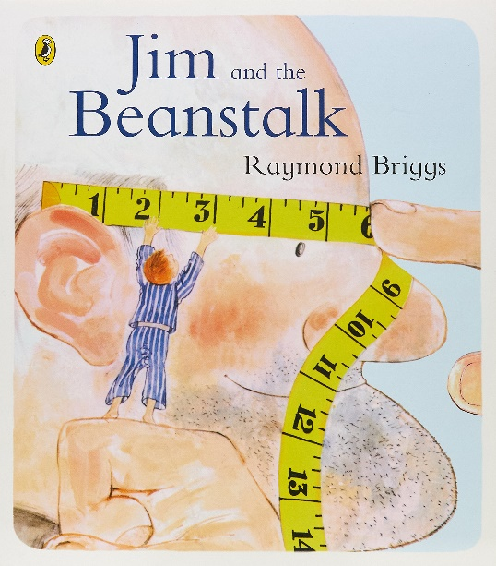 | 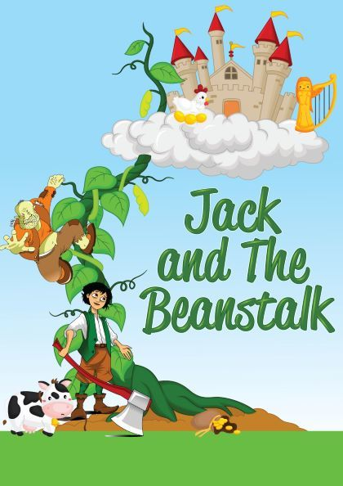

Use the pictures above and below to help you write your sentences:

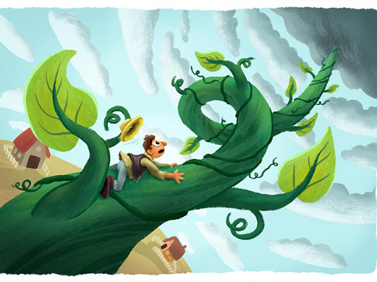
What is the same in the stories?
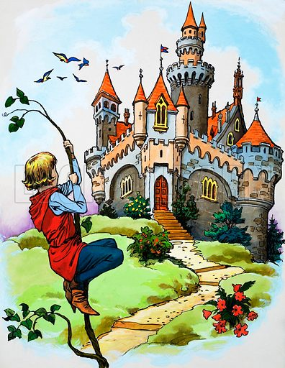
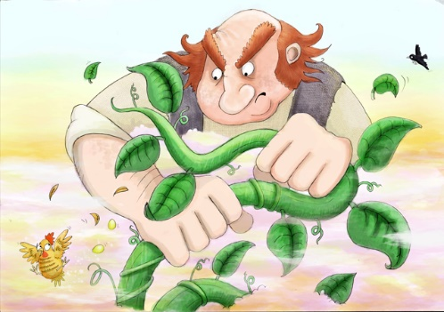

In both stories, there is ____________________________________
_______________________________________________________

What is different between the stories?
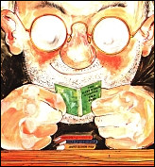
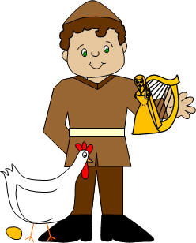

In Jack and the beanstalk, Jack _____________________________.
In Jim and the beanstalk, Jim _______________________________.

Use the pictures above and below to help you write your sentences:

What is the same in the stories?
_____________________________________________________________________________________________________________________________________________________________________

What is different between the stories?

_____________________________________________________________________________________________________________________________________________________________________
Please look at the pictures below. These give you hints to some similarities and some differences between the stories. Please write as many similarities and differences that you can:

________________________________________________________________________________________________________________________________________________________________________________________________________________________________________________________________________________________________________________________________________________________________________________________________________________________________________________________

