Home Learning
English
Today we are going to be writing a letter in response to the Giant in ‘Jim and the Beanstalk.’
Let’s recap the story: https://www.youtube.com/watch?v=dMaMNpod3Es

Year 1:
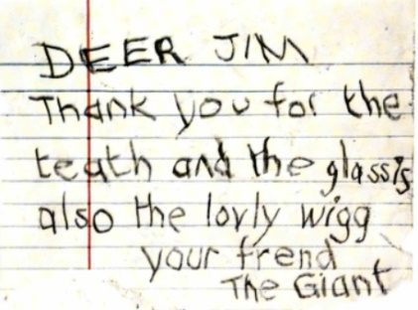
Please look at the letter below. Imagine that you are Jim and think about what you would respond to the Giant. (Please use the sentence starters below)

Dear Giant,

Thank you for your letter, ___________________________________
_______________________________________________________
I hope that you are feeling __________________________________

Your friend,
____________________________________

Year 2:
Please look at the letter below. Imagine that you are Jim and think about what you would respond to the Giant.

Questions to think about:
- What is Jim’s personality?
- How do you think Jim feels?
- Do you think the Giant means what he wrote in his letter?

Dear Giant,

Thank you for your letter, ___________________________________
_______________________________________________________
_______________________________________________________
_______________________________________________________

Your friend,
____________________________________

