Home Learning
English
Today we are going to be altering the story of ‘Jim and the Beanstalk.’
Let’s just recap the story: https://www.youtube.com/watch?v=dMaMNpod3Es
In the original story, Jim helps the Giant with:
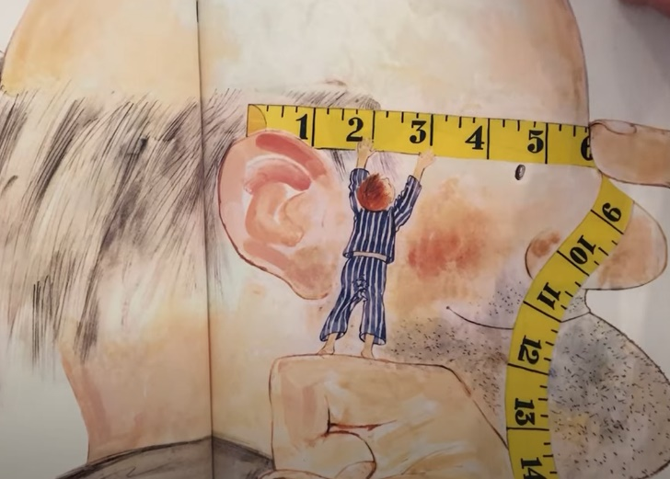
1.

Glasses

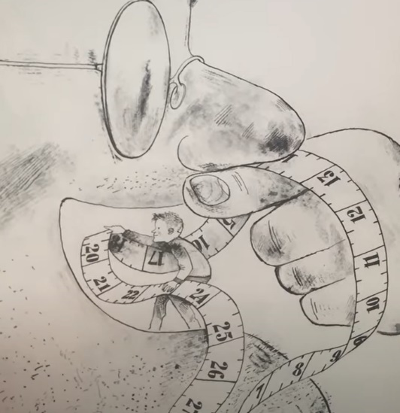
2.

Teeth

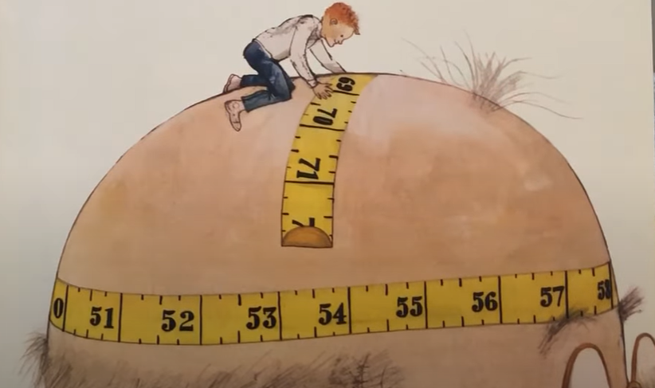
3.
Hair

We are going to think about 3 different things that Jim helps the Giant with. Please choose one of the star choices below and complete the activity:

Please draw a picture of what Jim does to help the Giant and write a sentence about what he does.

___________________________________________________________
___________________________________________________________
___________________________________________________________
___________________________________________________________
___________________________________________________________

Please draw 2 pictures of what Jim does to help the Giant and write a sentence about each one.
You need to include:
- What you are going to do to help the Giant.
- Why you are helping him.

__________________________________________________________________________________________________________________________________________________________________________
___________________________________

___________________________________________________________
___________________________________________________________

__________________________________________________________________________________________________________________________________________________________________________
___________________________________

___________________________________________________________
___________________________________________________________

Please draw 3 pictures of what Jim does to help the Giant and write a sentence about each one.
You need to include:
- What you are going to do to help the Giant.
- Why you are helping him.

__________________________________________________________________________________________________________________________________________________________________________
___________________________________

___________________________________________________________
___________________________________________________________

__________________________________________________________________________________________________________________________________________________________________________
___________________________________

___________________________________________________________
___________________________________________________________

__________________________________________________________________________________________________________________________________________________________________________
___________________________________

___________________________________________________________
___________________________________________________________

