**Home Learning**

**Maths**

Year 1:

Today we are going to be looking at understanding our numbers up to 50.

Please watch the video below: <https://vimeo.com/500466597>

1. Find these numbers on the number chart below.

twenty sixteen thirty-three forty-seven eleven

twenty-two forty-five thirty-nine twenty-eight

|  |  |  |  |  |  |  |  |  |  |
| --- | --- | --- | --- | --- | --- | --- | --- | --- | --- |
| 1 | 2 | 3 | 4 | 5 | 6 | 7 | 8 | 9 | 10 |
| 11 | 12 | 13 | 14 | 15 | 16 | 17 | 18 | 19 | 20 |
| 21 | 22 | 23 | 24 | 25 | 26 | 27 | 28 | 29 | 30 |
| 31 | 32 | 33 | 34 | 35 | 36 | 37 | 38 | 39 | 40 |
| 41 | 42 | 43 | 44 | 45 | 46 | 47 | 48 | 49 | 50 |

2. How may are being shown in these ten frames?

a.

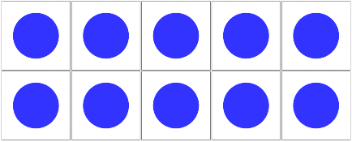  

b.

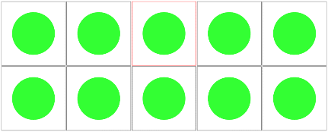 

 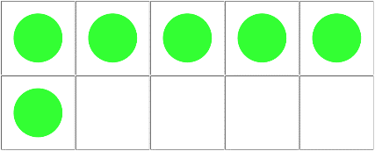

c.

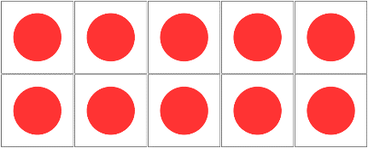 

  

3. If I am counting from 29 to 46 which of these number will I say? Circle the answers.

|  |  |  |
| --- | --- | --- |
| Twenty-six | Forty-seven | Forty-one |
| Fifty | Twenty-three | Thirty-five |

Here is a counting track to help you

|  |  |  |  |  |  |  |  |  |  |  |  |  |  |  |  |  |  |
| --- | --- | --- | --- | --- | --- | --- | --- | --- | --- | --- | --- | --- | --- | --- | --- | --- | --- |
| 29 | 30 | 31 | 32 | 33 | 34 | 35 | 36 | 37 | 38 | 39 | 40 | 41 | 42 | 43 | 44 | 45 | 46 |

4. Oh no! Tom has dropped all his bananas. Can you help him pick them all up by counting them into ten frames so he knows how many there are?











Year 2:

Today we are going to be learning about ‘Making equal groups by sharing’ in more detail.

Please watch this video: <https://vimeo.com/492603633>

**Activity:**

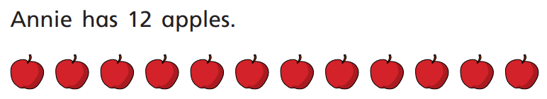1.

She shares them equally into 2 boxes.

Show how Annie shares the apples equally:

Complete the sentences.

There are 12 apples.

There are boxes.

There are boxes in each box.

2. Find 20 objects at home and have a go at completing the following parts:

a) Share them into 2 equal groups.

There are 20 cubes.

There are groups.

There are cubes in each group.

b) Share the cubes into 5 equal groups.

There are 20 cubes.

There are groups.

There are cubes in each group.

So, if you were working out 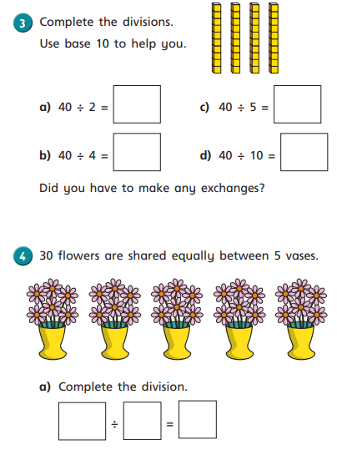

You could be sharing 40 between 2 groups.

3. Complete these division questions.

Remember: Division is sharing parts equally.

4.

**Challenge:**



A party bag contains 5 sweets.

A jar contains 5 party bags.

Ron has 75 sweets.

How many party bags will he need?

How many jars will he need?