**Home Learning**

**Maths**

Year 1

Today we are going to be learning to count forwards and backwards to 50.

Please watch the video below.

<https://vimeo.com/500467345>

1. Complete the below number tracks.

|  |  |  |  |  |
| --- | --- | --- | --- | --- |
|  |  |  |  |  |
| 2 | 3 |  |  |  |

a.

|  |  |  |  |  |
| --- | --- | --- | --- | --- |
|  |  |  |  |  |
| 10 | 9 |  |  |  |

b.

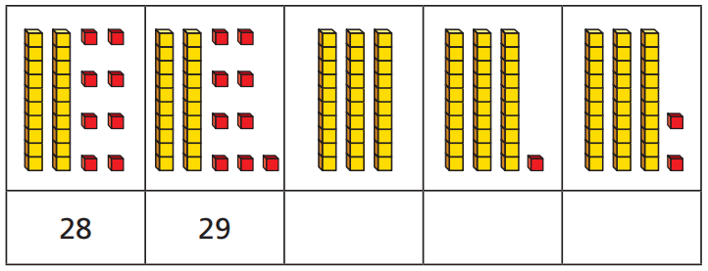

c.

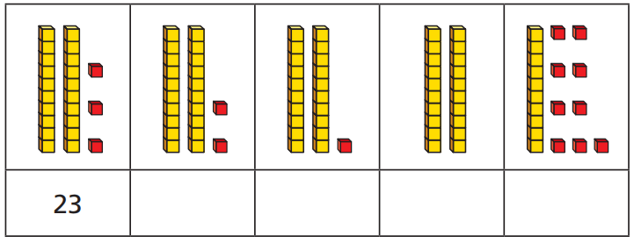d.

2. Complete the number tracks.

a.

|  |  |  |  |  |  |  |  |  |  |
| --- | --- | --- | --- | --- | --- | --- | --- | --- | --- |
| 14 | 15 | 16 |  |  |  |  |  |  |  |

b.

|  |  |  |  |  |  |  |  |  |  |
| --- | --- | --- | --- | --- | --- | --- | --- | --- | --- |
| 37 | 38 | 39 |  |  |  |  |  |  |  |

c.

|  |  |  |  |  |  |  |  |  |  |
| --- | --- | --- | --- | --- | --- | --- | --- | --- | --- |
| 11 | 10 | 9 |  |  |  |  |  |  |  |

d.

|  |  |  |  |  |  |  |  |  |  |
| --- | --- | --- | --- | --- | --- | --- | --- | --- | --- |
| 33 | 32 | 31 |  |  |  |  |  |  |  |

3.

a. Which number is **after** 25? ­­­­________

b. Which number is **before** 15? ­­­­________

c. Which two numbers are **after** 45? ­­­­________ ­­­­________

d. Which two numbers are **before** 21? ­­­­________ ­­­­________

**Challenge:**

4.

Complete the number track.

|  |  |  |  |  |  |  |  |  |  |  |  |  |  |
| --- | --- | --- | --- | --- | --- | --- | --- | --- | --- | --- | --- | --- | --- |
|  |  |  |  |  | 36 | 37 |  |  |  |  |  |  |  |

Year 2:

Today we are going to learn about ‘Making equal groups’ by grouping.

Please watch this video: <https://vimeo.com/492603961>

**Activity:**

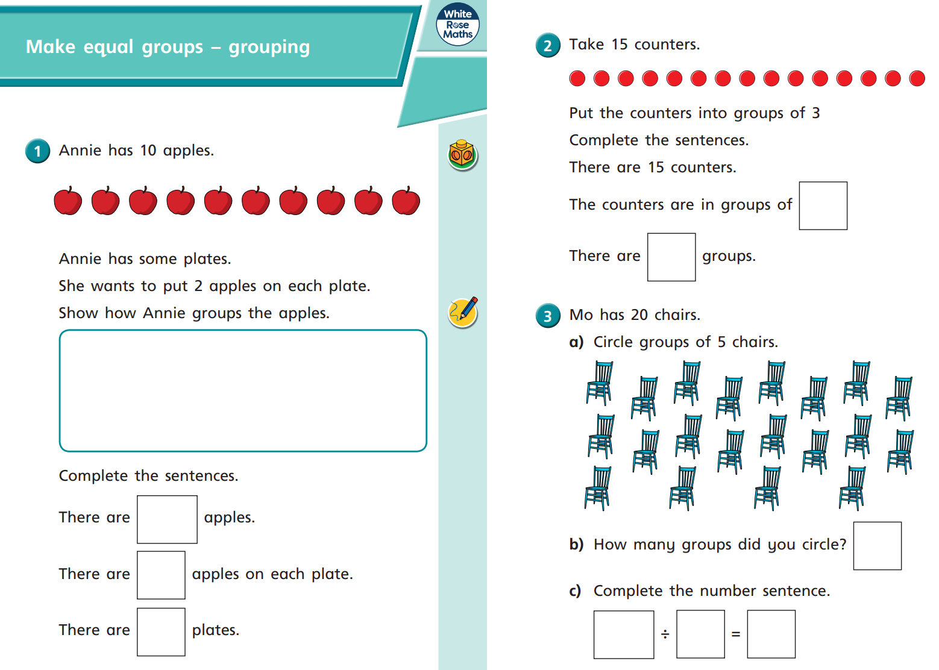1.

Annie has some plates.

She wants to put 2 apples on each plate.

Show how Annie groups the apples.

There are apples.

There are apples on each plate.

There are plates.

2.

3.

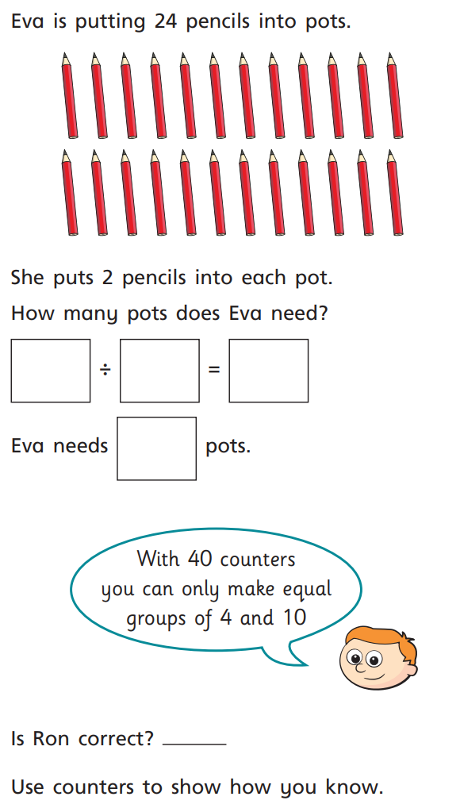4.

5. Please draw pictures below to represent these division number sentences.

a) 30 10 =

b) 30 5 =

**Challenge:**