**Home Learning**

**Maths**

Year 1 -Today we are going to be learning about tens and ones.

Please watch this video: <https://vimeo.com/500467998>

1. a. How many strawberries are there?

|  |  |  |  |  |
| --- | --- | --- | --- | --- |
|  |  |  |  |  |
|  |  |  |  |  |
|  |  |  |  |  |
|  |  |  |  |  |
|  |  |  |  |  |

|  |  |
| --- | --- |
|  |  |
|  |  |
|  |  |
|  |  |
|  |  |

|  |  |
| --- | --- |
|  |  |
|  |  |
|  |  |
|  |  |
|  |  |

There are ­­­______ tens and ______ones.

There are _______ strawberries.

1. b. How many ice creams are there?

|  |  |  |  |  |
| --- | --- | --- | --- | --- |
|  |  |  |  |  |
|  |  |  |  |  |

|  |  |  |  |  |
| --- | --- | --- | --- | --- |
|  |  |  |  |  |
|  |  |  |  |  |

|  |  |  |  |  |
| --- | --- | --- | --- | --- |
|  |  |  |  |  |
|  |  |  |  |  |

There are ­­­______ tens and ______ones.

There are _______ ice creams.

2. What number is shown?

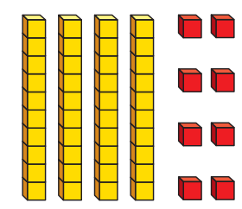a. b.

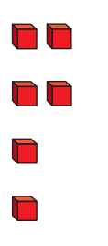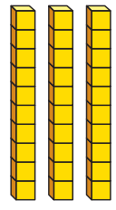

There are ­­­______ tens and ______ones.

The number shown is _______.

There are ­­­______ tens and ______ones.

The number shown is _______.

3. Using one blocks and ten sticks draw the numbers below in the boxes.

a. 26

b. 4 tens and 2 ones

4. Complete the number sentence.

a. 17 = _____ tens and _____ ones.

b. _____ = 3 tens and 5 ones.

c. 22 = _____ tens and _____ ones.

d. 40 = _____ tens and _____ ones.

e. _____ = 3 tens and 0 ones.

f. 49 = _____ tens and _____ ones.

**Challenge:**

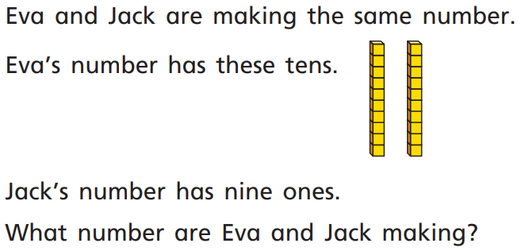

______________

Year 2:

Today we are going to do a recap lesson on sharing and grouping.

Please watch this video and work through the activities: <https://vimeo.com/492604113>

**Activity:**

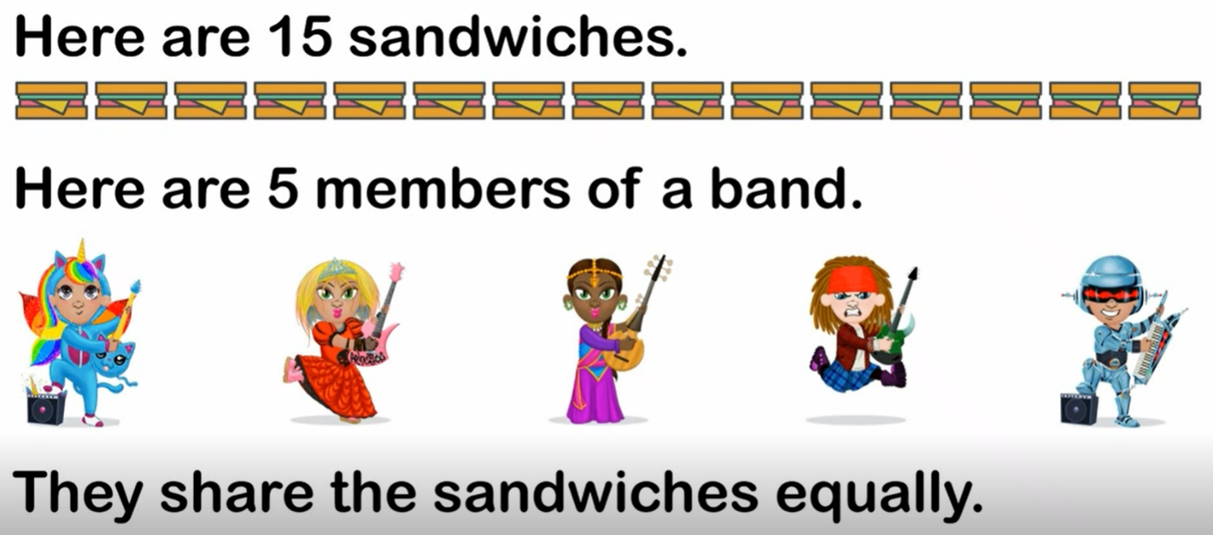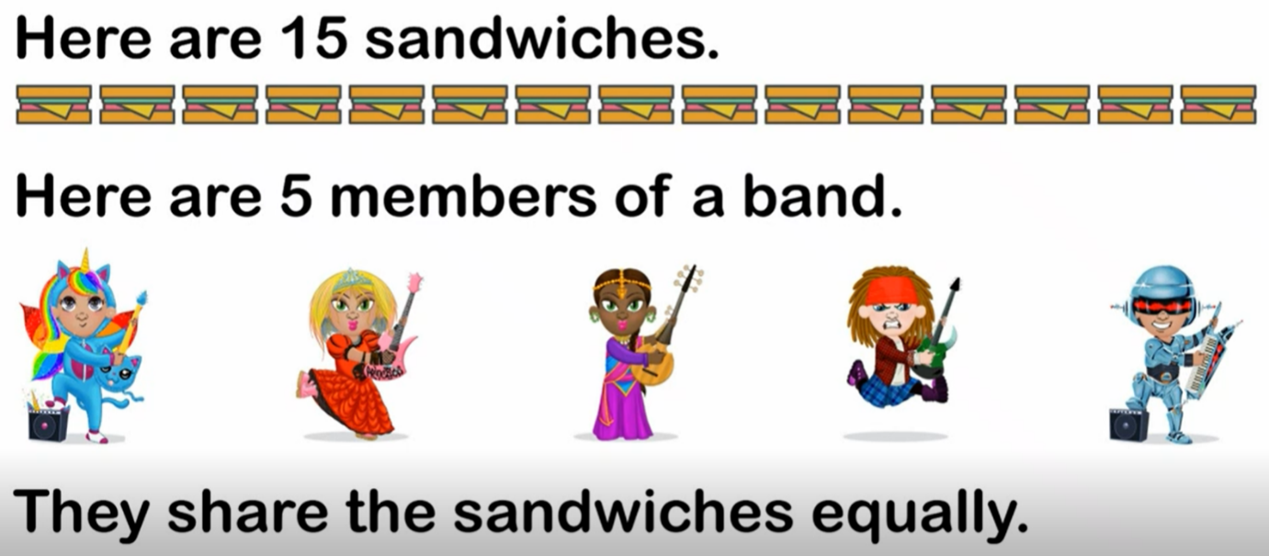1. There are 15 sandwiches. They need to be shared equally between the rock stars. Can you work out the division number sentence for this?

There are sandwiches.

There are groups.

There are sandwiches in each group.

**=**

Division Number Sentence:

2. Look at the flowers below. There is a number sentence that is missing some parts. Use the flowers to help you work it out.

This number tells you how many are in each group.

 20 5 = 4

This is the big number that you always share.

This number tells you how many groups there are.

To work out these questions, draw circles to represent your big number and then group them into groups of the number that is the answer.

1. 14 _____ = 7
2. 30 ______ = 5

3. As shown in the video, you can work out division questions using a number line. Please look at the following questions using the first as an example.

Example

To find the answer, look at what number is meant to be in each group and count up in jumps of that number (2) until you reach the big number (12).

 12 2 =

6

This is the number of objects that is in each group.

This is the big number that we are sharing.

6

5

4

3

2

1

There were 6 jumps. This is the answer.

0 2 4 6 8 10 12 14

1. 20 5 =

0 5 10 15 20 25 30 35

1. 24 4 =

0 4 8 12 16 20 24 28

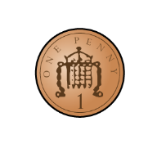**Challenge:**

I have 24 p.

I divide it equally between 2 friends.

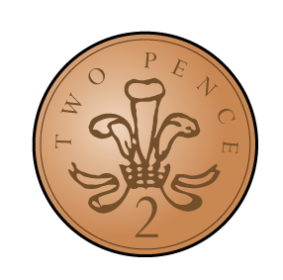How much will they get each?

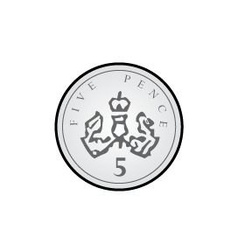I have 24 p in 2 p coins.

How many 2 p coins do I have?

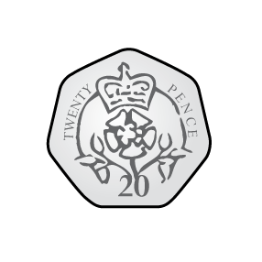

Consider the two questions above.

What is the same and what is different?