Home Learning
Maths
Year 1
Today we are going to be learning how to represent numbers up to 50.
Please watch the video below.
https://vimeo.com/500468562
1. Complete the part whole model for each picture
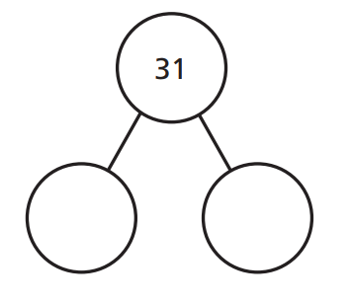
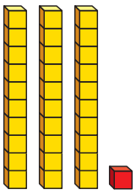
a.

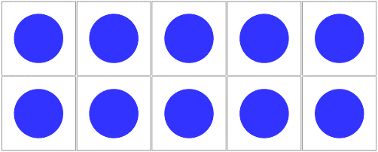
b.
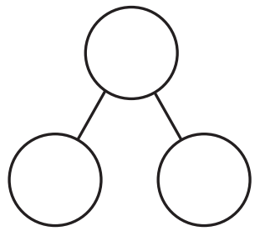

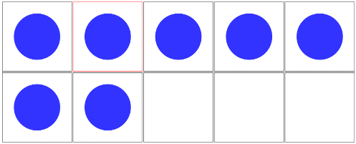

c.
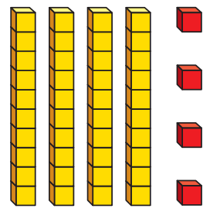

2. Draw a picture to represent each part-whole model.
a.
26

6
20

b.
41

1
40

Challenge
These part-whole models and pictures representing them are incomplete. Can you fill the missing pieces?
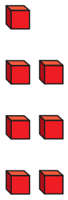
a.
_____
17
10

b.
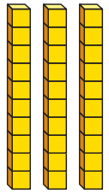
_____
_____
_____

8
_____

Year 2:
Today we are going to be learning how to divide by 2.
Please watch this video and complete the activities: https://vimeo.com/498260506

Activity:
1.
a) b)

2. Please complete the number sentences:

a)

b)

3.
Remember: There are 2 ways that you can do this.

Challenges: There are 2 challenge questions.
a)

b)

c)
Ron has shared some grapes equally between two friends.
Each friend receives fewer than 50 grapes.
Complete the sentences to describe the number of grapes Ron started with.
He must have started with…
He could have started with…
He can’t have started with…

