Home Learning
Maths
Year 1
Today we are going to be learning how to find one more and one less.
Please watch the two videos below:
https://vimeo.com/503093120
https://vimeo.com/503098045

1. Use cubes or counters to make each number.
a. One more than 18
b. One more than 34
c. One less than 22
d. One less than 45

2. Use different colours to show each number on the grid.
a. One more than 26 d. One less than 31
b. One more than 39 e. One less than 49
c. One more than 20 f. One less than 16
1 | 2 | 3 | 4 | 5 | 6 | 7 | 8 | 9 | 10
11 | 12 | 13 | 14 | 15 | 16 | 17 | 18 | 19 | 20
21 | 22 | 23 | 24 | 25 | 26 | 27 | 28 | 29 | 30
31 | 32 | 33 | 34 | 35 | 36 | 37 | 38 | 39 | 40
41 | 42 | 43 | 44 | 45 | 46 | 47 | 48 | 49 | 50
3. Fill in the missing numbers.
One Less | Number | One More
 | 45
17
 |  | 31
 | 22
29
 |  | 50

4.
My number has three tens. One more than my number would make the tens digit change.


My number is one more than thirty-five.

Whitney

Dexter
Who has the greater number? _______
Year 2
Today we are learning about odd and even numbers.
Please watch the video below.
https://vimeo.com/498261586
1. Jane has used counters to make the numbers 1 to 10.
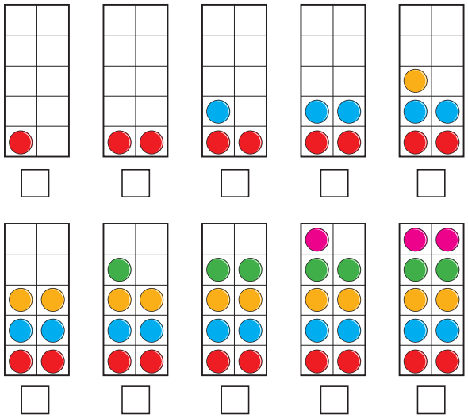
Tick the ten frames that show an even number.
What do you notice about all the numbers that are even?

2. Use ten frames and counters. You can draw them if you want to.
a. Show that 12 is an even number.
b. Show that 15 is an odd number.
c. Work out if 19 is an odd or even number.

3. Draw circles to help you answer these questions.
a. Group the shoes into 2s to show that 14 is even.

b. Group the socks into 2s to show that 17 is odd.


4. Colour in all the squares with odd numbers.
1 | 2 | 3 | 4 | 5 | 6 | 7 | 8 | 9 | 10
11 | 12 | 13 | 14 | 15 | 16 | 17 | 18 | 19 | 20
21 | 22 | 23 | 24 | 25 | 26 | 27 | 28 | 29 | 30
31 | 32 | 33 | 34 | 35 | 36 | 37 | 38 | 39 | 40
41 | 42 | 43 | 44 | 45 | 46 | 47 | 48 | 49 | 50

What do you notice about the last digit of all the odd numbers?
What do you notice about the last digit of all the even numbers?


5.
a. Teddy has a two-digit number.
The first digit has been covered up.
Is the number odd or even? Circle the answer.
Odd Even You cannot tell
How do you know?

b. Suzie has another two-digit number.
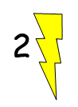
This time the second digit has been covered up.
Is the number odd or even? Circle the answer.
Odd Even You cannot tell
How do you know?

Challenge
Roll two dice and find the total. Complete the table.
Dice 1 | Dice 2 | Total | Odd or even?
1 (odd) | 4 (even) | 1 + 4 = 5 | Odd

What patterns do you spot?

