**Home learning**

**Maths**

For this session, I have split the Year 1 questions into ‘Year 1’ and ‘Year 1 .’ The ‘Year 1’ questions are a little easier. The ‘Year 1 ‘ questions are harder. Please choose which set of questions you would like to complete.

Year 1:

We are going compare objects and numbers up to 10.

1. a) Count the numbers of objects and draw that number as counters in the tens frame.



|  |  |  |  |  |
| --- | --- | --- | --- | --- |
|  |  |  |  |  |
|  |  |  |  |  |

There are _______ bananas.

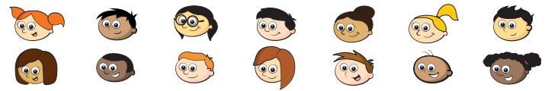b)

|  |  |  |  |  |
| --- | --- | --- | --- | --- |
|  |  |  |  |  |
|  |  |  |  |  |

There are _______ children.

c) Who has more? Circle the correct object.

or

2. Use the greater gator to make the statements correct.

**Remember:** The gator always eats the biggest number.

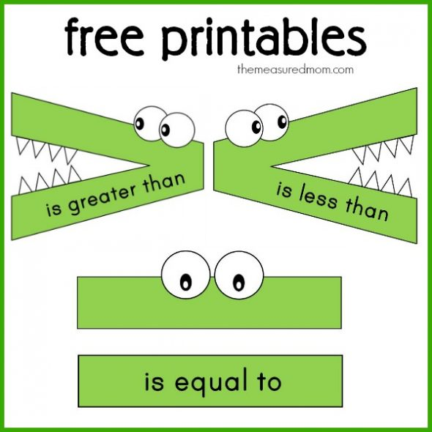

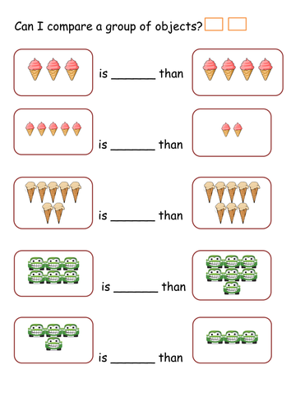

3. Please get yourself 12 objects (E.g. cubes, lego or toys). This will help you with this activity. Make the numbers that are shown below and use the stem sentences to fill in the space to make them correct.

The first one is done for you:

is greater than

is less than

is equal to

is greater than

1. 6 __________________________ 3

2. 5 __________________________ 7

3. 3 __________________________ 3

4. 9 __________________________ 2

Year 1

Today we are learning about comparing objects and numbers.

Please watch the below videos.

<https://vimeo.com/503099894>

<https://vimeo.com/503102857>

1. a) Draw counters in the ten frame to show bananas.



|  |  |  |  |  |
| --- | --- | --- | --- | --- |
|  |  |  |  |  |
|  |  |  |  |  |

|  |  |  |  |  |
| --- | --- | --- | --- | --- |
|  |  |  |  |  |
|  |  |  |  |  |

b) Draw counter to show the children.



|  |  |  |  |  |
| --- | --- | --- | --- | --- |
|  |  |  |  |  |
|  |  |  |  |  |

|  |  |  |  |  |
| --- | --- | --- | --- | --- |
|  |  |  |  |  |
|  |  |  |  |  |

c. Complete the sentences.

There are ______ bananas.

There are ______ children.

There are more _____________ than _______________.

d. Bob says that all children can have a banana.

Is Bob correct?

2. Draw counters to make the statements true.

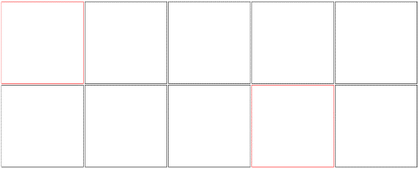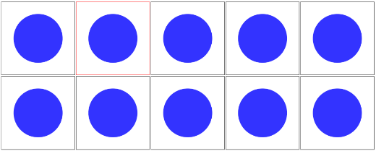a.



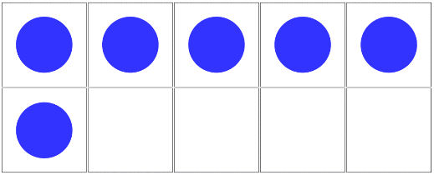

b.



c.

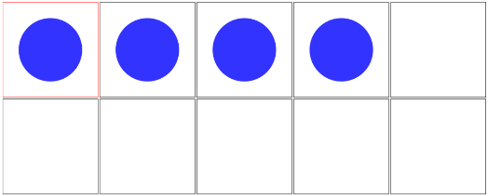

3. Tick the number sentences that are true.

a. Eleven is more than 15.

b. 14 is equal to 1 ten and 4 ones.

c. Fifteen is less than 2 tens.

d. 26 is more than 21.

e. 20 + 2 is equal to 22.

f. Thirty-six is less than 3 tens.

4. Write < , > or = in each circle.

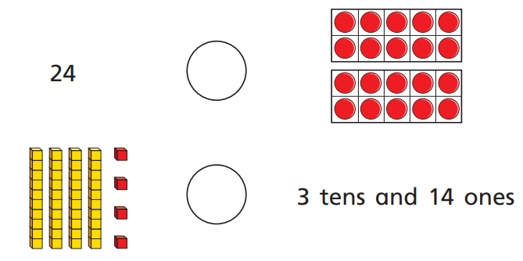

Year 2

Today we are going to learn about dividing by 5.

Please watch the video below.

<https://vimeo.com/498262138>

1. Here are some counters. 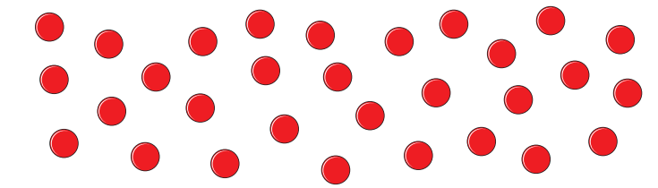

a. Draw circles round groups of 5.

b. Complete the sentences.

There are 30 counters.

There are ______ counters in each group.

There are ______ groups.

30 ÷ 5 = ______

______ x 5 = 30

2. Share the sweets between the party bags.



There are ______ sweets.

There are ______ party bags.

There are ______ sweets in each bag.

15 ÷ ______ = ______

3. Complete the number sentences for each array.

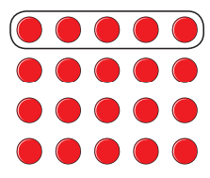a. ______ x 5 = 20

20 ÷ 5 = ______

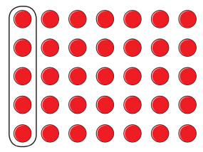

b. ______ x 5 = ______

______ ÷ 5 = ______

4. A boat can fit 5 people.

Work out how many boats will be needed for 45 people.

______ ÷ ______ = ______

______ boats are needed.

5. Complete the divisions.

a. 40 ÷ 5 = e. ______ ÷ 5 = 3

b. 35 ÷ 5 = f. ______ ÷ 5 = 6

c. 60 ÷ 5 = g. ______ ÷ 5 = 10

d. 20 ÷ 5 = h. ______ ÷ 5 = 0

Challenge.

James buys 5 chocolate bars.



This costs him 50p.

How much do 2 chocolate bars cost?

Annie has 40p.

The sweet she wants to buy is 5p each.

How many sweets can she buy for 40p?