Home Learning
Maths
Year 1:
Today we are going to be learning about counting to 50 by making 10s.
Please start by watching this video
https://vimeo.com/500465193
1. How much is being shown here?
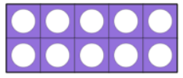
a.

b.

c.

d.

2. Practice making 5 groups of 10 with whatever you can find in your house.
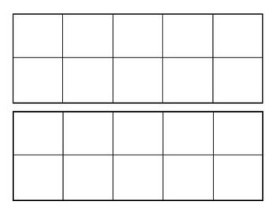
Or if you want you can draw the items. Draw them as cubes, or on a ten frame. I have put 8 ten frames below.

You can also attach a photo of your groups to Teams as well.

Year 2:
Today we are going to be learning about ‘Making equal groups by sharing.’
Please watch this video: https://vimeo.com/492603273
- Please answer the questions asked in the video on plain paper.

Activity:
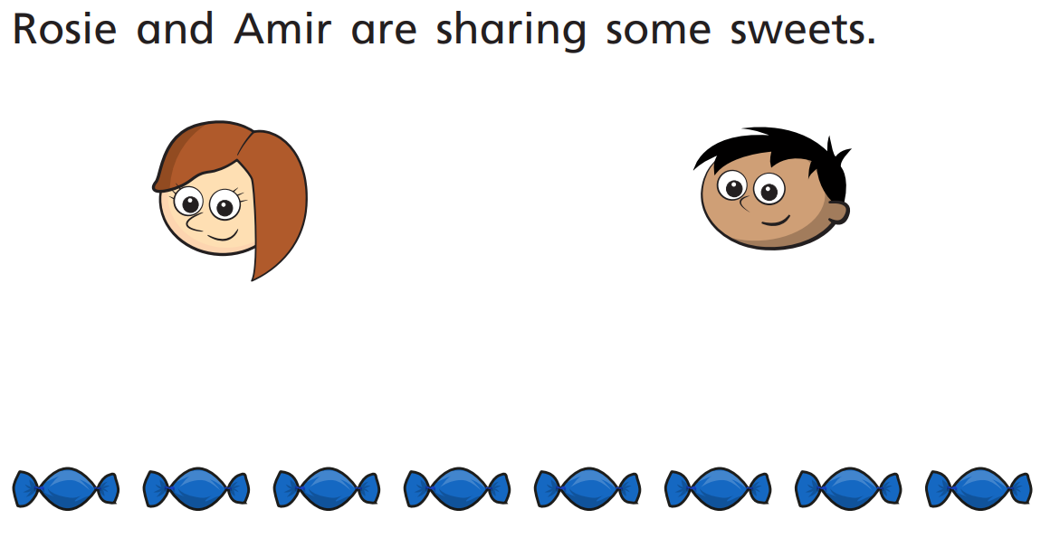
1.

- Draw lines to share the sweets equally.
- How many sweets foes each child get?

Each child gets .

8 sweets shared equally between 2 is .

2.

- How many bananas will there be in each box?

- 20 bananas shared between 5 boxes is .

- There will be bananas in each box.

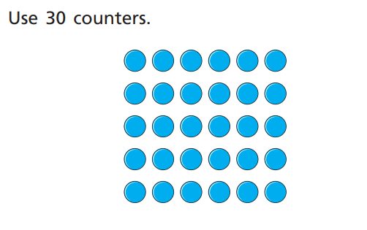
3.

- Share the counters between 2 friends. How many does each friend get?

- Share the counters between 5 friends. How many does each friend get?

- Share the counters between 10 friends. How many does each friend get?
Challenge:

1. Jane has 10 sweets and shares them between 2 friends.
Tom has 10 sweets and shares them between 5 friends.
Draw pictures to show whose friends will receive the most sweets?

2. Tommy and Annie have some counters.

Tommy shares his counters in to 2 equal groups.
He has 15 in each group.
Annie groups her counters in twos.
She has 19 groups.

Who has more counters and by how many?
How did you work it out?

