**Home learning**

**Maths**

I have split the Year 1 questions into ‘Year 1’ and ‘Year 1 .’ The ‘Year 1’ questions are a little easier. The ‘Year 1 ‘ questions are harder. Please choose which set of questions you would like to complete.

Year 1

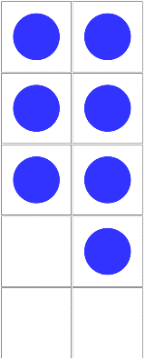1. Count up the counters and write the answers in the box:

1. ­

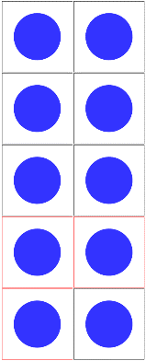



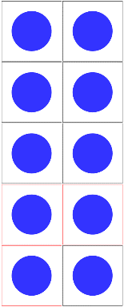

1. 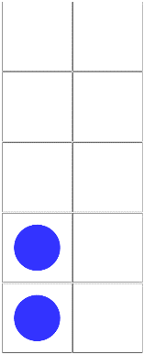

Please put these numbers in order from smallest to greatest:

Smallest Greatest

_________ ___________ _________

2. Count up the counters and write the answers in the box: 

1. ­­

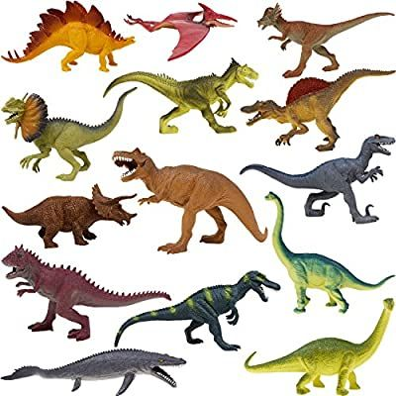

1. 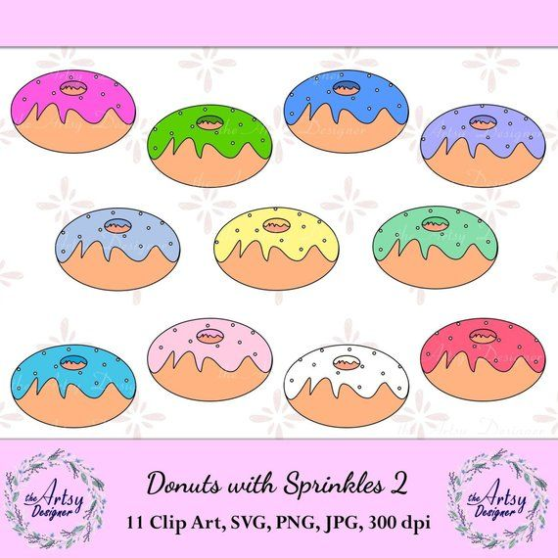

Please put these numbers in order from smallest to greatest:

Smallest Greatest

_________ ___________ _________

3. Write the numbers in order.

Start with the smallest number.

a)

12

4

8

Smallest Greatest

_________ ___________ _________

b) Write these numbers in order.

Start with the greatest.

2

7

15

Greatest Smallest

_________ ___________ _________

**Challenge:** Is this correct?

See if you can put these numbers in the correct order.

Smallest Greatest

10 11 8

Year 1

Today we are ordering numbers up to 50.

Pleas watch the video below.

<https://vimeo.com/503093819>

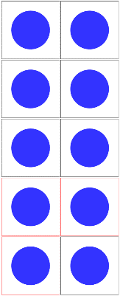1. What are the numbers?

a.



__________ ____________

__________

Write the numbers in order.

Start with the smallest number.

Smallest Greatest

_________ ___________ _________

b. 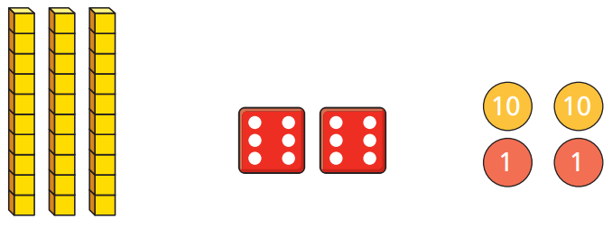

__________ ____________ __________

Write the numbers in order.

Start with the smallest number.

Smallest Greatest

_________ ___________ _________

2. Write the numbers in order.

Start with the smallest number.

a.

33

26

41

Smallest Greatest

_________ ___________ _________

b.

34

32

37

Smallest Greatest

_________ ___________ _________

c.

25

35

45

Smallest Greatest

_________ ___________ _________

3. Write these numbers in order.

Start with the greatest.

17

32

40

Greatest Smallest

_________ ___________ _________

4. Complete the number sentence.

3 tens and 4 ones < _________ < 44

Could there be more than one answer?

Year 2

Today we are dividing by 10.

Please watch the video below.

<https://vimeo.com/498262386>

1. Here are some crayons.

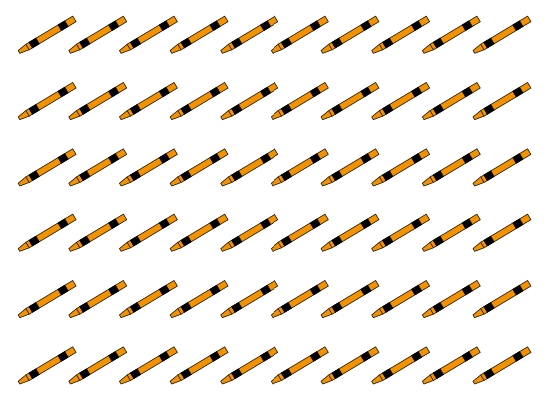

A pack holds 10 crayons.

How many packs can be made?

Complete the sentences below.

There are _______ crayons.

There are _______ crayons in a pack.

60 ÷ 10 = _______

_______ packs can be made.

2. Share 40 counters equally between ten groups.

|  |  |  |  |  |  |  |  |  |  |
| --- | --- | --- | --- | --- | --- | --- | --- | --- | --- |
|  |  |  |  |  |  |  |  |  |  |

Complete the division.

40 ÷ _______ = _______

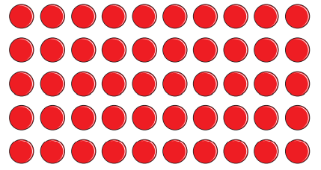3. Use the array to complete the fact family.

_______ x _______ = _______

_______ x _______ = _______

_______ ÷ _______ = _______

_______ ÷ _______ = _______

4. Write the missing numbers.

a. 70 ÷ 10 =_______ d. _______ tens ÷ 10 = 2

b. 90 ÷ 10 =_______ e. _______ ÷ 10 = 5

c. 1 ten ÷ 10 =_______ f. 90 = 10 ÷ _______

5. Jessie has 3 number cards.

10

90

9

Complete the number sentences below using only these numbers.

_______ x _______ = _______

_______ ÷ _______ = _______

Are there any other ways to complete the sentences?

Challenge.

What is the mass of one of the boxes?

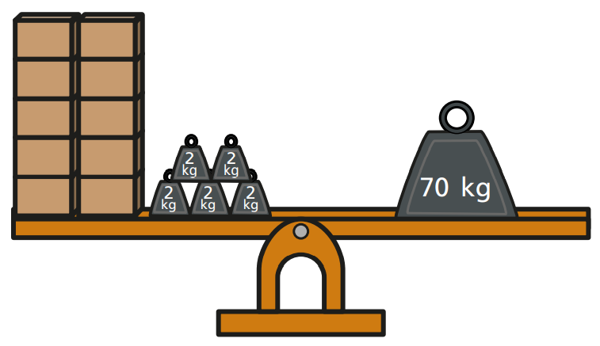

|  |
| --- |
| Please show how you worked it out in this box.  _______ |