Home learning
Maths
Year 1
Today we are going to be looking at our numbers to 20.
Activity 1:
First, find yourself 2 dice.
If you do not have them, please follow this link and use it to get your numbers: https://www.random.org/dice/?num=2

Once you have done this, I would like you to roll the dice, then count the number and write it down in numerals and words.
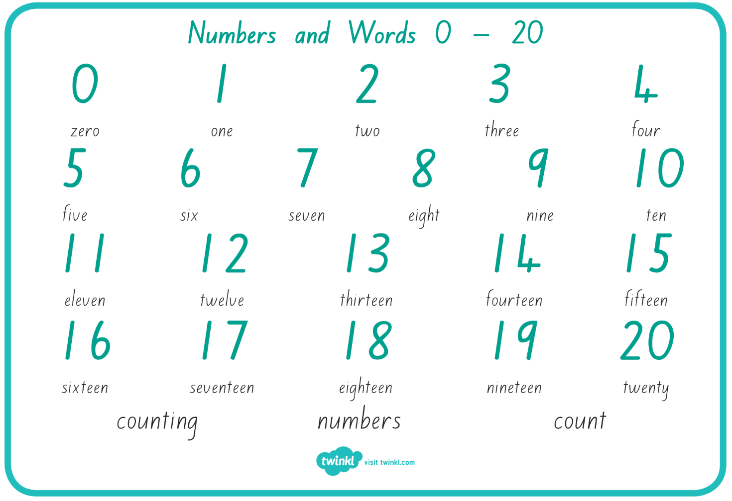
Use the word mat below to help you with this activity.
Activity 2:
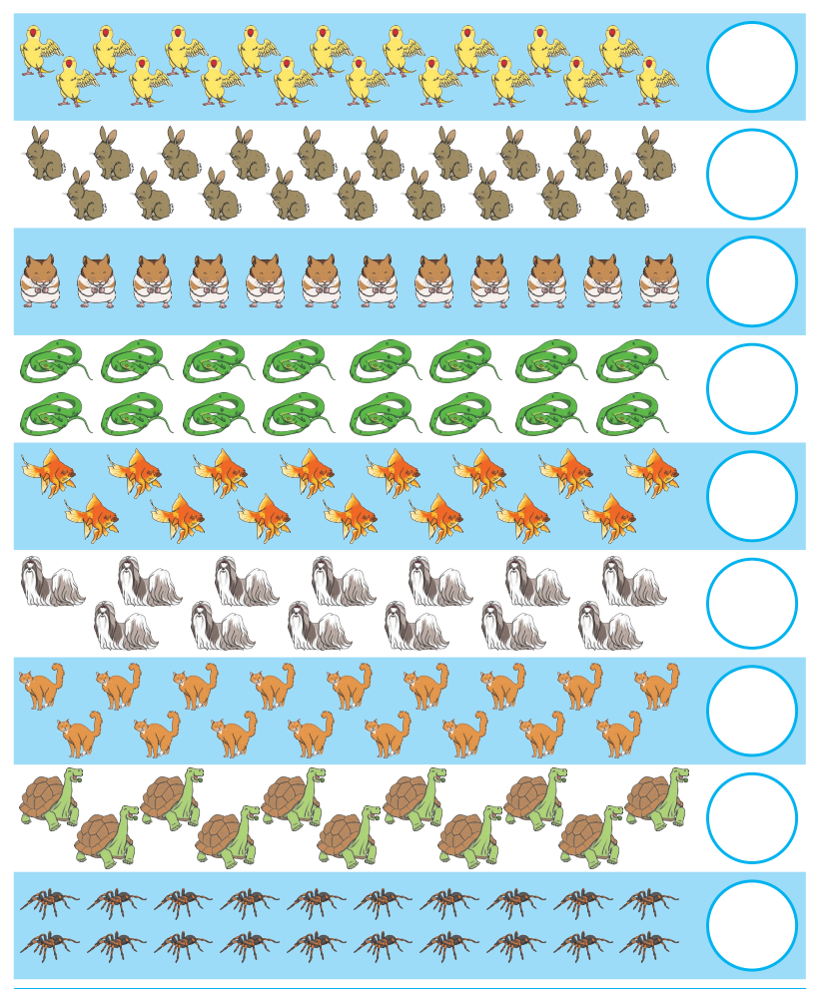
Please look at the animals below. Have a go at counting them and writing the number into the circle. Use the word mat above to help you.

Activity 3:
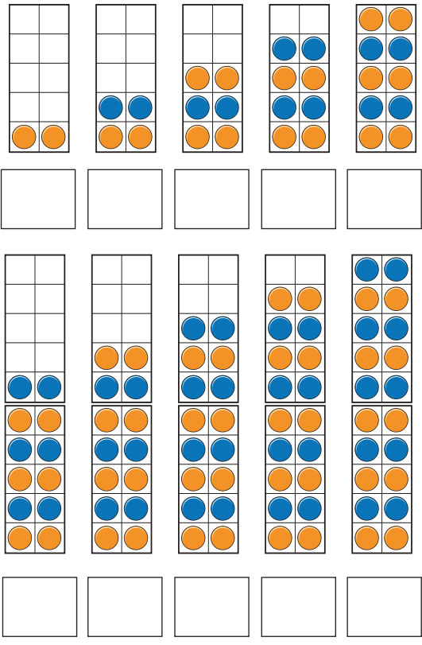
Please look at the ten frames below. Count the numbers and write them into the boxes.

Now using the numbers, you have counted, please look at the number line below. You need to colour in the numbers that you have counted above.

Year
Today we are going to be counting in 2s.
Please watch the videos below.
https://vimeo.com/507065512
https://vimeo.com/505658511
1. How many counters are there in each set? Write the answers in the boxes below the ten frames.

2. How many flowers are there?
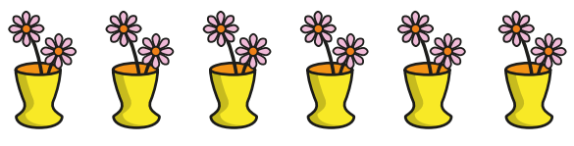

There are _____ flowers.
3. Here are 20 socks.

Circle 14 socks.
4. Fill in the missing numbers.
a.
0 | 2 | 4

b.
20 | 18 |  | 14 |  | 10 |  |  | 4

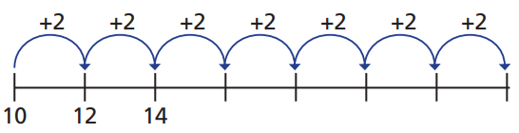
c.

Challenge:
Practice counting in 2s starting at 0.
What number did you manage to get to? ______
Practice counting down in 2s from 20.
Now try from 30.
Now try from 40.
Year 2
Today we are going to go over dividing by 5 and 10 again.

1.
a. Share 20 counters between these 5 groups.
Draw the counters in the boxes, then write the division sentence.
______________
b. Share 20 counters between these 10 groups.
Draw the counters in the boxes, then write the division sentence.
______________
c. Share 60 counters between these 5 groups.
Draw the counters in the boxes, then write the division sentence.
______________

d. Share 60 counters between these 10 groups.
Draw the counters in the boxes, then write the division sentence.
______________

2.
a. Complete the number sentence for the array.
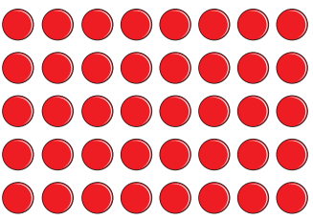

_____ x 5 = _____
_____ ÷ 5 = _____
____ x 10 = _____
____ ÷ 10 = _____
b. Challenge. Have you noticed a pattern between the answers when you divide the same number by 10 and by 5? What is the pattern?

3. Complete the divisions.
a. 15 ÷ 5 = _____ b. 30 ÷ 5 =_____
c. 55 ÷ 5 =_____ d. _____ ÷ 5 = 4
e. 50 ÷ 10 =_____ f. 90 ÷ 10 =_____
g. 110 ÷ 10 =_____ h. _____ ÷ 10 = 1

4.
a. There are 80 seats in a cinema.
The seats are sorted out into rows of 10.
How many rows of seats are there?
_____ ÷ _____ = _____
There are _____ rows.

b. Mrs Smith has 5 Children in her class.
She wants to share her 60 crayons evenly between the children.
How many crayons will each child get?
_____ ÷ _____ = _____
Each child will get _____ crayons.

