Home learning
Maths
Year 1
Today we are going to be learning to count in 5s.
Please watch the videos below.
https://vimeo.com/507067325
https://vimeo.com/507075995
1. What are the numbers?
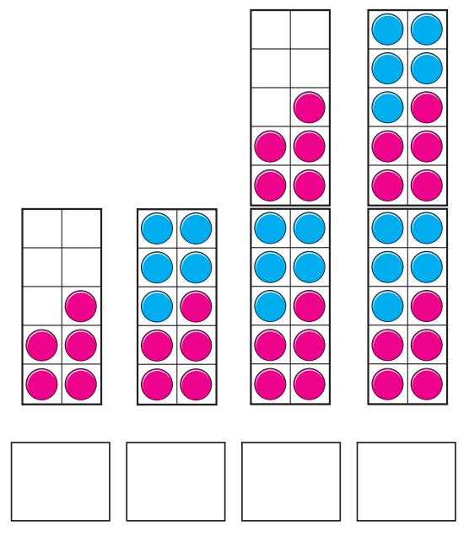

2. Each ladybird has 5 spots.
How many spots in total?

There are _____ spots in total.

3. Colour in 35 petals.

4. Fill in the missing numbers.
a.
0 | 5 | 10
b.
50 | 45 | 40
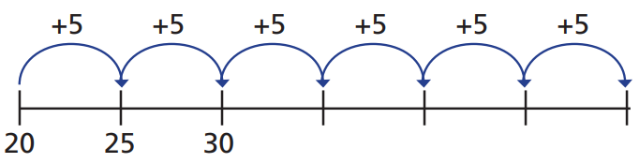
c.

Challenge.
Mo counts up to 50 in 5s.
Eva counts up to 50 in 2s.
What numbers do they both say?
Can you spot a pattern?
Year 2
You have all done so well with your learning this term!
We are going to do an end of term assessment.
1. Circle 5 groups of counters.
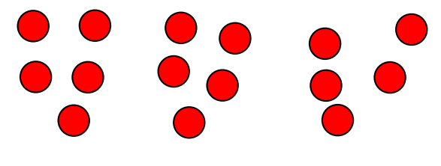

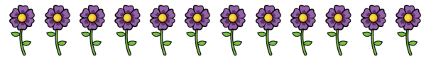
2. Mo is putting 12 flowers into pots.
He is putting 2 flowers in each pot.
How many pots will he need?
________ pots.
3. Dora has 10 sweets.

She shares them between two plates.
How many on each plate?
__________ sweets.

4. Three children share 6 crayons equally.

They want to know how many they will get each.
Fill in the number sentence to work it out.
_______÷_______=_________

5. Here is a bar model.
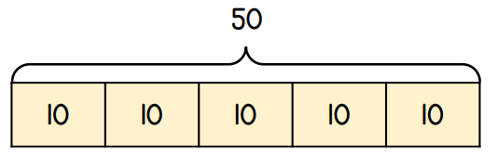

Use it to complete these number sentences.
50 ÷ _______ = 10
50 ÷ 10 = _______

6. You may use the number lines to help you.
90 ÷ 10 = _____
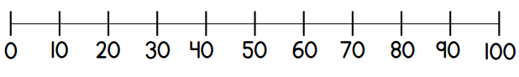

14 ÷ 2 = ______
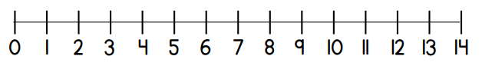

7. Use <, > or = to complete the number sentence.
35 ÷ 5 _____ 40 ÷ 10

8. Circle the odd numbers.
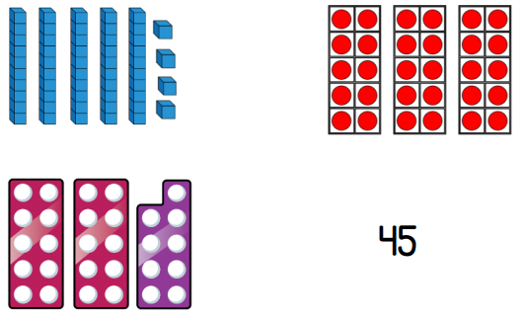

9.
Teddy has 20 pence in 2p coins.
He uses 7 of the coins to buy a can of drink.
How many 2p coins does he have left?

___________coins.

