Home Learning
Maths
Year 1
Today we are going to be learning about ‘Comparing lengths.’
Please watch this video: https://vimeo.com/507433257
- Have a go at completing the activities in the video.
Activity:
1. Please go and find yourself 5 objects. Complete the questions below using your objects to help you.
To answer the questions, write the name of your object in the boxes next to the questions or take pictures of your objects and attach them to teams.

a) Which is the longest object?

b) Which is the shortest object?

c) Are there any objects which are the same length?

d) Can you order them from shortest to longest?

e) Can you find another object that is longer than the longest object?

f) Can you find another object that is shorter than the shortest object?

2. Have a look at the objects below. Can you order them from longest to shortest?
To complete this activity, you can number the objects, move the objects on the screen or write the names of the objects in the spaces below.
spoon
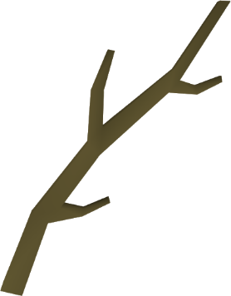
cubes

fish

stick

Longest Shortest

3. We are going to be using the language we learnt in the video to help us compare the objects below. Please look at the objects that are labelled A and B. You need to decide which order they go in to fit the stem sentence. I have done the first one for you.

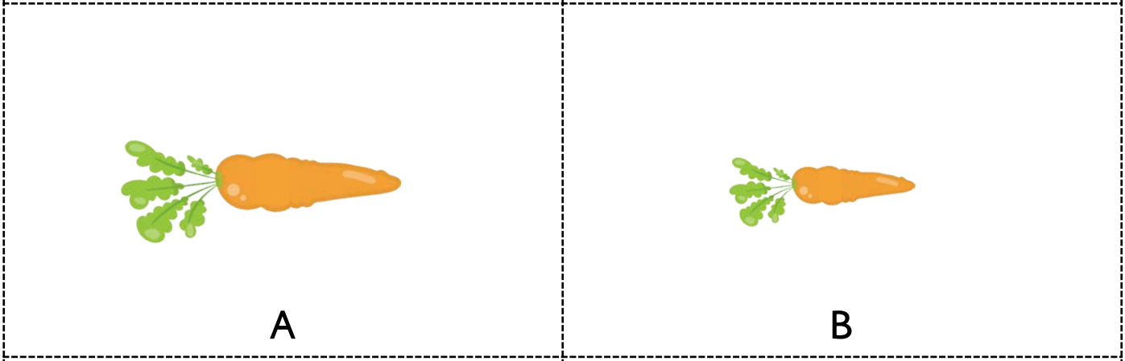
a)

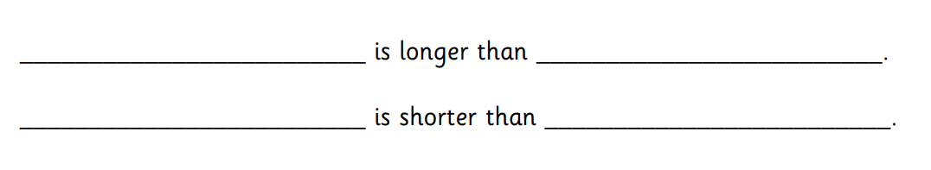
B
A
B
A

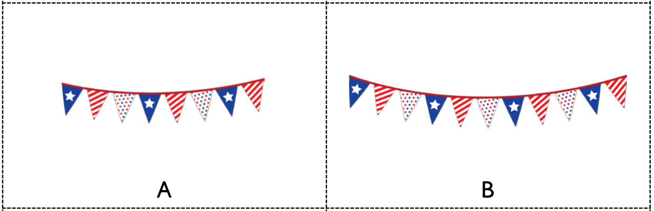
b)

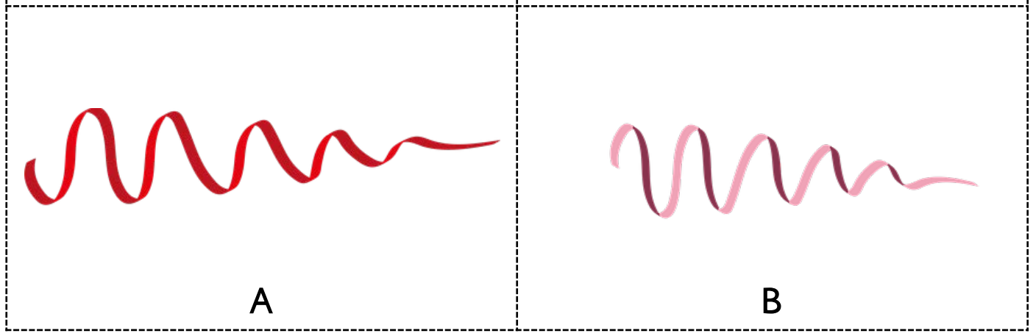
c)

Year 2:
Today you are going to be recapping comparing length and height, we have looked at this before so today is about refreshing your memories and developing understanding.
Please watch this video: https://vimeo.com/507943851

Activity:
Complete the questions below. Once you have completed these questions, please have a go at the practical activity.
- Complete the sentences using longer, taller and shorter to compare the objects.

- The blue pencil is ____________________ than the green pencil.
The green pencil is ____________________ than the blue pencil.
- The pink tower is ______________________ then the yellow tower.
The yellow tower is ______________________ than the pink tower.

- The rabbit is _____________________ than the cow.
The cow is ______________________ than the rabbit.

- Compare the animals using the worlds taller and shorter.
The pig is ______________ than the chicken.
The pig is ______________ than the giraffe.
The chicken is _______________ than the pig.
The chicken is _______________ than the giraffe.
The giraffe is ______________ than the pig.
The giraffe is ______________ than the chicken.
The ___________________ is the tallest.
The ___________________ is the shortest.

Practical activity: Go around your house and find 5 different objects, these objects can range from your teddies to kitchen utensils, anything you are allowed to use. Remember to check with an adult first.

First practical: Once you have collected your objects order them from shortest to longest and then answer the questions below.

Which object is the shortest? ___________________________
Which objects is the longest? ___________________________
Are there any objects that are the same? If so which objects? ___________________________________
Can you find an object that is shorter than your shortest object? _________________________________
Can you find an object that is longer than your longest object? _________________________________

Second practical: Use the same objects as the first practical, but this time order then from shortest to tallest and then answer the questions below.

Which object is the shortest? _____________________________
Is it the same object as before, give reasons? ___________________________
Which object is the tallest? ______________________________
Is it the same object as before, give reasons? ___________________________
Are there any objects that are the same? If so which objects? ___________________________________
Can you find an object that is shorter than your shortest object? _________________________________
Can you find and object that is taller than you tallest object? ___________________________________

Take pictures of your ordered objects for each practical and upload them to Teams. You can answer the questions above on this document or on a piece of paper.

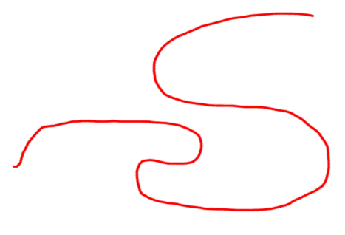
Challenge
Reasoning questions:

- How long is this piece of string? How could you find out?
Does the length change if you change the orientation?

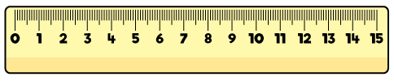
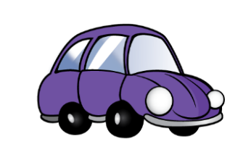

- Mo has used the ruler to measure the length of the car.
Mo says the car is 8 centimetres long. Do you agree?
Explain your answer.

