Home Learning
Maths
Year 1:
Today we are going to be learning about ‘Comparing heights.’
Please watch this video: https://vimeo.com/507433540
- Please have a go at the activities in the video.

Activity:
1.

2.

3. Please look at the animals below. Use the words below to fill in the blank spaces.

a) Who is the shortest? ________________________
b) Who is the tallest? _________________________
c) Tiger is _________________ than Mouse.
d) Giraffe is _________________ than Hippo.
e) Hippo is __________________ than Giraffe.
d) Giraffe is _________________ than Mouse.

Challenge:
1. Who is taller than Mouse but shorter than Hippo?
_______________
2. Who is shorter than Giraffe and shorter than Tiger?
_______________

4. Circle the tallest tower of cubes.

5.

Challenge:
Compare these pairs using the words below:

a)

b)

Year 2:
Today we are going to be learning how to ‘Measure.’
Please watch this video: https://vimeo.com/508439670
- Please have a go at the activities in the video.

Activity:
1. Please look at the questions below. Work out what each object measures in cubes and fill in the stem sentences.
a)

b)

c) ________________ is longer than the __________________.

________________ is shorter than the __________________.

2. Now it is your turn. You are going to go on a measurement hunt. Look at the table below and find the objects on the left in your house. Then, have a go at measuring each object in the 3 different ways shown along the top and write down the number of hands, shoes and teaspoons you use to measure each object.

Object: | Hands | Shoes | Teaspoons
A table
A pencil
A lunchbox
A chair

Challenge:
What other non-standard unit could you use to measure an object?

___________________________

3. Please find yourself a teddy or a toy. Below there are some options of how you can measure your teddy or toy using non-standard units. Use the word bank below to help you with your explanation.
length | equal | unequal
small | big | height

- In your opinion, which object would be the best to use to measure the teddy or toy accurately? Explain your answer.
Hands
Sticks
Door
Lego Bricks

_____________________________________________________________________________________________________________________________________________________________________

- In your opinion, which object would be the worst to use to measure the teddy or toy accurately? Explain your answer.
Hands
Sticks
Door
Lego Bricks

_____________________________________________________________________________________________________________________________________________________________________

Challenge:
Problem Solving
1. Amir has a metre stick. He wants to measure the length of his classroom.
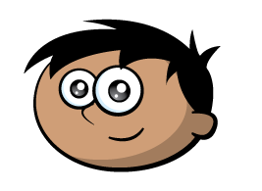
I can’t measure the length of the classroom because my meter stick isn’t long enough.

Explain to Amir how he could measure the length of his classroom.

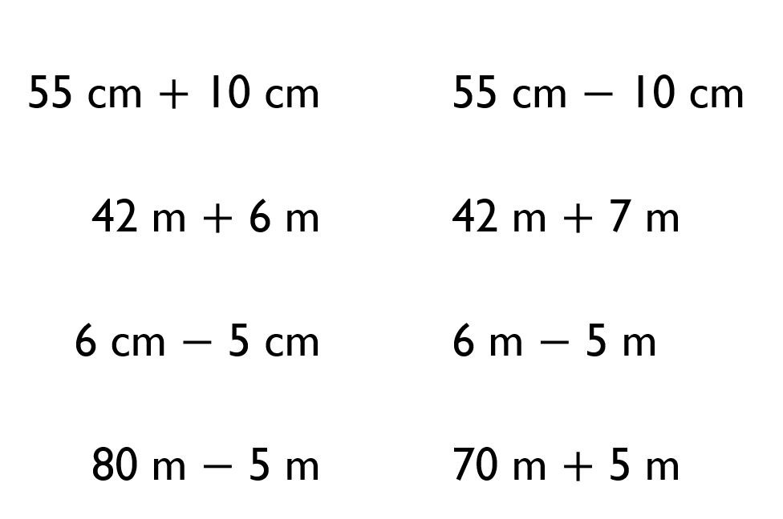
2. Compare the measurements using <, > or =

3. A green pencil is twice as long as a blue pencil.

Using this, complete the statements below using longer than, shorter than or equal to.
3 green pencils are _________________ 2 blue pencils.
2 green pencils are _________________ 5 blue pencils.
4 green pencils are _________________ 8 blue pencils.

