Home Learning
Maths
Year 1:
Today we are going to be recapping ‘Comparing length and heights.’
Please watch the video below: https://vimeo.com/507943851

Activity:
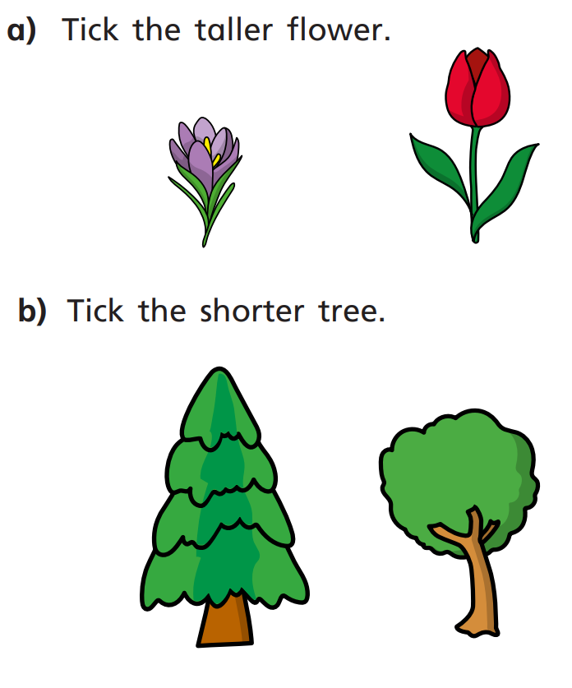
1

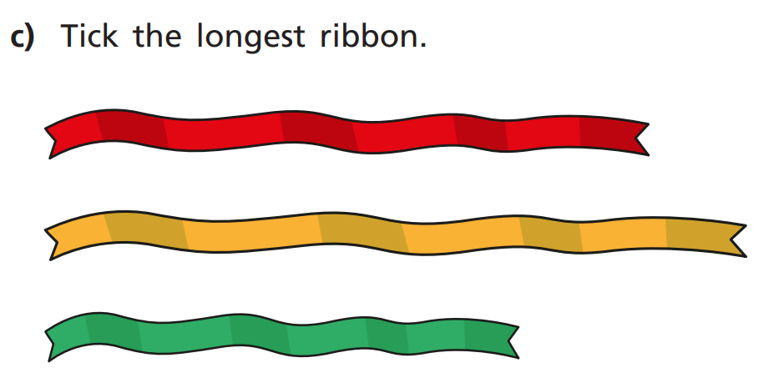

2. Complete the sentences using longer or taller.
- The blue pencil is ____________________ than the green pencil.
The green pencil is ____________________ than the blue pencil.
- The pink tower is ______________________ then the yellow tower.
The yellow tower is ______________________ than the pink tower.
- The rabbit is _____________________ than the cow.
The cow is ______________________ than the rabbit.

3. Compare the animals using the worlds taller and shorter.
The pig is _________________ than the chicken.
The pig is _________________ than the giraffe.
The chicken is __________________ than the pig.
The chicken is _________________ than the giraffe.
The giraffe is ________________ than the pig.
The giraffe is ________________ than the chicken.
The _____________________ is the tallest.
The _____________________ is the shortest.
Challenge:
1. Below there are some towers. Is Tommy correct? Explain.
I think that the green pencil is the tallest.

--------------------------------------------------------------------------------
2. Below there are some cars. Is Isabelle correct? Explain.
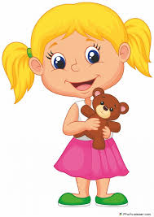
I think that the yellow car is longer than the blue car.

----------------------------------------------------------------------------------

Year 2:
Today we are going to be recapping ‘Measuring using standard units. ‘
Please watch this video: https://vimeo.com/510394371

Activity:
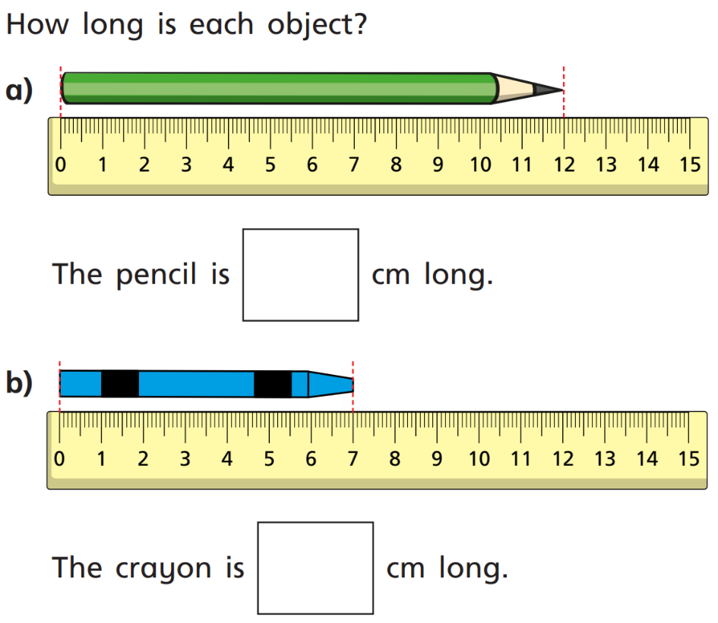
1.

2. Please look at the pictures below. You need to work out the height of both of these towers.
Remember: You need to write what you are measuring in.
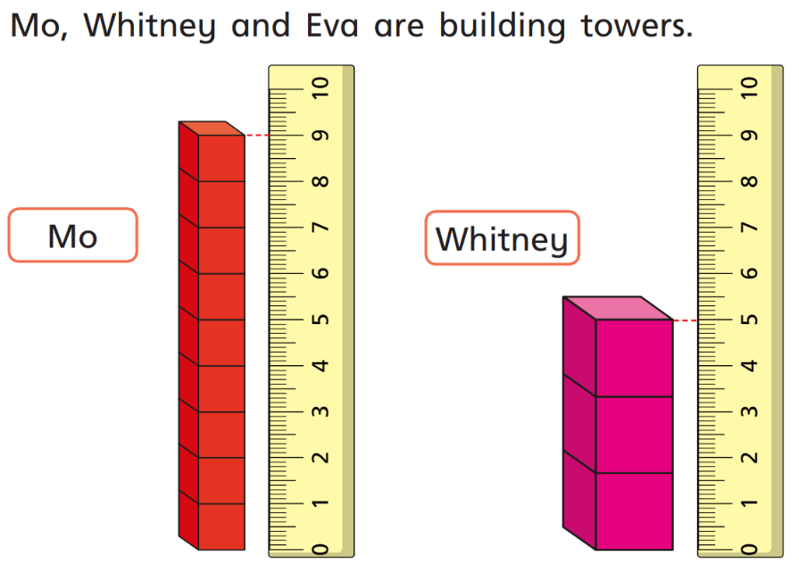

- Mo’s tower is _____________ tall.
- Whitney’s tower is ______________ tall.

- How much taller is Mo’s tower to Whitney’s? ___________.

3. Practical: Please find yourself a ruler. If you do not have one, find some lined paper and turn it landscape and use the margin to make your own. An example is shown below.
9
8
7
6
5
4
3
2
1
1
0
1

Now it is your turn to do some measuring of your own. Below is a table. You need to go around and find different objects. Then you can measure them and write in your findings:

Object: | Measurement (cm):

- Which was the longest/tallest object? _____________

- Which was the shortest object? _____________

- How much longer/taller is your object than the shortest one?

Challenge:
1. Four children ae measuring their heights.
Eva is taller than Rosie, but not as tall as Mo.
Dexter is taller than Mo.
Write down their names in order of their heights, starting with the shortest.

2. Here is a strip of orange paper.

A blue strip is four times longer than a orange strip.

The strips are joined together end to end.

50 cm

How long is the orange strip?
How long is the blue strip?

3. Have a go at making a metre stick using your rulers.
There are 100cm in a metre.
Have a go at thinking about how many 10s there are in 100cm.
Then use your ruler and make the metre by making lines of ten.

