Home Learning
Maths
Year 1:
Today we are going to be learning about ‘Measuring using non-standard units.’
Please watch this video: https://vimeo.com/507969952
- Have a go at the activities in the video.

1. Please work out how many cubes each of the objects below are in length:

c)

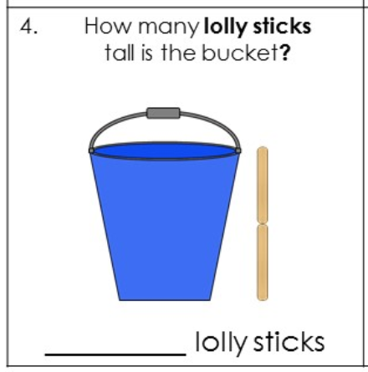
d)

2. Please tick the correct answer and write how long each object is.
a)

=

=

Can you explain your answer? __________________________________________
________________________________________________________________

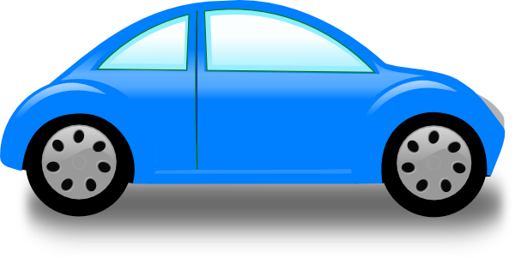
b)

Can you explain your answer? ___________________________________________
_________________________________________________________________

3. Practical: Please find the objects below in your house and choose some objects that you can use to measure their lengths and heights.
Make sure that they are the same sized object.
You could measure using:
- Lego blocks
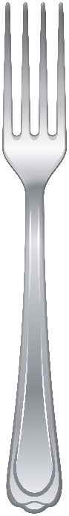
- Coins
- Hands
- Shoes

- How long is the fork?

=

- How tall is the teddy?
Remember to write what you are measuring in.
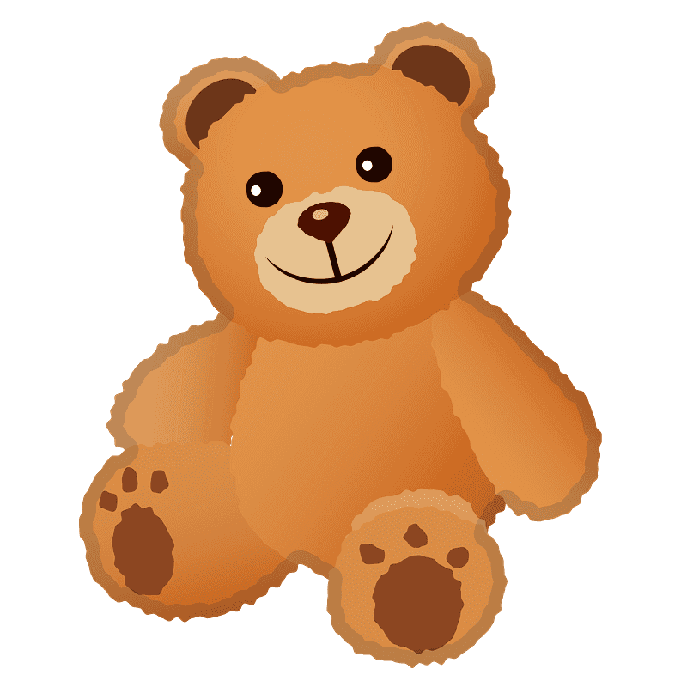

=

- Pillow
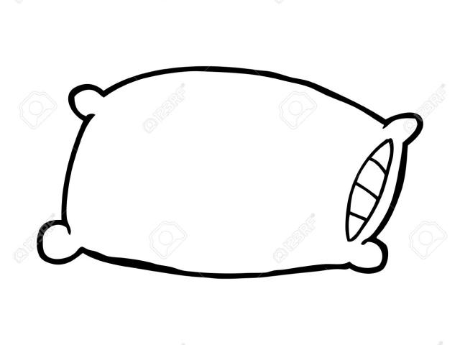

=

Challenges:
Rosie, Alex and Mo are comparing the height of Mrs Rose and Jack.
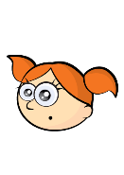
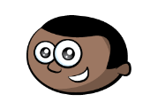
Mrs Rose is longer than Jack.
Jack is short than Mrs Rose.
Mrs Rose is tall than Jack.

Can you improve their sentences to make them more accurate?

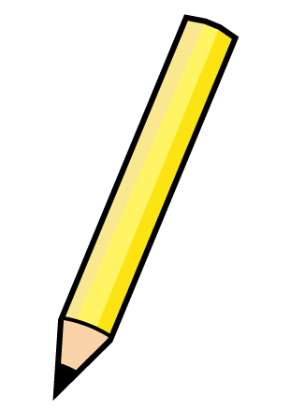
2. Eva thinks the pencils are the same length.

How can Eva check if she is correct?

3. True or False?

The flower is 5 cubes tall.
Explain your answer.

4. Whitney measures the length of 2 toys.
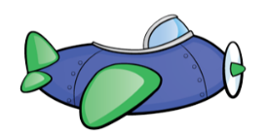
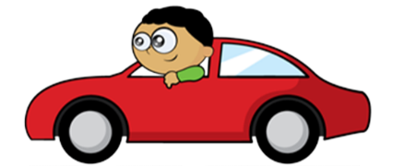

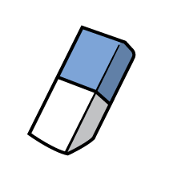

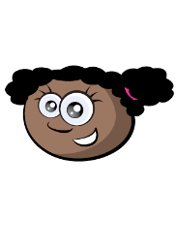
She says:
The toys are the same length.

Do you agree with Whitney?
Explain your answer.
Year 2:
Today you are going to be learning about ‘measuring in Metres’
Starter: Please answer these questions to recap your learning.
- How many cubes long is the crayon?
- How many sides does a hexagon have?
- What is one more than twenty-three?
- How long is the leaf (middle picture)?
- How many tens are there is 82?
- Write down an object that you think is longer than a metre.
- How many tarts are there altogether (bottom picture)?
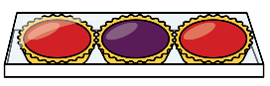
- Time has 23 beads. Sam has 8 fewer beads than Tim. How many beads does Sam have?

Watch this video: https://www.youtube.com/watch?v=azeQ--rFG5Y

Main activity: Please complete the activities below.
Look around your house and choose 10 objects, they can be anything.
- Estimate which objects are longer than 1 metre and which are shorter than 1 metre.
- Draw or write each object in the correct part of the table below.
Longer than 1 metre | Shorter than 1 metre

Now you have made your estimations it is time to find out whether you were correct. For this activity you are going to need a metre measure.
What you could use: metre stick, measuring tape, 30cm ruler used 3 times and then for 10cm = 100cm which is 1m, make your own metre stick using card board taped together, a metre measure of string.
Complete this table below by measuring using your metre measurement. I have filled in an example for you to help. You can measure length and height of objects.

Object | Measurement | Can you find an item that is bigger? | Can you find a smaller item?
Height of wardrobe | 1m 78cm | Height of a door | Height of desk chair

- Where any of your estimations you made before correct? Which ones?
- Which object is closest to 1 metre? ____________________________________________

Challenge:
- Put an X in the box of the tallest tree. Put a 0 in the box of the shortest tree.
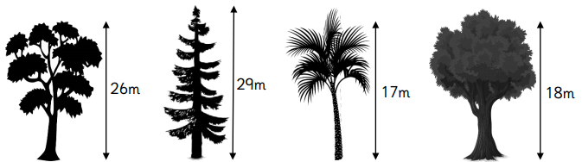

- The table below shows the length of items in a house. Answer the questions below about the items in this table.

Item | Length
Sofa | 1 metre and 15 centimetres
Dining table | 2 metres and 10 centimetres
Desk | 1 metre and 5 centimetres
Bed | 2 metres and 5 centimetres

- Which item has the greatest length? _________________________

- Which item has the shortest length? __________________________

- What is the different in length between the longest and the shortest item?
__________________________________________________

- Matt says if the dining table was 25cm longer it would be over two and a half metres. Is Matt correct? Explain your answer.
________________________________________________________________________________________________________________________________________________________________

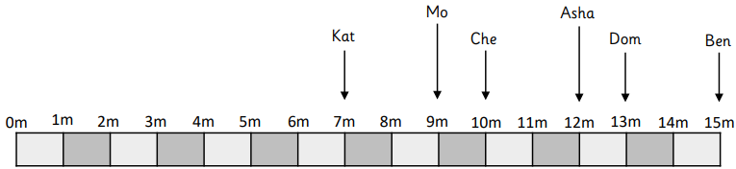
- Six children recorded how far they hit a baseball. Complete the sentences.

- _______________ hit the baseball between 6m and 8m.
- _______________ hit the baseball 5m further than Che.
- _______________ hit the baseball 3m less than Asha.
- _______________ hit the baseball equivalent to a half of 24m.
- _______________ hit the baseball 4m further than Mo.

