Home Learning
Maths
Year 1:
Today we are going to be ‘Measuring using non-standard units.’
Please watch this video: https://vimeo.com/508439670
Activity:
1. Please look at the questions below. Work out what each object measures in cubes and fill in the stem sentences.
a)

b)

c) ________________ is longer than the __________________.

________________ is shorter than the __________________.

2.

Do you agree with Rosie? Explain: ______________________________
_______________________________________________________

3.

Do you agree with Tommy? Explain: ____________________________
_______________________________________________________

4. Now it is your turn. You are going to go on a measurement hunt. Look at the table below and find the objects on the left in your house. Then, have a go at measuring each object in the 3 different ways shown along the top and write down the number of hands, shoes and teaspoons you use to measure each object.
If you do not have these objects in your house, please use something else.

Object: | Hands | Shoes | Teaspoons/Cubes
A table
A pencil
A lunchbox
A chair

Challenge:
What other non-standard unit could you use to measure an object?

___________________________

Year 2:
Today we are going to be learning about ‘Comparing Lengths.’
Please watch this video: https://vimeo.com/505647236

Activity:

1.

The rubber is ____________ than the sharpener.
The sharpener ____________ than the rubber.

2. Write <, > or = to complete the statements:

3. Write digits in the boxes to make the statements correct:
a) ________ cm < 41 cm

b) 14 m < ______ m

c) 14 cm < ________ cm

d) 12 m < ________ m

Challenge:
Is there more than one answer for each? ________________________
_______________________________________________________

4. Would you measure each one using centimetres or metres?

a) the height of a baby
b) the length of a pencil
c) the height of a school
d) the height of your teacher

What else would you measure in metres?

Challenge:
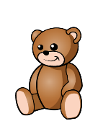
1. There are 3 teddies in a box.
The brown teddy is 15 cm taller than the yellow teddy.
The yellow teddy is 3 cm shorter than the pink teddy.
The pink teddy is 42 cm tall.
How tall are the brown and yellow teddies?
How much taller is the brown teddy than the pink teddy?

2. Whitney’s ruler is broken.
How could she use it to still measure items?
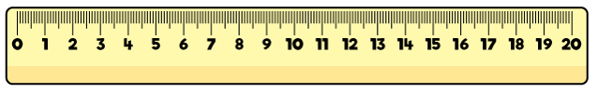

3. Tommy thinks that this chocolate bar is 4cm long.
Is he correct?
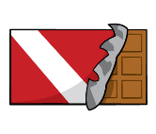

Convince me.

