Home Learning
Maths
Year 1:
Today we are going to be learning about ‘Related Facts.’
Please watch this video: https://vimeo.com/497920336
Activity:
We are going to do a practical activity today to work out these related facts.
First, please use either the set of tens frames below or draw them yourself on paper and find 20 objects.

Tens Frames Template:
As you can see on the right-hand side of the template, there are 2 addition number sentences and 2 subtraction number sentences – These are what you need to work out for each question you do.
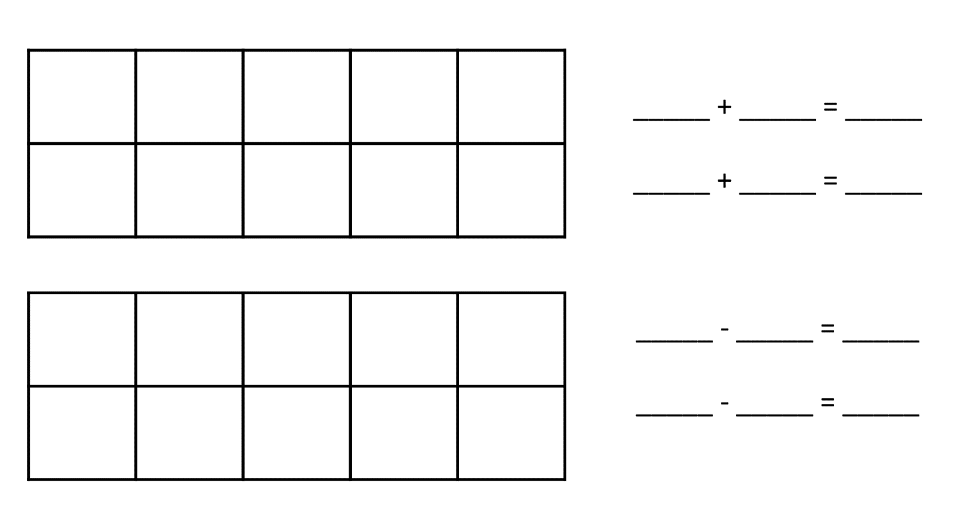
Below, I have modelled how to do each question:
When doing the addition number sentences:
1. Add the red counters and then the yellow counters.
2. Next, add the yellow and then the red counters.
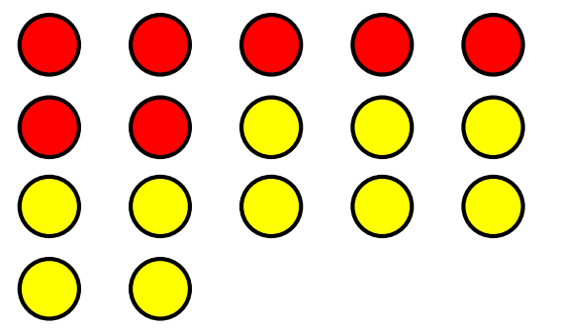
I have chosen these counters -
I am going to put them into my ten frames.

When completing the subtraction number sentences:
1. Find the whole number and subtract the number of red counters.
2. Next, find the whole number and subtract the number of yellow counters.

The children need to choose 4 from the 6 sets of counters below and put the counters into their tens frames.
They need to complete each question just as above.
Please attach a photo of this or type your questions and answers below.

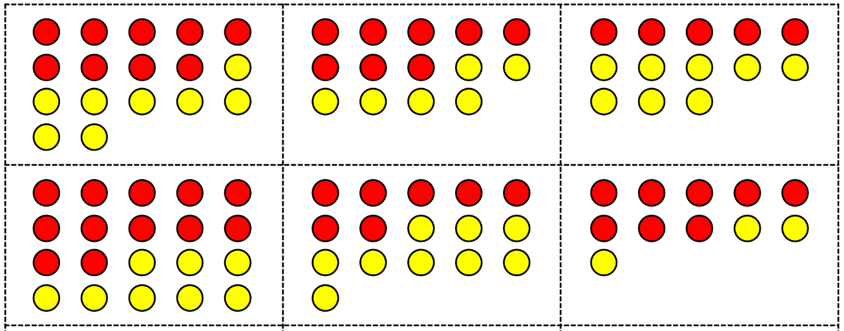

Space for Questions and Answers:
1. | 2.
3. | 4.

Year 2:
Today we are learning our 2 times table.
Please watch this video https://vimeo.com/490420447

1. Write the multiplication number sentence to work out the number of cubes shown in each question.

a.

____________________________

b.

____________________________

c.

____________________________
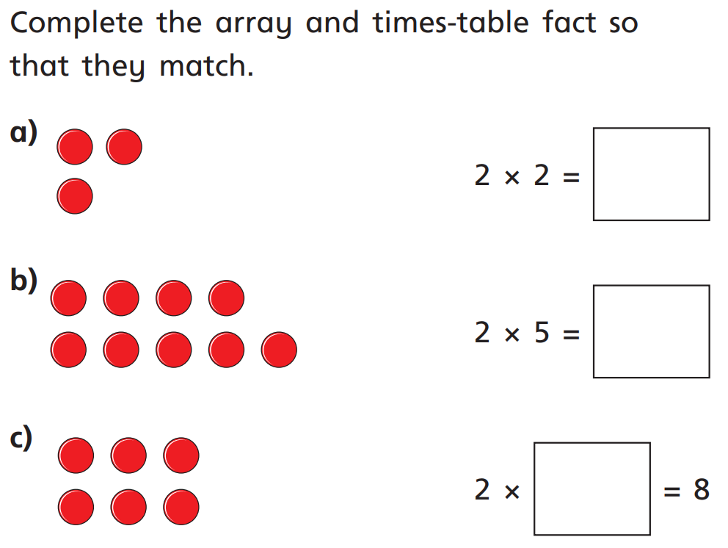
2.

Challenge: Please show your working
Luke has a stick that is 14 metres long.
Lucy’s stick is double the length of Luke’s.
How long is Lucy’s stick?

__________________________________________

__________________________________________
Think back to the lesson on doubling.

