Home Learning
Religious Education
Year 1 and 2:
This term we have been learning about the question ‘What is God like?’
We have learnt about the story of ‘The lost son’ and we have learnt from this parable that God is loving and forgiving.

Activity 1:
Now we are focusing on what Christians do to show God their love. Look at the pictures below and write what each picture is showing. There are words below which you can match to the correct picture as well.
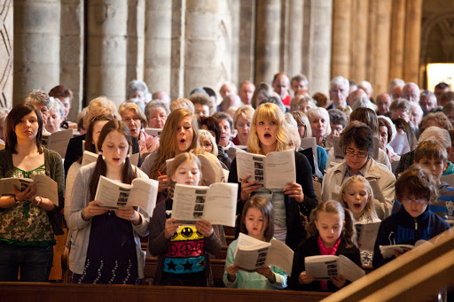
Christians do all of these things to show their love for God.
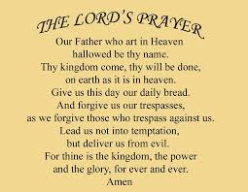
Saying thank you to God.
Singing
Praying

Activity 2:
Please look at the pictures below. These are pictures of situations that could happen at school. What would you do in these situations?
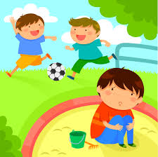
Someone who is being left out.
Someone that is sad.
Someone that has hurt themselves.

Please choose a picture from here and draw a picture to show what you would do to help the person in the picture.
Challenge: Can you write a sentence explaining what you would do?

Activity 3
Can you think of a time that you said sorry?
Let’s think about ‘Saying Sorry.’
What happened when you said sorry?
How did it make you feel?

Have a look at the scenarios below. Read the speech bubbles to see what the people are sorry for.
Think about:
How do the children that are upset feel?
Why is it good for them to say sorry?
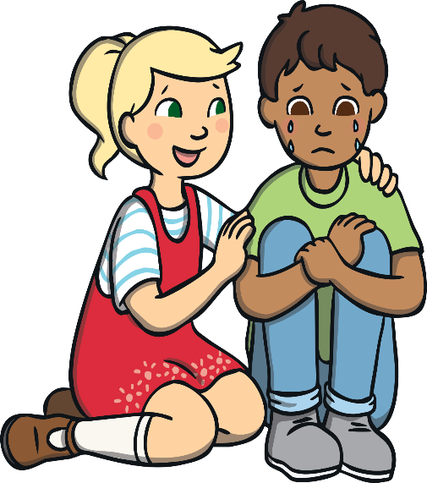
Do you think they were forgiven?
My little brother kept following me around. I got cross and shouted at him. He started to cry. I felt really bad and apologised to him.

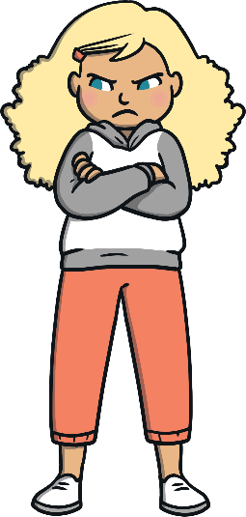
I had to say ‘sorry’ to my sister, when I accidentally dropped her tablet and smashed the screen.

Now it is your turn:
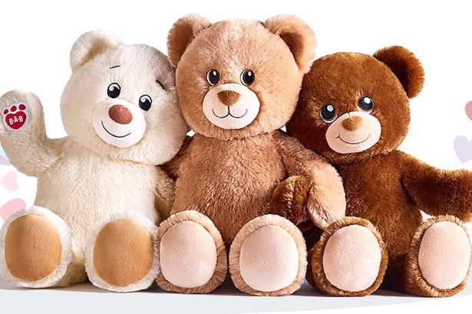
Please go and find some of your favourite toys/teddies.
They are going to help you act out some scenarious. Please choose a scenario from below and use your teddies to act it out.
Please attach a photo of this to Teams.
Choose which characters your teddies are going to be and think about what they will say to eachother.
Nick tripped over Jen’s school bag, that she
she had left on the floor.
Tom was throwing a ball with Drew and accidently hit Ben.
1. 2.

Molly took Joy’s toy and didn’t share.
Zoe kicked Mark on the leg.
3. 4.

