Home Learning
Religious Education
Year 1 and 2
This term we have been looking at the Parable of the Lost Son, and thinking about the question “What is God like?”
Watch this video to recap the story. https://www.youtube.com/watch?v=V96rkM5Gpn0

Activity 1
Christian prayers have 4 main types.
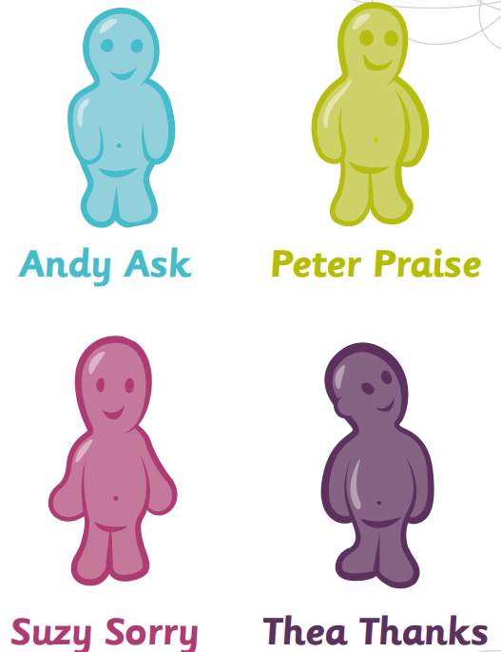
Andy Ask is where you pray to ask God.
Peter Praise is where you pray to praise and worship God.
Suzy Sorry is where you pray to say sorry and apologise to God.
Thea thanks is where you pray to thank you to God.

Some prayers say all 4 types, and some will only show one or two.
Thinking about the Parable of the Lost Son, what types of prayers do you think the characters in the story would say?

Activity 2
Looking at Suzy Sorry prayers, what a 6-year-old Christian may say in a prayer that is saying sorry?
Write the prayer in the space at the bottom of the page.
Here are some words that may help you.
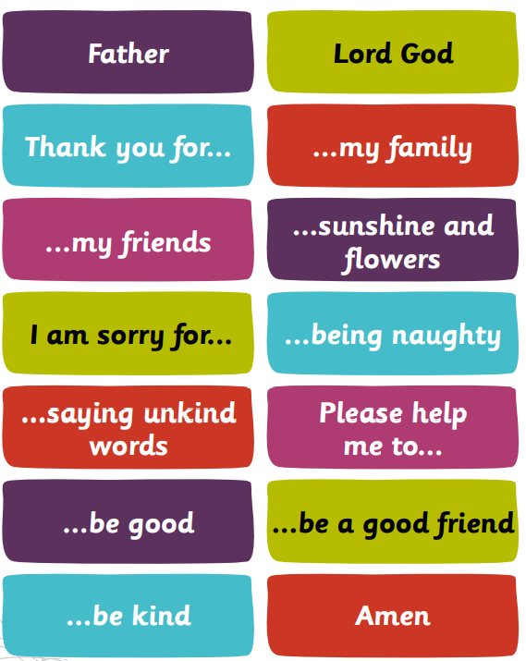

Challenge.
Write a prayer that uses both Suzy Sorry and Peter Praise.

Activity 3
It is not always easy to forgive someone the way the father showed forgiveness to his son.
Draw a picture of a time when you have had to forgive someone.
Write a short sentence describing what happened and how it felt to forgive them.

