**Home Learning**

**Religious Education**

We are going to be learning about Judaism.

LQ: What is precious to us? What is precious to Jewish people?

**Activity 1:**

Have a think about an object that is precious to you. Please draw a picture of it and write why it is precious to you.

_______________________________________________________

_______________________________________________________

_______________________________________________________

_______________________________________________________

**Activity 2:**

Please watch the video below showing you the home of a Jewish family. It gives you some insight into some precious objects that Jewish people keep in their homes.

Video: <https://www.bbc.co.uk/bitesize/clips/zd9jxnb>

Now it is your turn to answer the I wonder question:

What is precious to Jewish people?

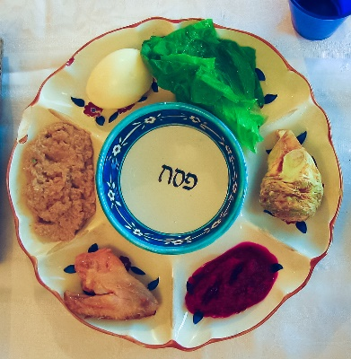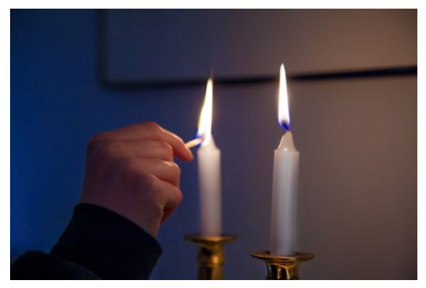Please think of one of the objects below and write a sentence about why it is important:

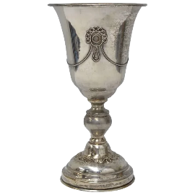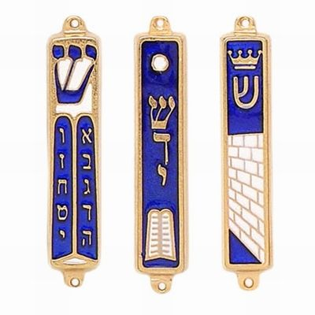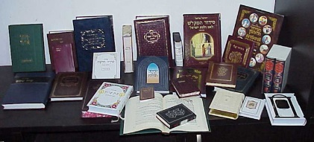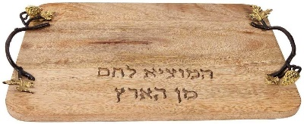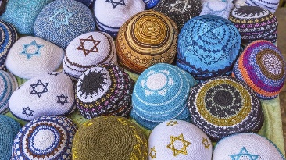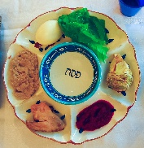

Candles

Wine Goblet

Sedar Plate

Mezuzah

Kippah

Prayer Book

Challah Board

__________________________________________________________________________________________________________________________________________________________________________________________________________________________________________________________________________________________________________________________________________

**Activity 3:**

Below there are two options:

1. Making your own Mezuzah. Please print the template below and have a go at making a Mezuzah. You can also decorate it using the pictures on the next page.

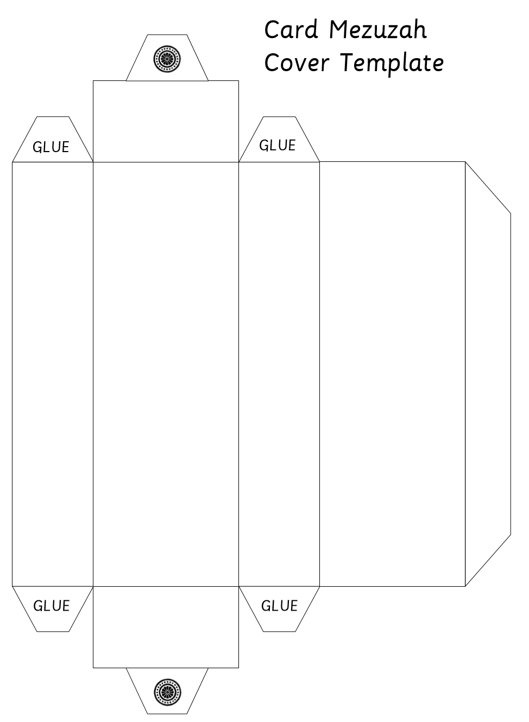

2. Please draw yourself a Mezuzah and use the outline below to help you. Then have a go at decorating it using the pictures surrounding the outline.

