Home learning.
Science
Year 1 and 2.
Today we are going to be thinking more about the properties of different materials.
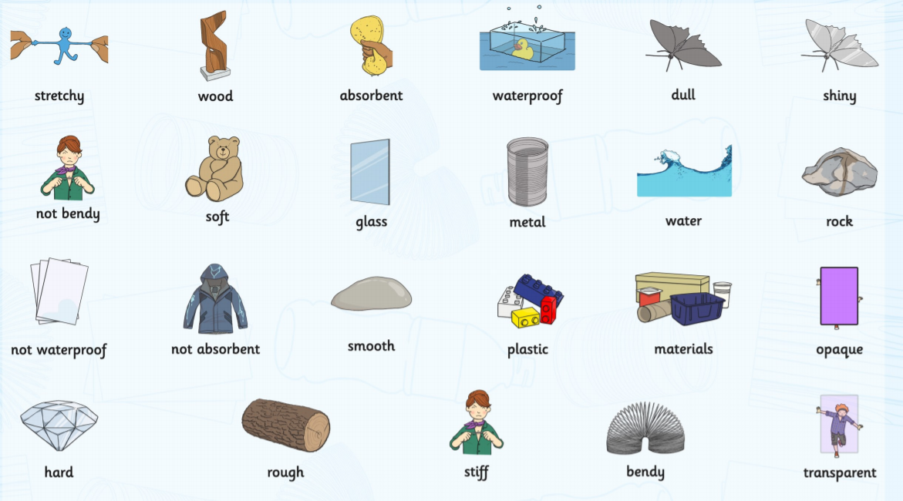
Activity 1:
Below are some of the scientific names we use to describe the properties of materials.
Write down what you think they mean, and one item you can think of that would have that property.
Property. | What does it mean? | Item.
Stretchy
Shiny
Smooth
Bendy
Transparent
Sticky
Absorbent

Activity 2:
Find one item for each property below. Think about the items you pick and answer the questions.
There is a challenge question for each property.
1. Hard
a. What item did you choose?
_______________________________
b. What material is your item made from?
_______________________________
c. Why do you think they used this material?
___________________________________________________
___________________________________________________
Challenge.
Could they have used a different material to make the same item?
_______________________________
If yes, what material and why?
___________________________________________________
___________________________________________________
2. Rough
a. What item did you choose?
_______________________________
b. What material is your item made from?
_______________________________
c. Why do you think they used this material?
___________________________________________________
___________________________________________________
Challenge.
Could they have used a different material to make the same item?
_______________________________
If yes, what material and why?
___________________________________________________
___________________________________________________
3. Bendy
a. What item did you choose?
_______________________________
b. What material is your item made from?
_______________________________
c. Why do you think they used this material?
___________________________________________________
___________________________________________________
Challenge.
Could they have used a different material to make the same item?
_______________________________
If yes, what material and why?
___________________________________________________
___________________________________________________
4. Sticky
a. What item did you choose?
_______________________________
b. What material is your item made from?
_______________________________

c. Why do you think they used this material?
___________________________________________________
___________________________________________________
Challenge.
Could they have used a different material to make the same item?
_______________________________
If yes, what material and why?
___________________________________________________
___________________________________________________

5. Transparent
a. What item did you choose?
_______________________________
b. What material is your item made from?
_______________________________
c. Why do you think they used this material?
___________________________________________________
___________________________________________________
Challenge.
Could they have used a different material to make the same item?
_______________________________
If yes, what material and why?
___________________________________________________
___________________________________________________

