Home Learning
Science
This term, our topic for science is ‘Plants.’ We are going to be looking at what we already know about plants and then being investigators.

Activity 1:
What do the pictures all have in common?
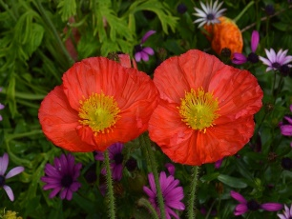
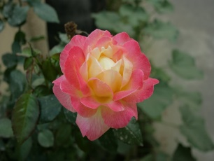
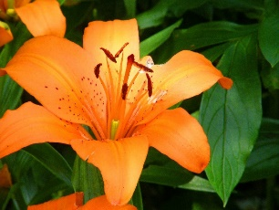
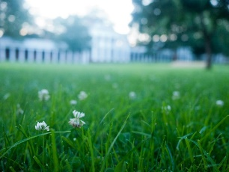
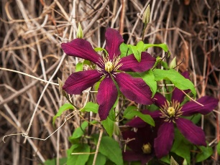

Please complete the Stem Sentence –
These are all ______________________________________.

Activity 2: Let’s see what we already know. Below I have put an example of a plant. Please have a go at drawing your own plant, making sure you have all the parts just like in the example.
Then have a go at labelling your picture using the word labels below.
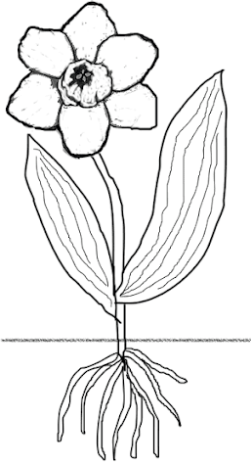

petals | leaves | roots | stem

Activity 3:
We are going to be ‘Plant Investigators.’ First, we need to make a camera with our hands.
Please make this shape with your hands:

Then, go outside and have a look through your camera and see what plants you can see.
Choose your favourite and draw a picture of that plant. See if you can answer the questions about your plant.
My Plant: _____________________

1. Write a description of what your plant looks like:
__________________________________________________________________________________________________________________________________________________________________________________________________________________________________________________________________

2. What is your plants scientific name? _____________________________________
3. Please tick what your plant has:
 | petal |  | leaves
 | stem |  | roots

4. Investigation:
Now it is your turn, please go outside and find 4 different plant. Then write the names of them in the table below (or on paper if you are unable to print). Then tick what each plant has:
Plant: | Does it have petals? | Does it have a stem? | Does it have roots? | Does it have leaves?

