Home Learning
Science
Year 1 and 2:
Below I have set 3 short activities. Please have a go at working through them.
Activity 1:
This is a recap activity about the season of Winter. Take a look at the pictures below. They both show weather in Winter. Please read through the word bank below and put them underneath the correct picture.
fog | snow | cold | mild
bright | frosty | damp | dull
Picture 1:  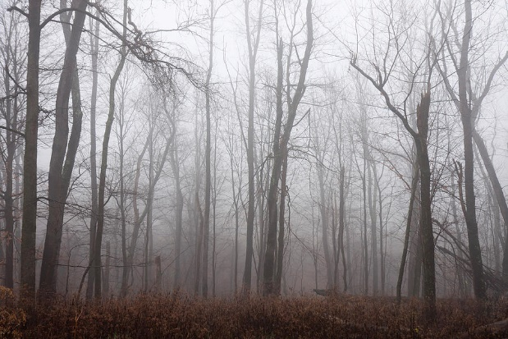 | 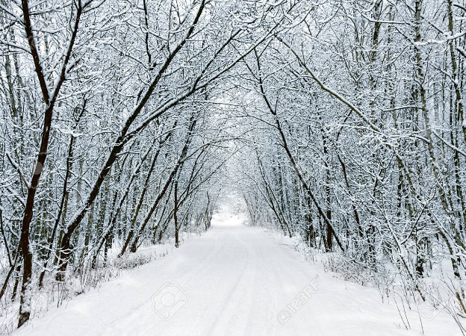  Picture 2:
1.  2.  3.  4. | 1.  2.  3.  4.

Activity 2:
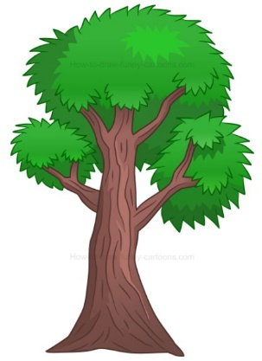
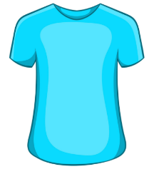
Have a look at the pictures below. Can you think about what materials they are made from?
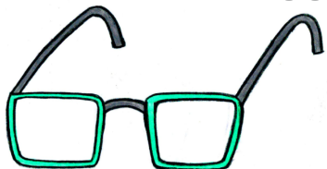

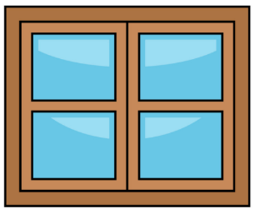
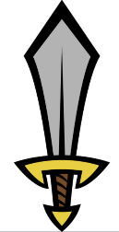
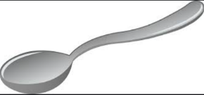

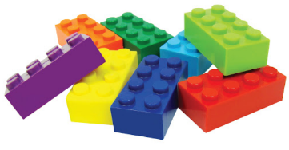

Write some of the materials you see on the lines below:

__________________________

__________________________

__________________________

__________________________

__________________________

I now want you to find an item in your house made from each of these materials.
Write what you found down below:

__________________________

__________________________

__________________________

__________________________

Challenge:
What are most things in your house made from?

Activity 3:
Next week, we are going to be doing an experiment. We are going to test what the best material is to use to make a boat.
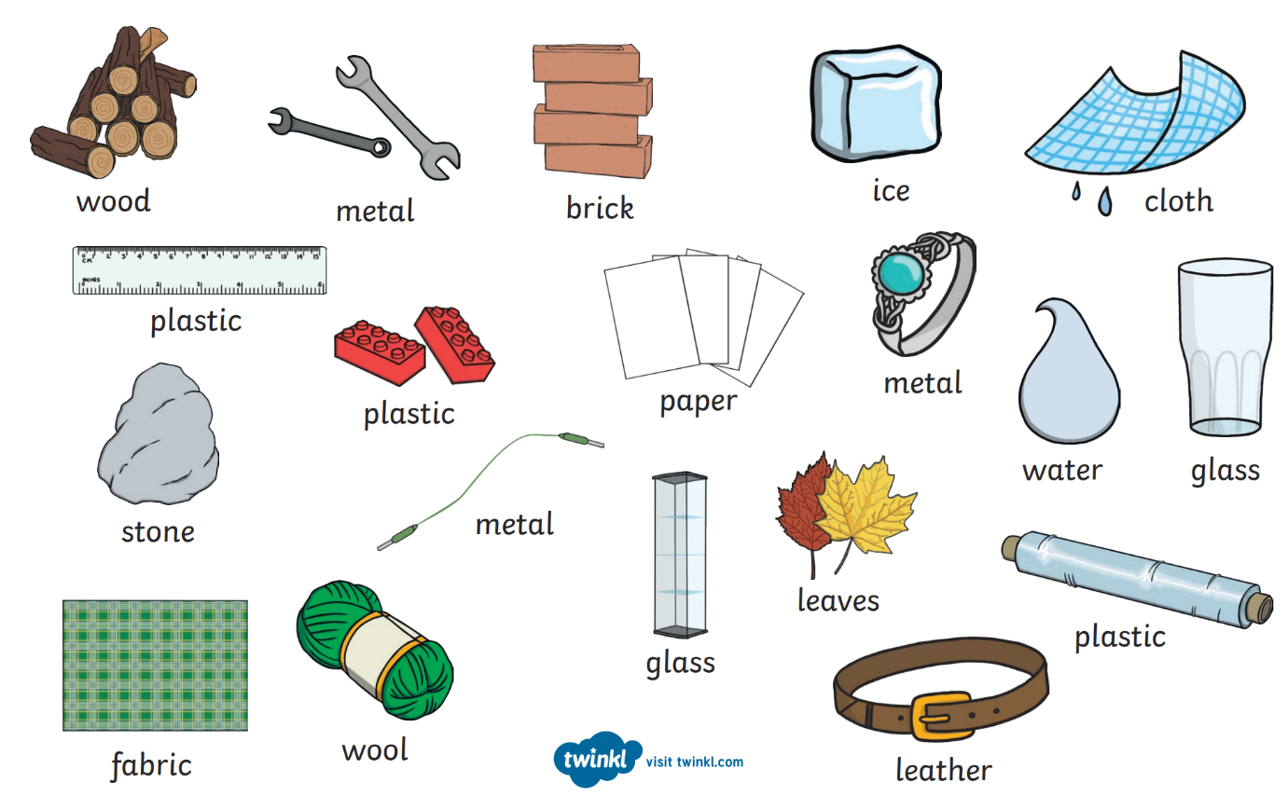
Our task today is to write a prediction about what material would be best. I have put some materials below. I would like you to look at them and choose the material that you think will be best.

Please write the sentence below and fill in the gaps.
Choose from the materials above and write your choice on this line.

“I predict that ____________________________ will be the best material to use to make a boat because _________________
_____________________________________________________________________________________________________”
Give a reason for your choice.

