Home Learning
Topic
Year 1 and 2
Last week we learnt about:  - Ordering Dates  - Physical and Human Features  - Naming the different oceans. | Today we are going to be learning about:  - Naming the different oceans.  - The Points of a Compass  - Labelling parts of a pirate ship.

Activity 1:
Please watch this video to recap the different oceans: https://www.bbc.co.uk/bitesize/topics/zqj3n9q/articles/zr8q7nb#:~:text=Human%20and%20physical%20features%20are,mountains%20and%20rivers%20are%20natural.&text=Human%20features%20like%20houses%2C%20roads,have%20been%20built%20by%20people.
Use the video to help you match the ocean to the picture. The pictures will help you remember each ocean.

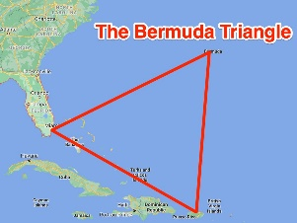
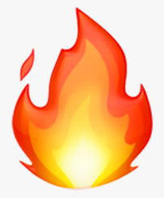
Pacific

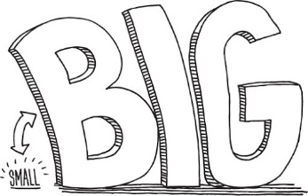
Arctic

Indian
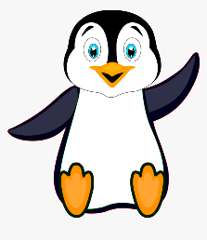
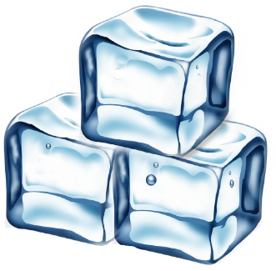
Atlantic

Southern

Activity 2:
We are going to learn about ‘Compasses.’ These are what Pirate’s would have used to navigate across the oceans.
Please watch this video: https://www.bbc.co.uk/bitesize/topics/zvsfr82/articles/zdk46v4#:~:text=Compasses%20show%20four%20directions%20%2D%20north,in%20which%20direction%20things%20are.&text=The%20scale%20on%20a%20map,example%2C%20as%201%3A25%2C000.
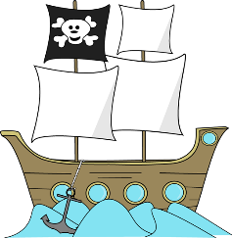
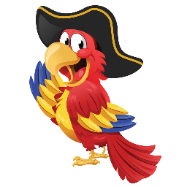
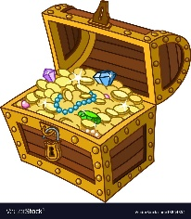
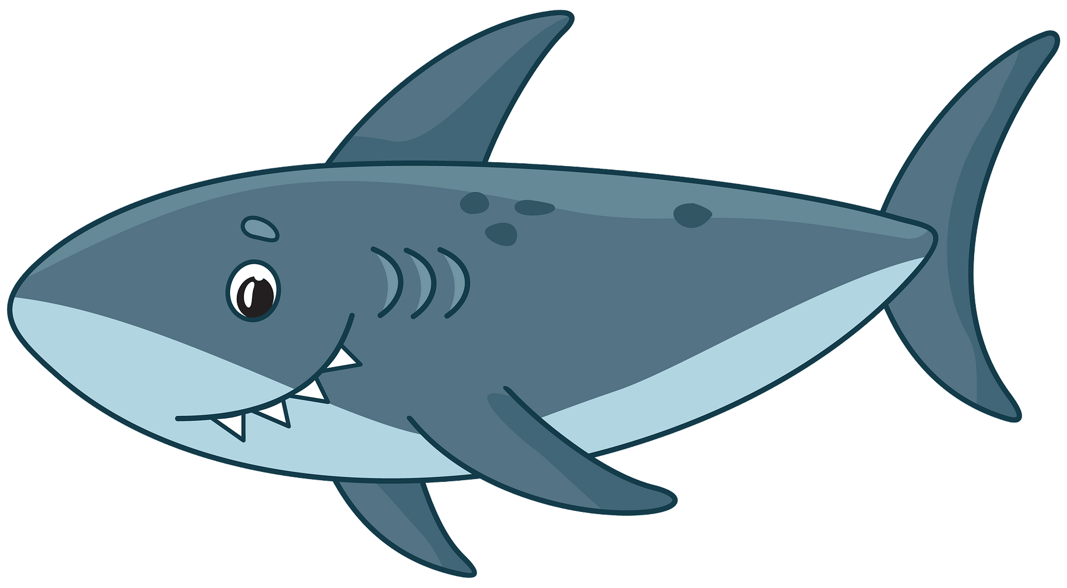
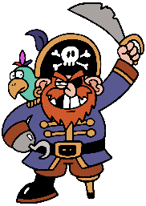
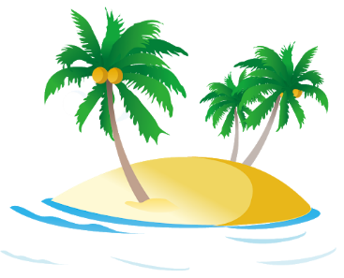
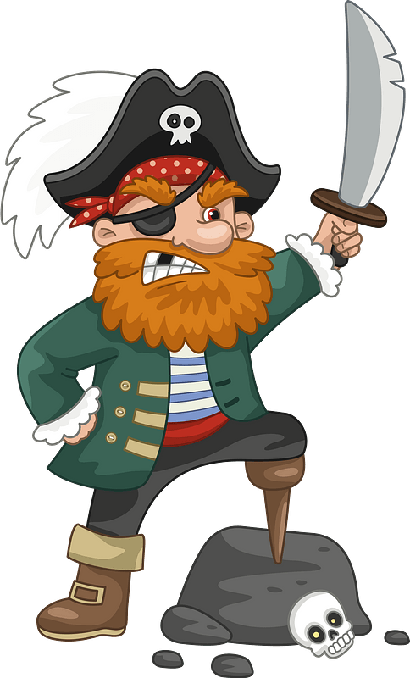
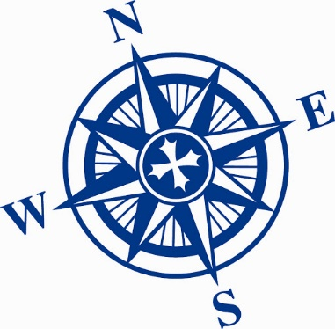
Below there is a map and it is your task to get the pirate to the treasure avoiding the obstacles in his way. Please use the compass on the side of the map to help you. I have written the first instruction for you.
Map Instructions: - There is more than one route so please write as many instructions as you need to get to the treasure. I have given you some lines to write on but please add more or use less if you can.

1. Take 2 steps East.
2. _____________________________________________________
3. _____________________________________________________
4. _____________________________________________________
5. _____________________________________________________
6. _____________________________________________________
7. _____________________________________________________
8. _____________________________________________________

Activity 3:
Let’s look at the parts of a ship. Please watch this video to help you understand the parts of a ship: https://www.youtube.com/watch?v=CMaPnlzGZM8
Have a go at drawing a pirate ship of your own including all of the parts that you saw in the video. Once you have drawn the ship, please label the parts of the ship using the words below.
How to draw a ship: https://www.youtube.com/watch?v=94agM0aGg9A
mast | flag | wheel | rigging
rails | rudder | portholes | Captains Cabin
hull | mermaid | sails

Challenge:
Can you think where the ‘Crows Nest’ might go on the ship?

