Home learning
Topic
Year 1 and 2
Last week we learnt about:  - Naming the different oceans.  - The points of the compass.  - Labelling parts of the pirate ship. | This week we are going to learn about:  - North Pole  - South pole  - The equator

Activity 1
Last week we learnt the points of a compass.
They are North, East, South and West.
An easy way to remember this is Never Eat Shredded Wheat
Or Naughty Elephants Squirt Water.
I want you to make up your own saying like this to help you remember the compass points.
N________
E________
S________
W_______

Activity 2
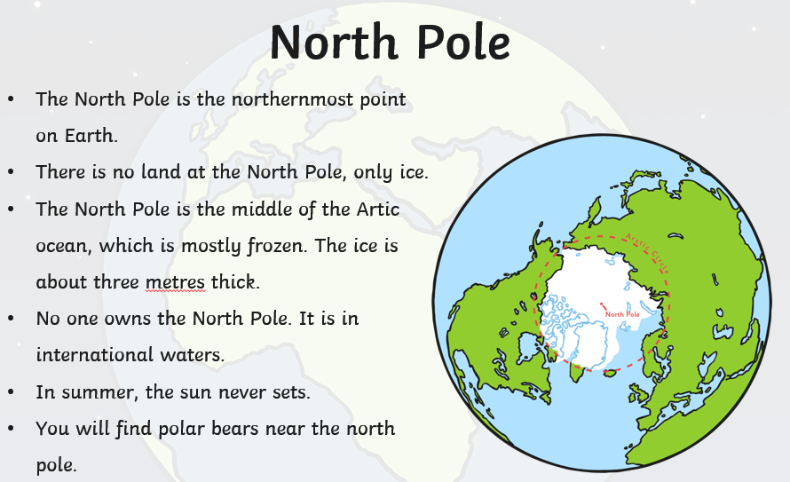
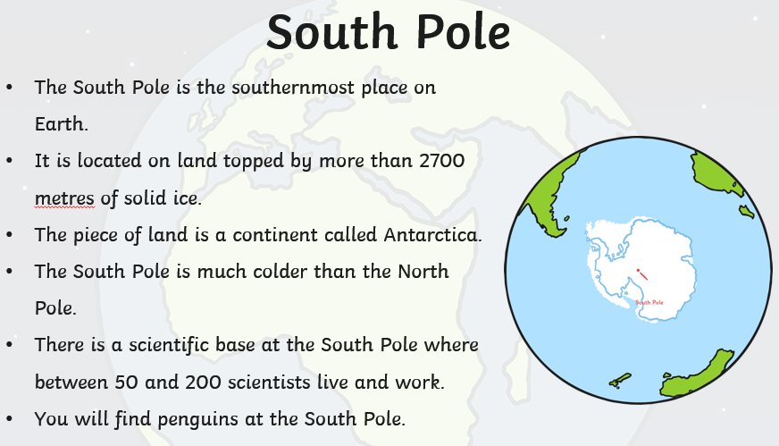
Look at the Fact cards below about the North Pole and South Pole.

Fill in the table with similarities and differences between the North Pole and the South Pole.
Similarities | Differences

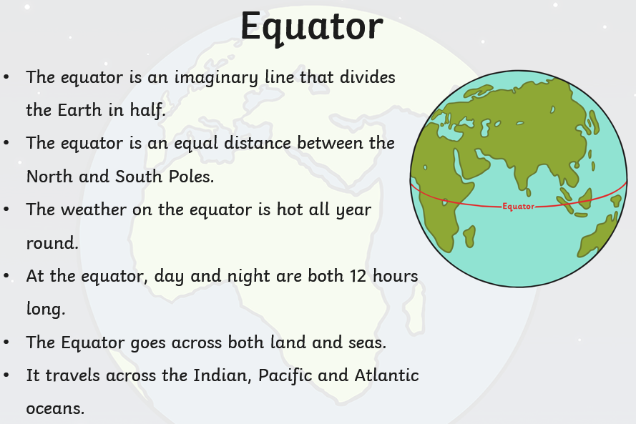
Activity 3
Read the fact card about the Equator.
Draw a picture of what you think it looks like at the North Pole, South Pole and on an island that is on the Equator.

Challenge:
Write why you have drawn different features. Are there more human or physical features? Why?

