**Home Learning**

**Topic**

Hello Squirrels! I hope that you had a lovely half term. This term our topic is ‘My Secret Garden.’ We are going to be doing a series of fun activities to kick start our learning.

**Activity 1:**

First of all, let’s have a look at our weather. We are going to be making a weather chart using weather symbols.

Have a look at the table below and see if you can match the words to the weather symbols.

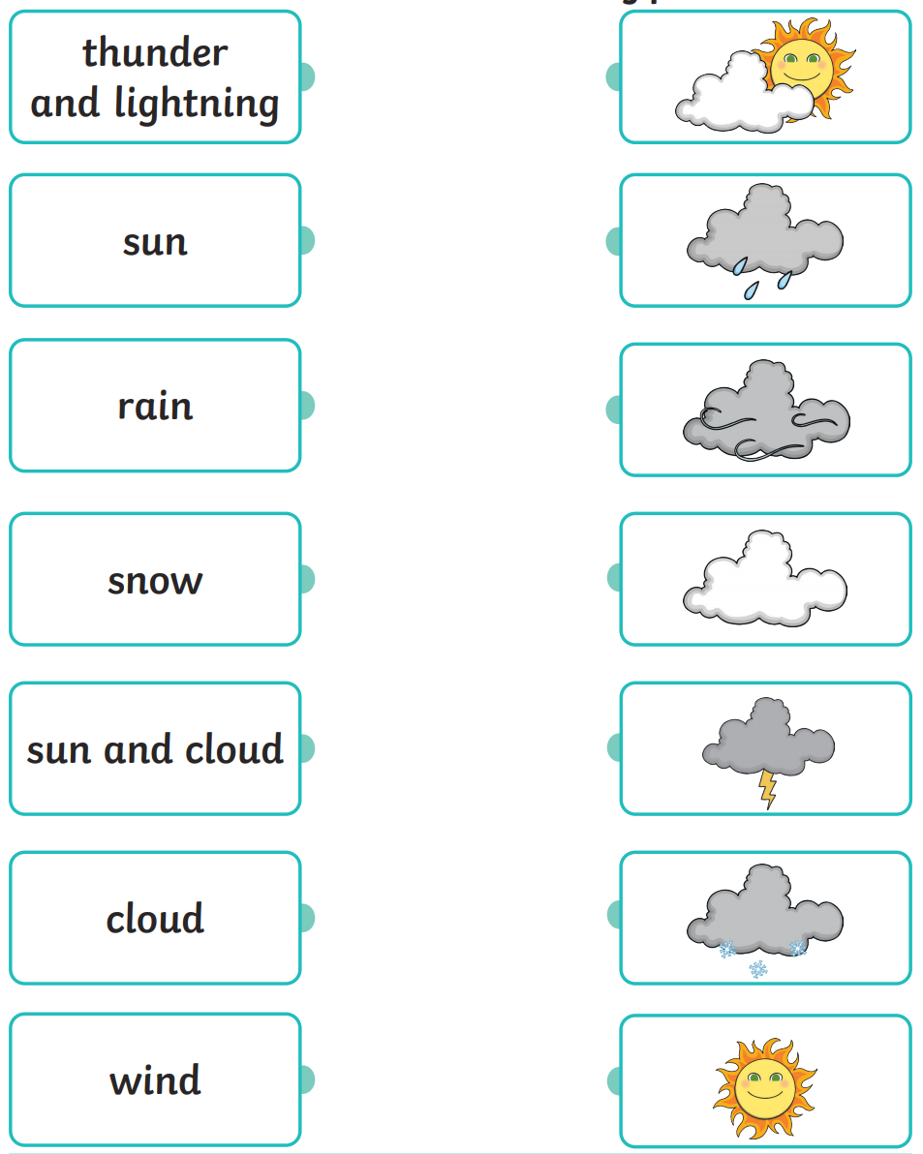

I have then made my own weather chart below using pictures of the weather, and it is your job to draw the correct symbol that matches the picture for each day.

If you are completing this on paper, please write the days of the week down the side of your page and draw the correct weather symbol next to each day.

|  |  |  |
| --- | --- | --- |
| **Weekday:** | **Picture:** | **Symbol:** |
| Monday | Image result for thunderstorm |  |
| Tuesday |  |  |
| Wednesday | Image result for hot sunny day |  |
| Thursday | Image result for snow |  |
| Friday | Image result for rain |  |

**Activity 2:**

We are going to be making our own secret garden. Have a look at the pictures below and gather everything you will need using the equipment list underneath. There is a diagram of how you could create your secret garden if you would like some guidance.

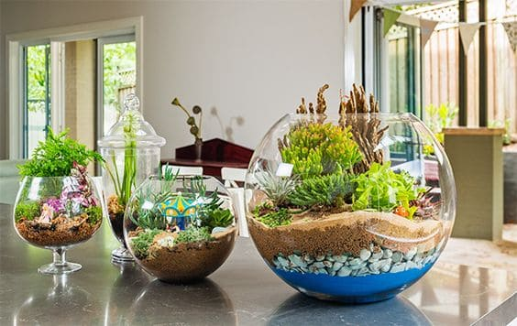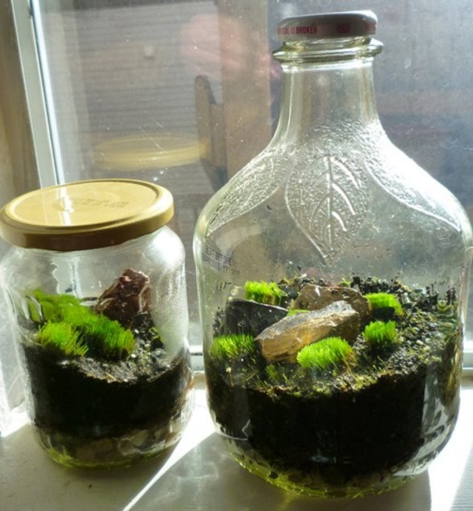

You will need: If you want to add anything else, you can. These are just some of the basic objects you will need.

Soil

Stones

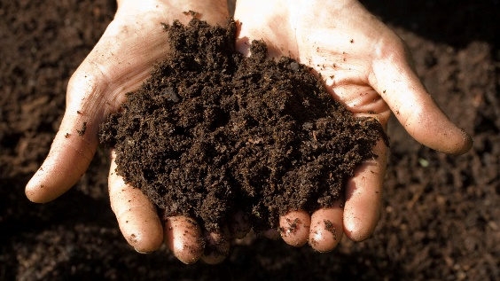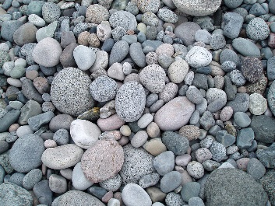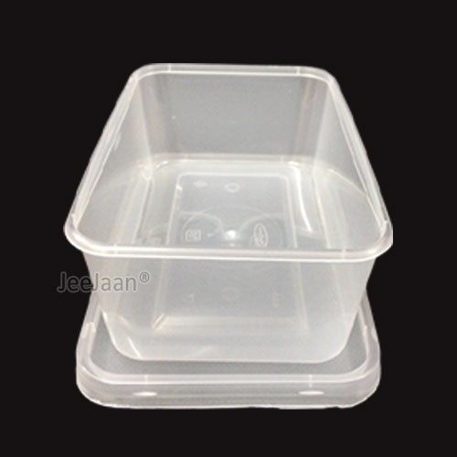

Plastic Container (or anything similar to this).

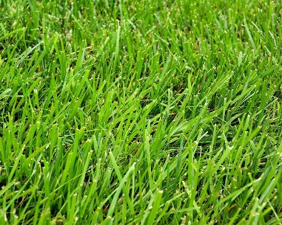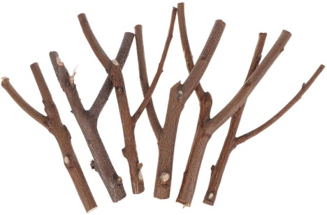

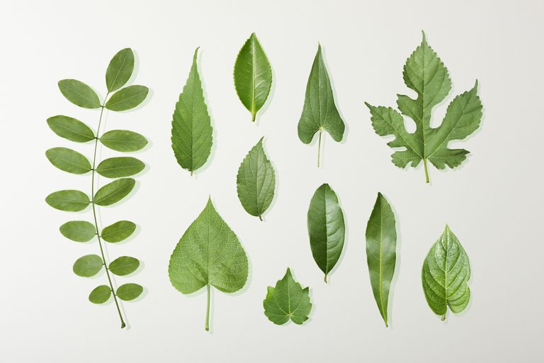

Grass

Twigs

Leaves

**Method:**

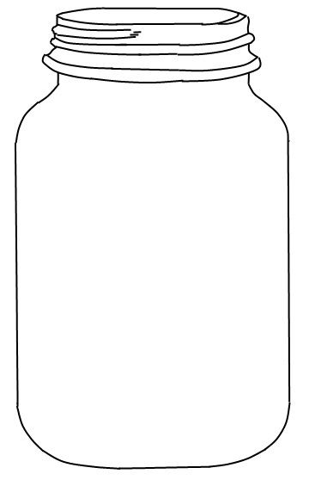

Twigs – Balance these to make a shelter.

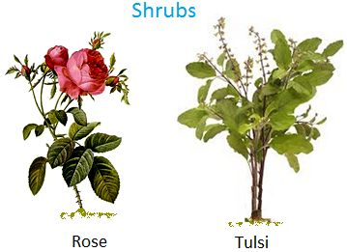

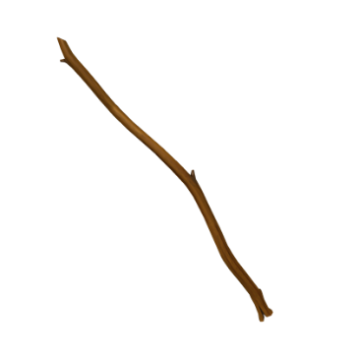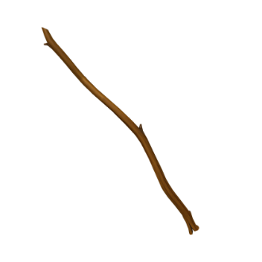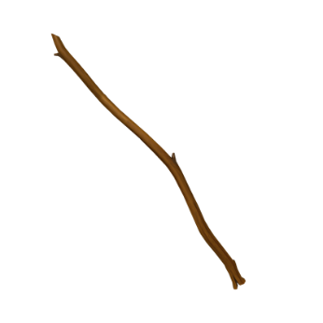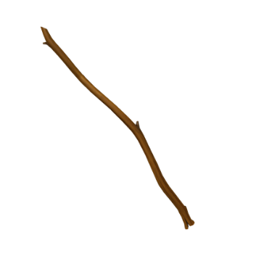

Shrubs – You can use leaves to make this.

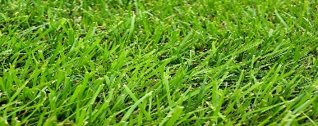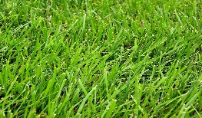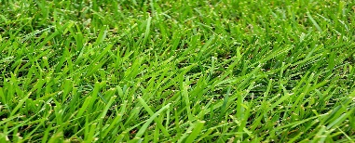

grass

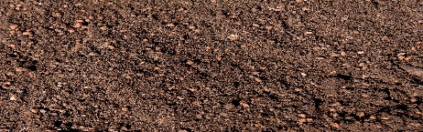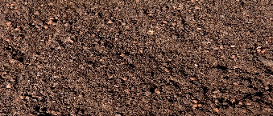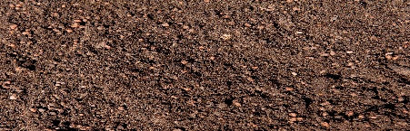

soil

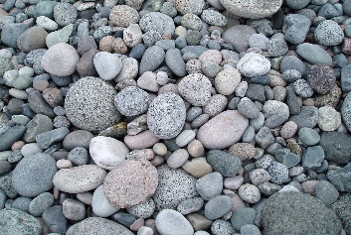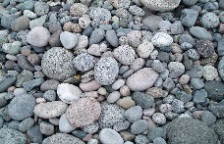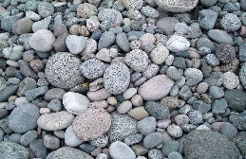

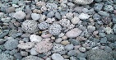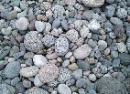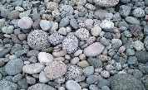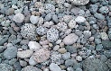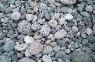



rocks/stones

**Activity 3:**

Your final activity is to write a secret for your secret garden. You do not need to send this to Miss MacMillan as these are your own secrets, but I would like you to make a leaf shape (or use the template below) and write a secret which you can then hide in your garden.