LO: IWBAT use and identify subordinate clauses
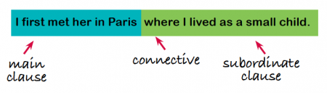
This is a complex sentence (also referred to as a multi-clause sentence). It has a main clause ('I first saw her in Paris') and a subordinate clause (' where I lived as a small child'), which relies on the main clause to make sense. The two clauses are joined by the connective 'where'.
Connectives that join clauses can be conjunctions, prepositions and adverbs.
Examples of subordinate clauses include embedded clauses and relative clauses.
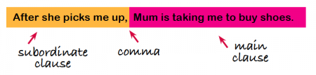
Highlight or underline the subordinate clause in each sentence.
As fast as she could, Sally typed on her computer.
Bobbing up and down, the boat was sailing in the sea.
The teacher, who was strict, shouted at the class.
With a whisper, Dr Doom announced his evil plan.
The villains, Dr Doom and Professor Chaos, plotted their next move.
At 9 O’clock in the evening, the party was in full swing.
Harry ran down the lane whilst laughing uncontrollably.

Add a main clause to these subordinate clauses
a) Whilst the sun was shining,
b) When he shouted,
c) ,who had red lipstick,

Complete these sentences by adding a subordinate clause
The dogs, , were playing together.
,we played games on the beach.

The classroom, , was a nice place to be.

