Monday 22nd February Home Learning

Maths

This week we will revise and cement our fractions learning. Please have a go at set A, then if you have time choose either set B or C.

**A**

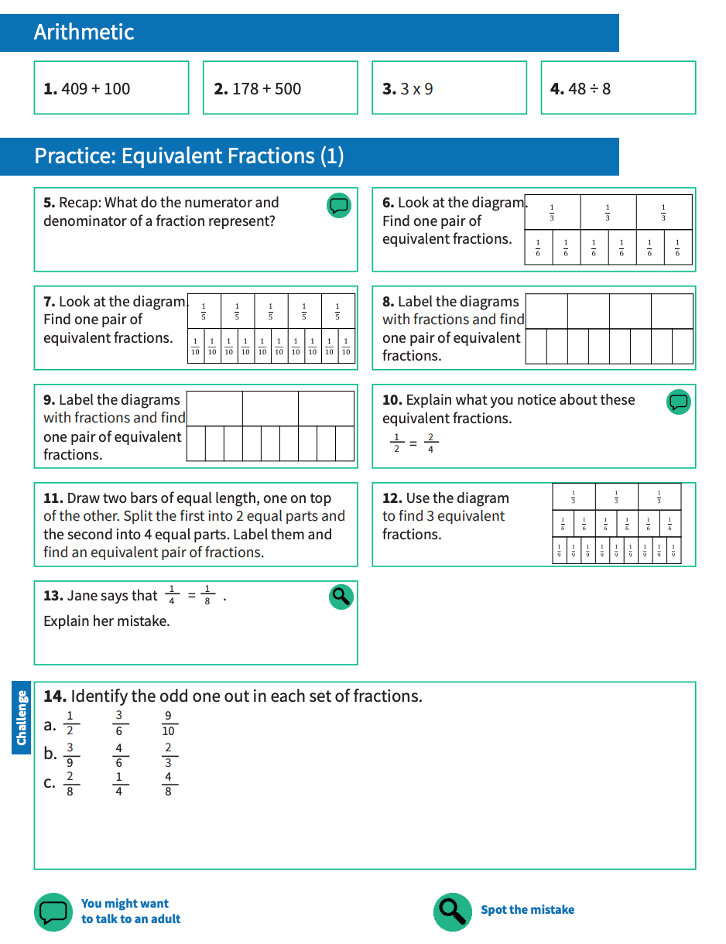

**B**

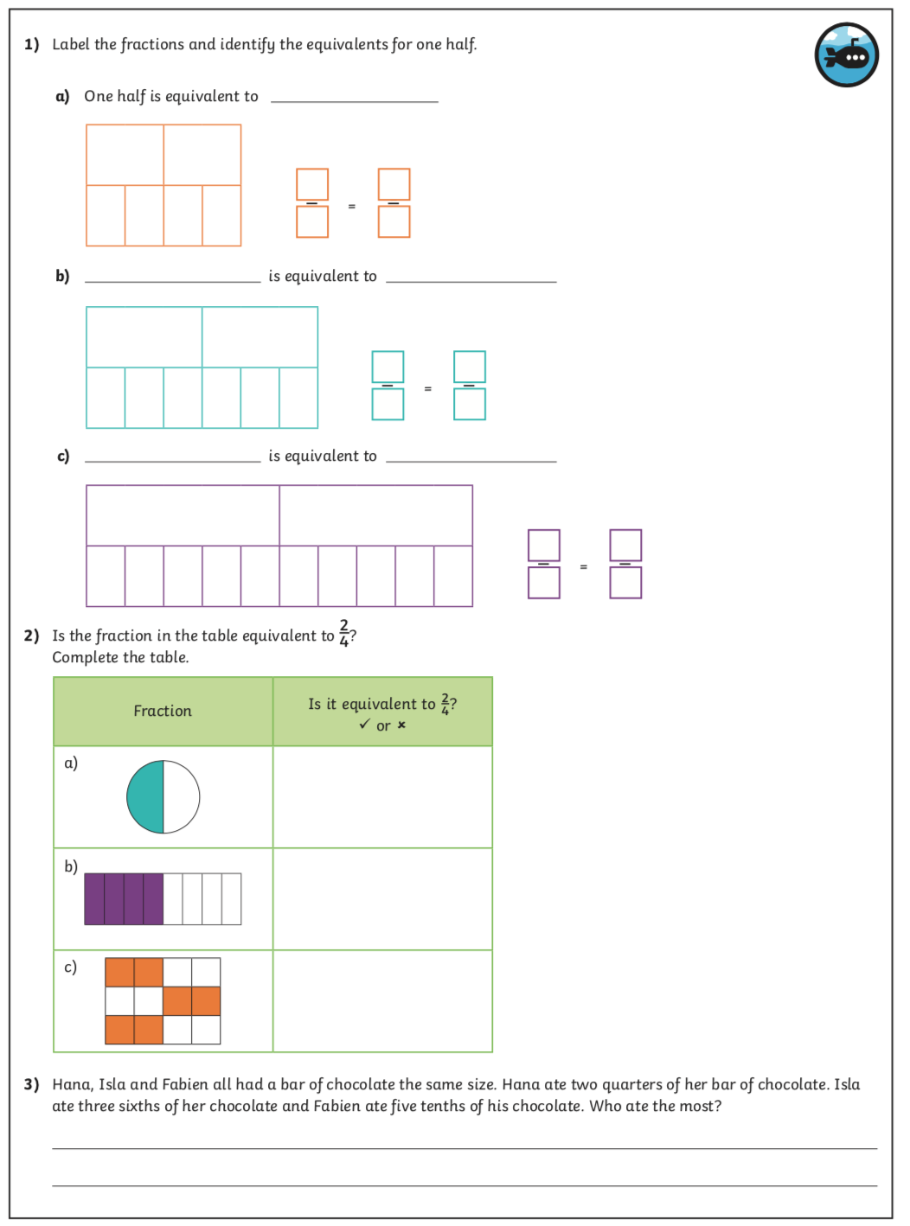

**C**

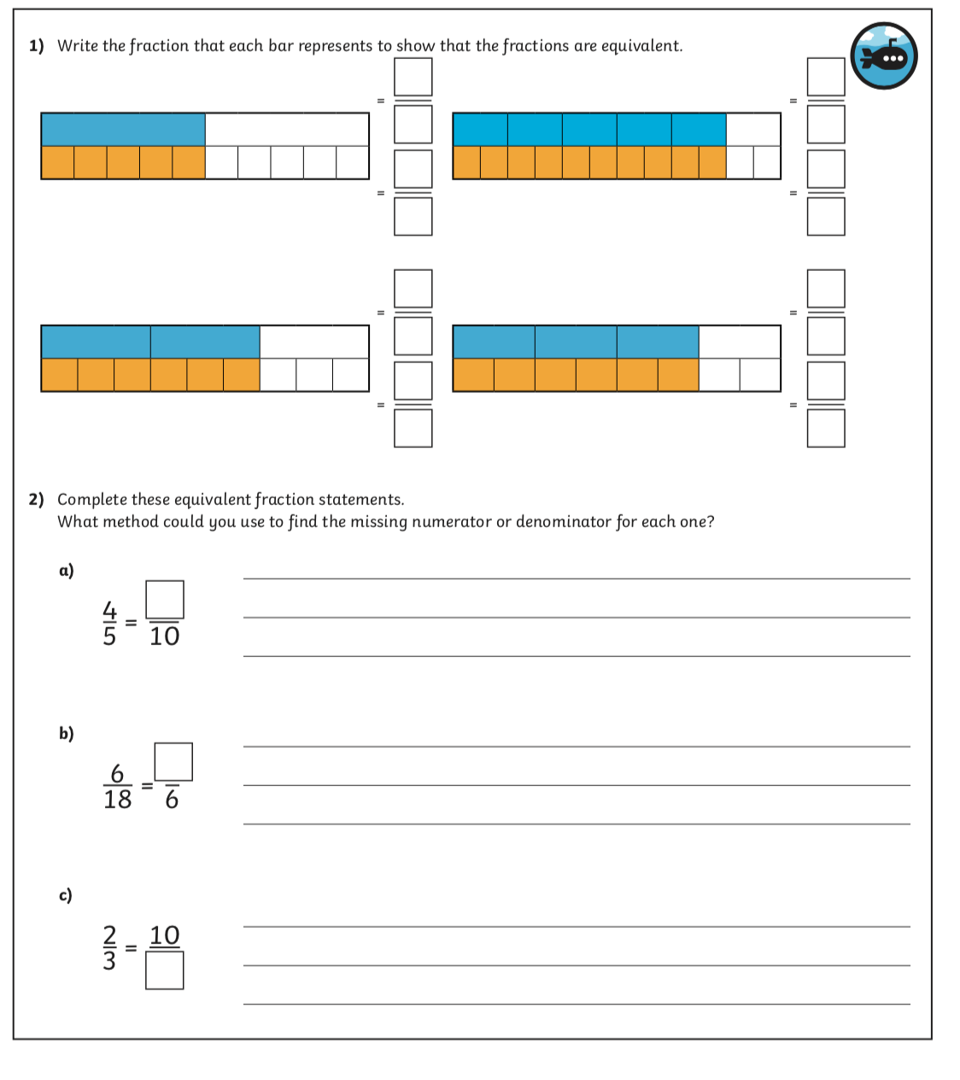

**ANSWERS**

**A**

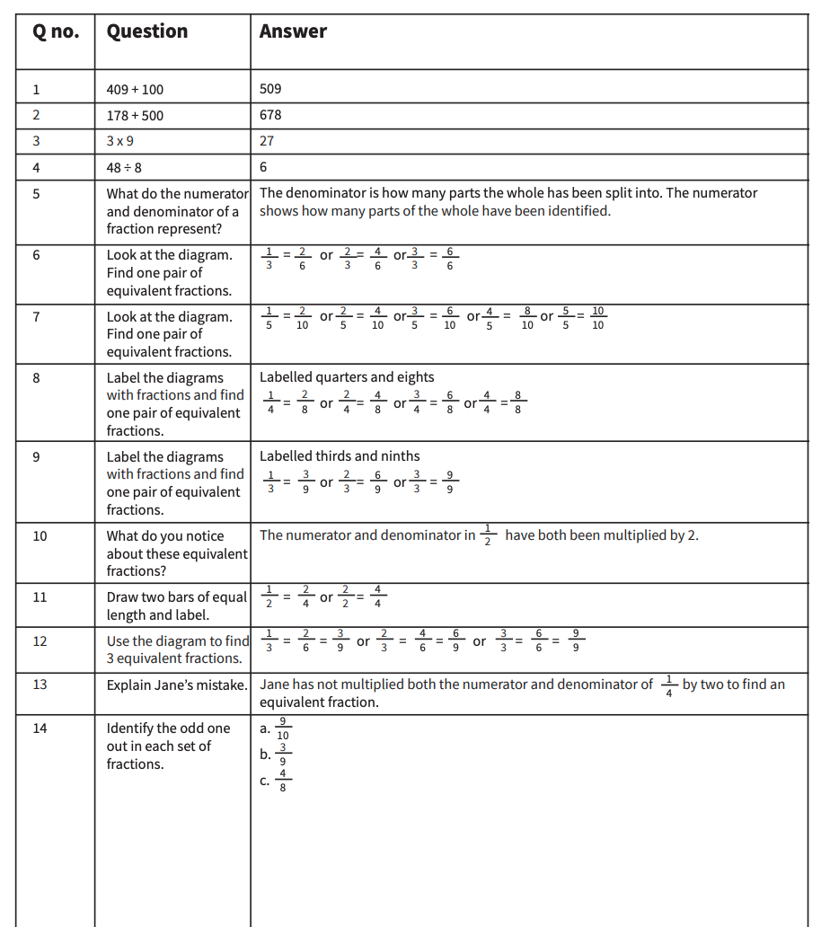

**B**

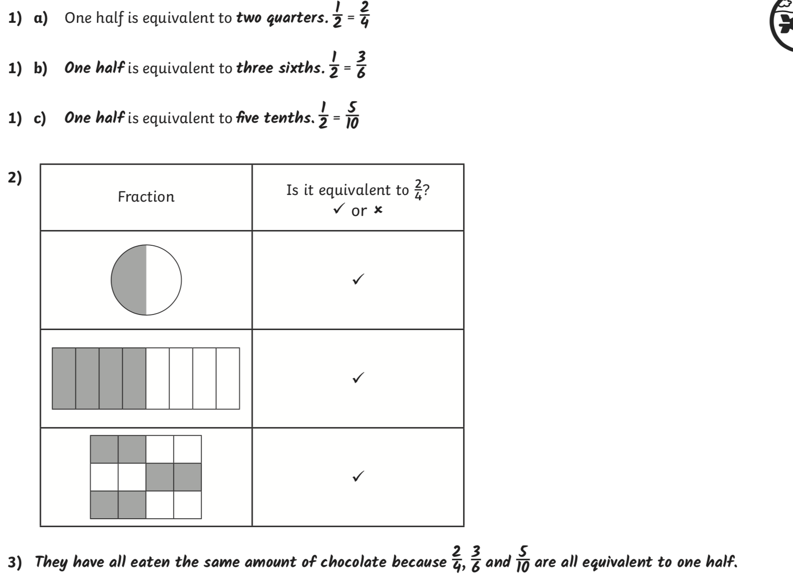

**C**

