Home Learning: Friday 26th February 2021
English

Today I’d like to you write a creative piece of writing trying to incorporate all the work we have done this week on using interesting, descriptive verbs. You should write at least three paragraphs. The first paragraph should be an introduction where you introduce the character, the second should say what the adventure or problem is and the third should be the resolution. Keep your ideas simple and concentrate on the quality of your writing. Choose your words wisely and be ambitious with your punctuation to add meaning and remember you are writing to entertain, so think of your audience!

Here are some pictures you can use for inspiration and I’ve given you a starter for each picture that you can magpie if you would like to.

Suddenly she found herself standing alone. Holding hope in her outstretched hands. The cool water trickled between her muddy fingers and the damp, soft earth felt comfortingly warm. She knew what she had to do; plant the tree of life…

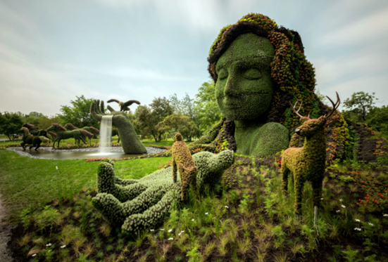
During the day, everything was peaceful. In fact, the garden was completely silent. The only sound that was ever heard during the day was a gentle whispering sound that seemed to be carried on the wind: a sweet melody of nature.

The lady of the garden seemed to be…

It all happened so quickly! One minute he was standing on the platform, the next he was hurtling through the air, hanging on for dear life…

Please listen to the chapter of our book, but there is no need to answer questions as your writing should take up all your English time. At school our lesson is an hour, so don’t spend any longer than that. I can’t wait to see what you’re amazing imaginations come up with.

