**Home Learning: Friday 26 February 2021**

**Maths**

Today I’d like you to apply your knowledge and solve these word problems involving fractions. Remember you need to find the common denominator (both bottom numbers must be the same) to add fractions. This means you must find the **equivalent** fraction. If there are whole numbers then add these first, then add the fractions.

**A**

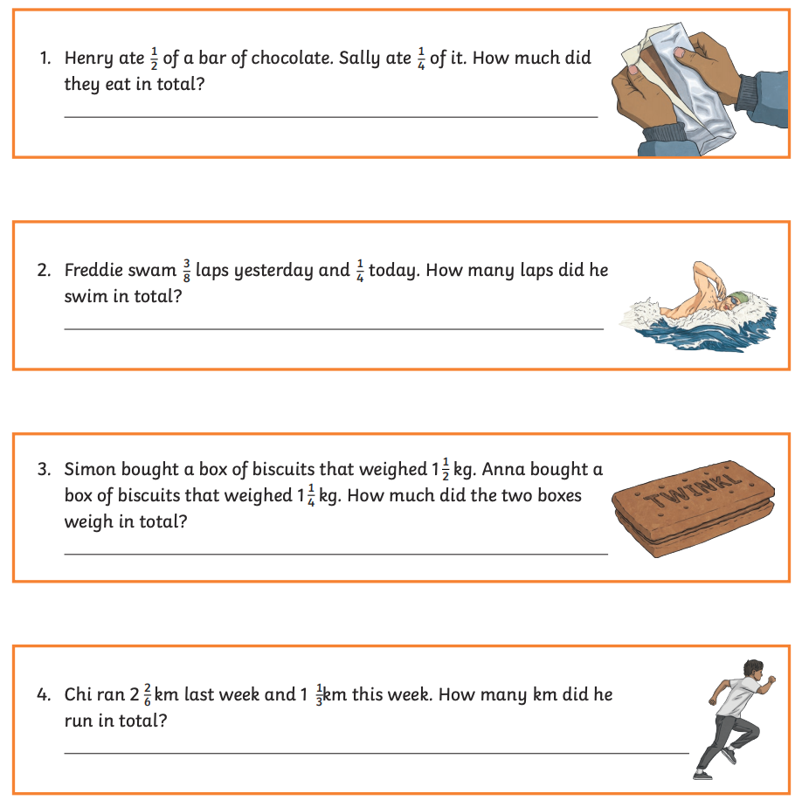

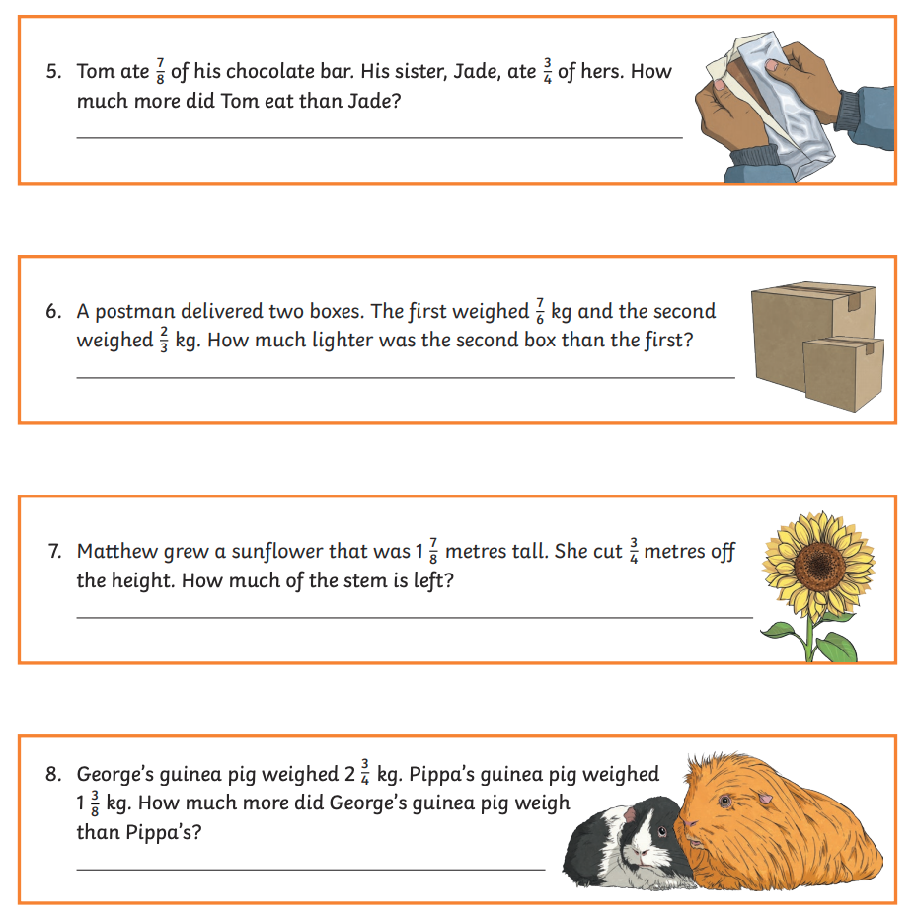

**B**

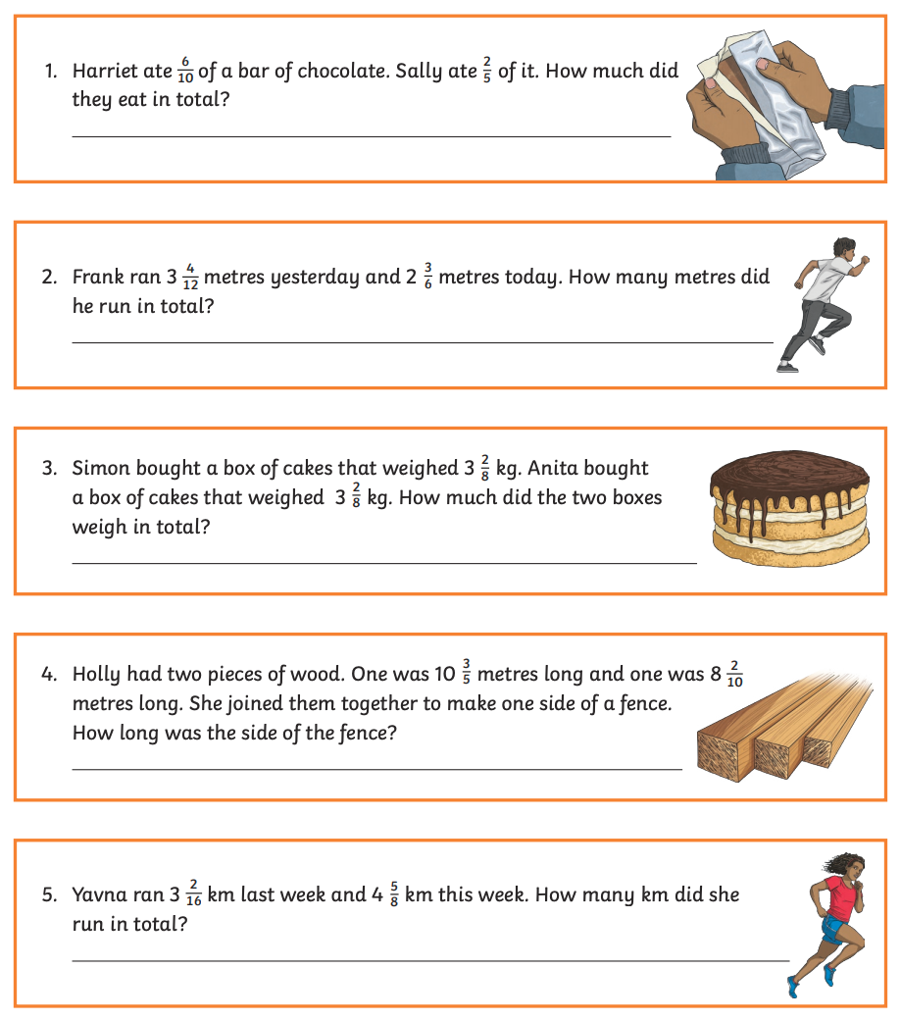

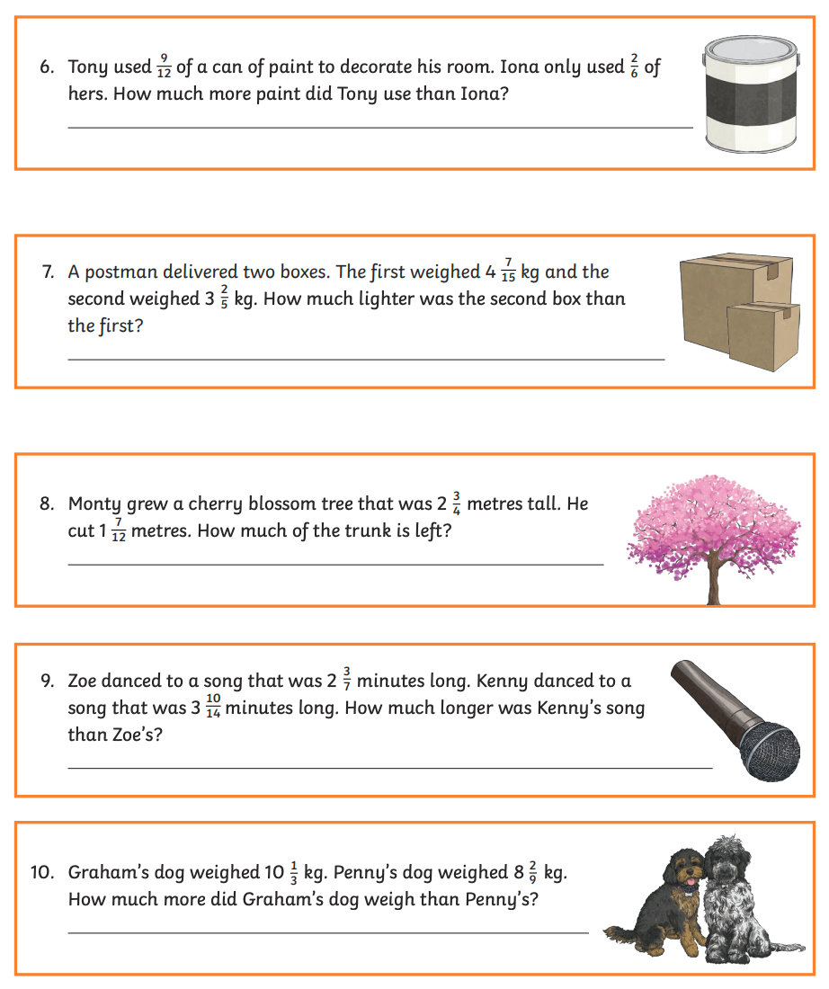

**C**

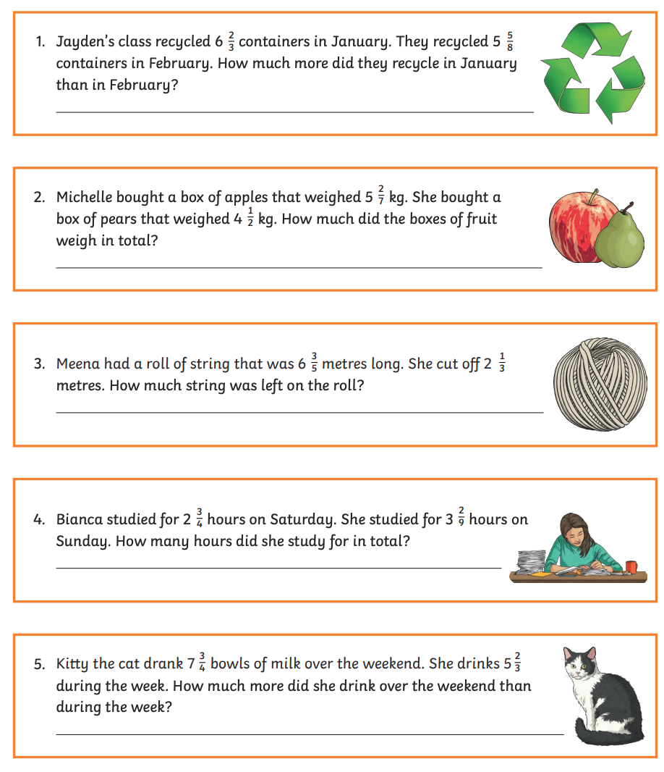

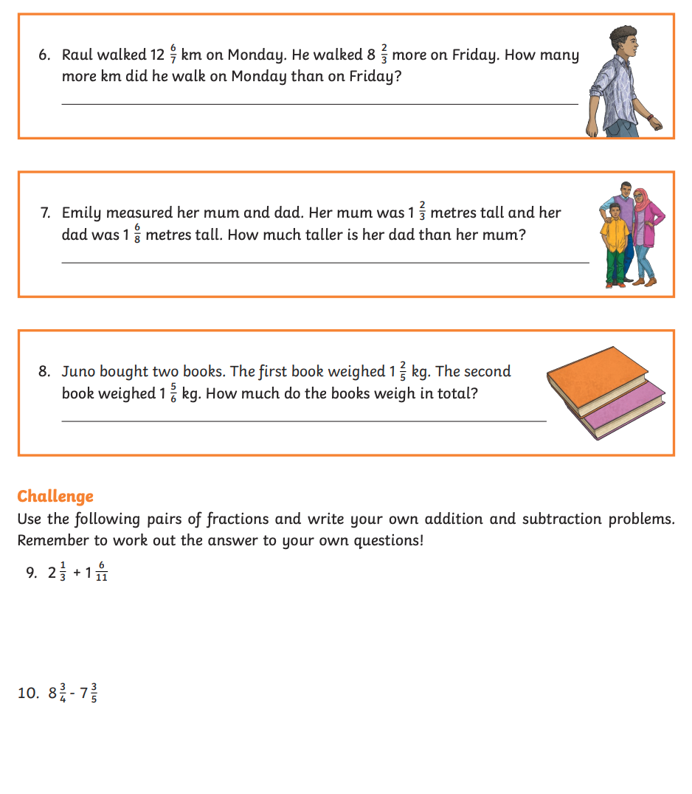

ANSWERS

**A**

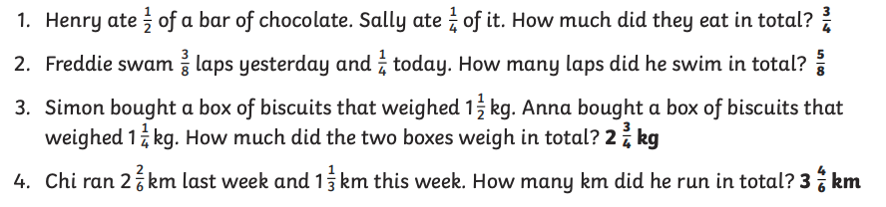

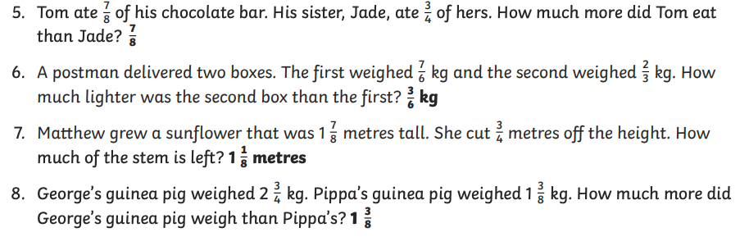

**B**

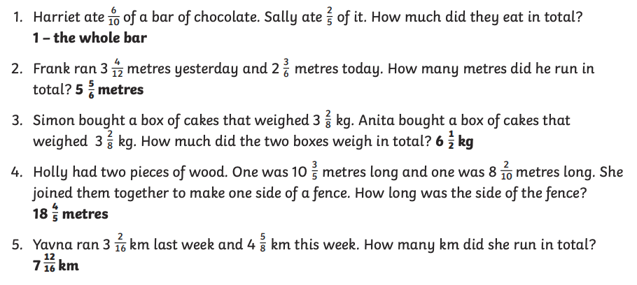

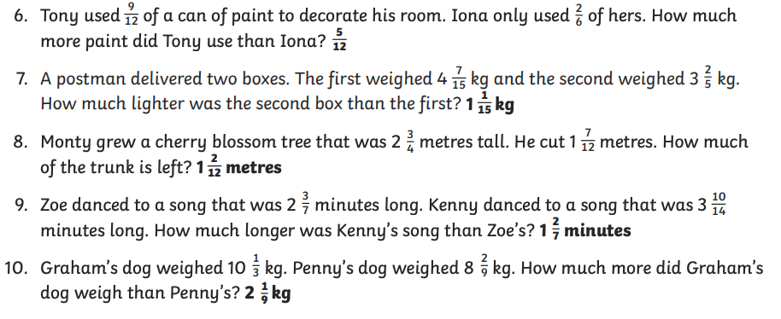

**C**

