Home Learning – Thursday 25th February 2021
Maths

Today I’d like you to concentrate on adding fractions. To add fractions you need to find the common denominator (make sure your pizzas are all divided in to the same amount of pieces) otherwise it’s like trying to add apples and oranges! To find the common denominator you need to be confident you can find equivalent fractions. If you are then please choose either task B or C. If you would like more practise at finding equivalents then choose task A.

I have attached the teaching PowerPoint for you to look at too.

A
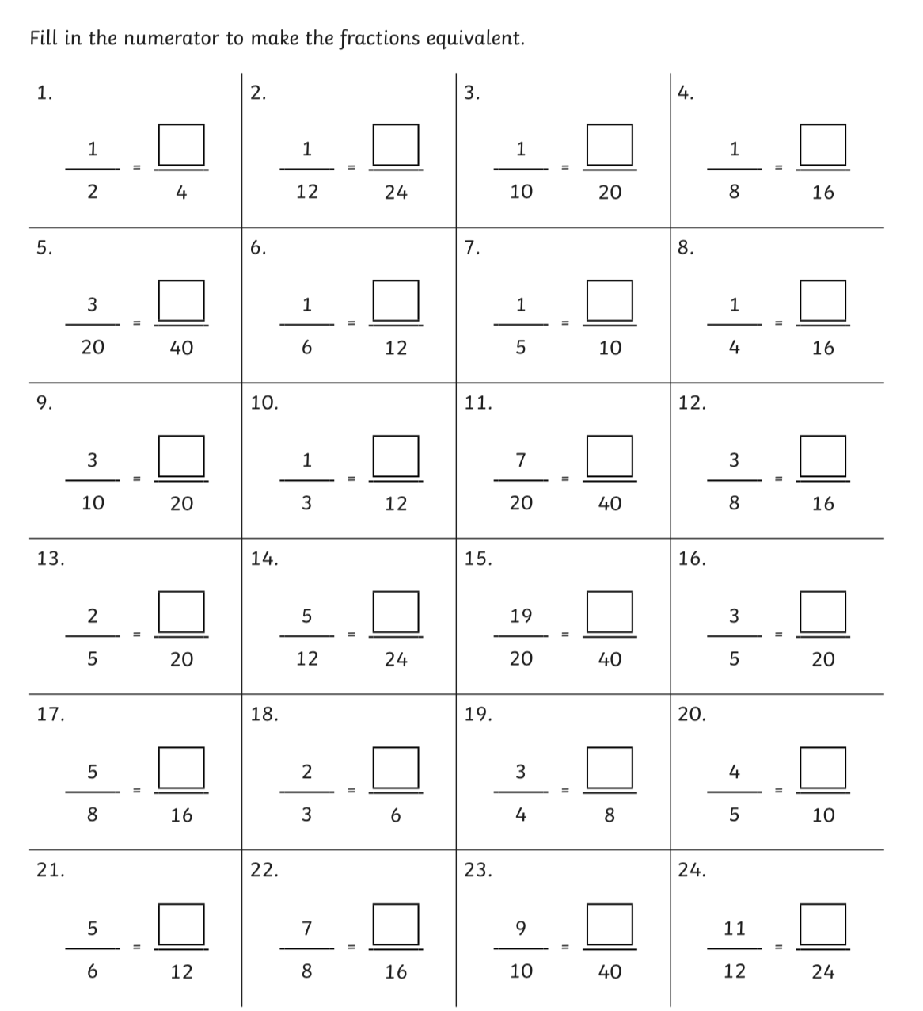

B

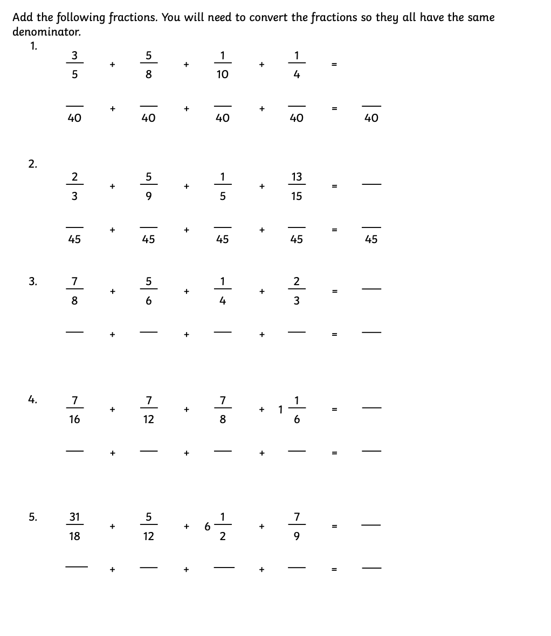

C

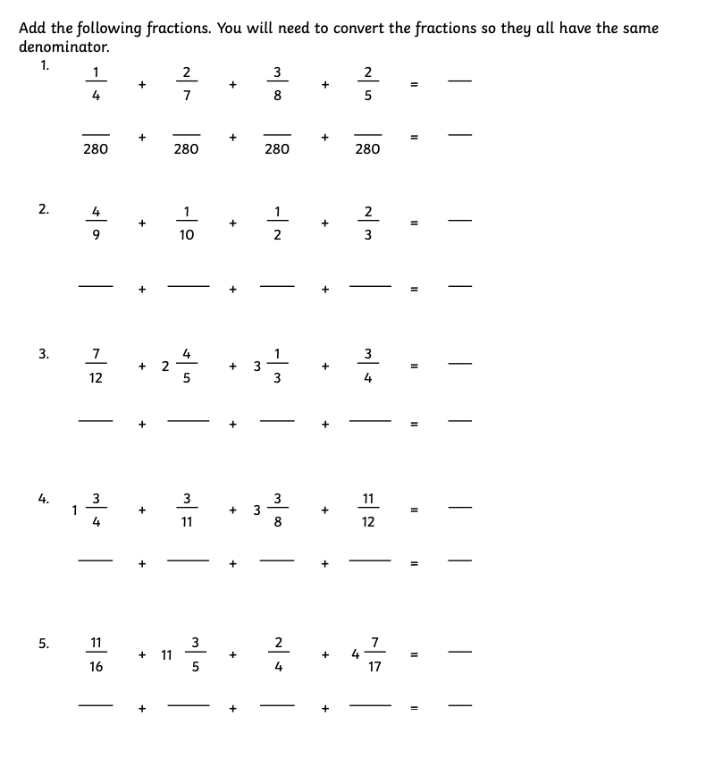

Answers

A
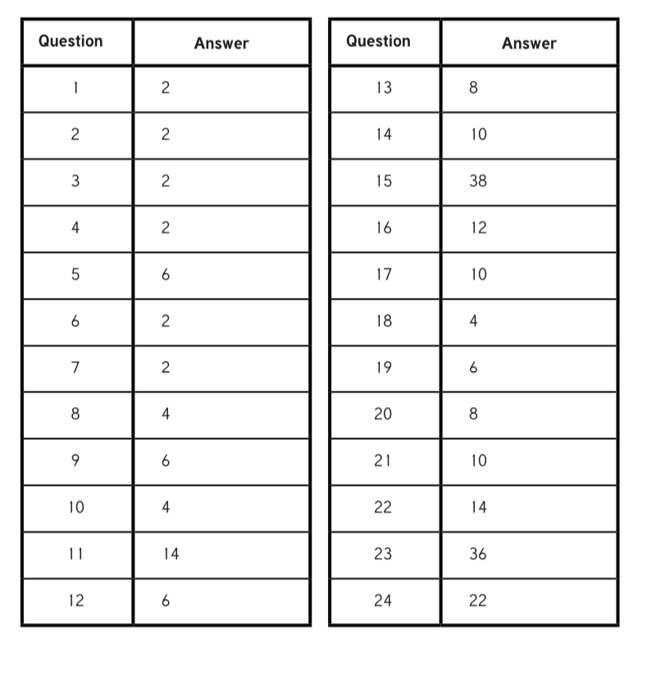
B

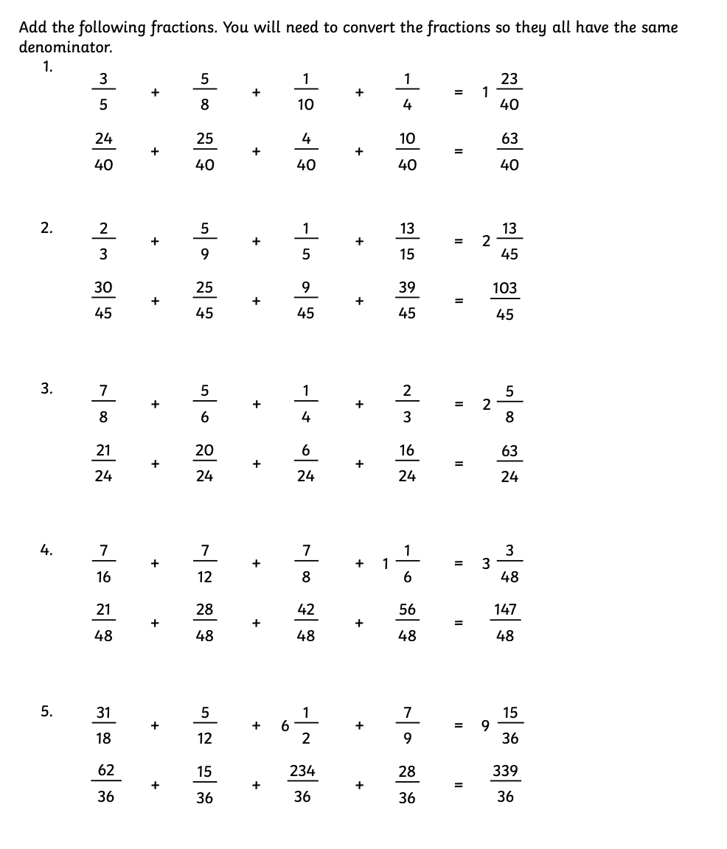

C

