**Home Learning – Wednesday 24th February 2021**

**Maths**

First have a go at the questions on the presentation. Then choose either A, B, or C. Then complete as many challenge questions as you can in 15 minutes.

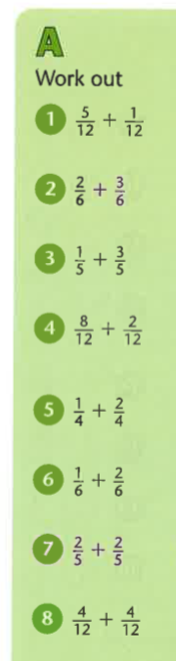

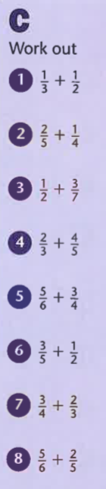 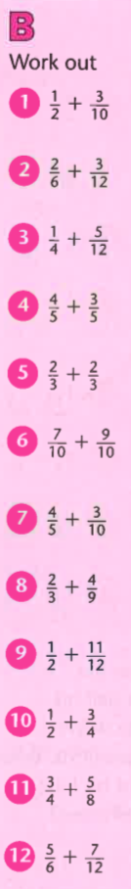

Challenges:

|  |  |
| --- | --- |
| 1. | 2. |
| 3. | 4. |

ANSWERS

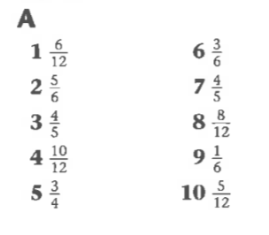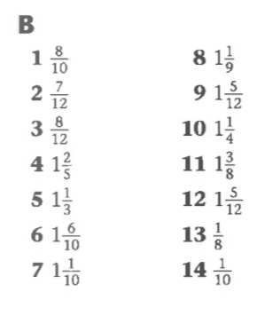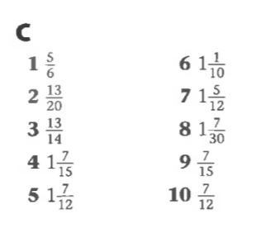

Challenge Answers

|  |  |  |  |
| --- | --- | --- | --- |
| 1. | 2. | 3. | 4. |