V/II/MMXXI
Converting Mixed numbers in to Improper Fractions

Please read the PowerPoint and then have a go at these questions. Choose the level you are comfy with. If you complete around 6 questions easily, check them and they are correct move on to the challenge questions.

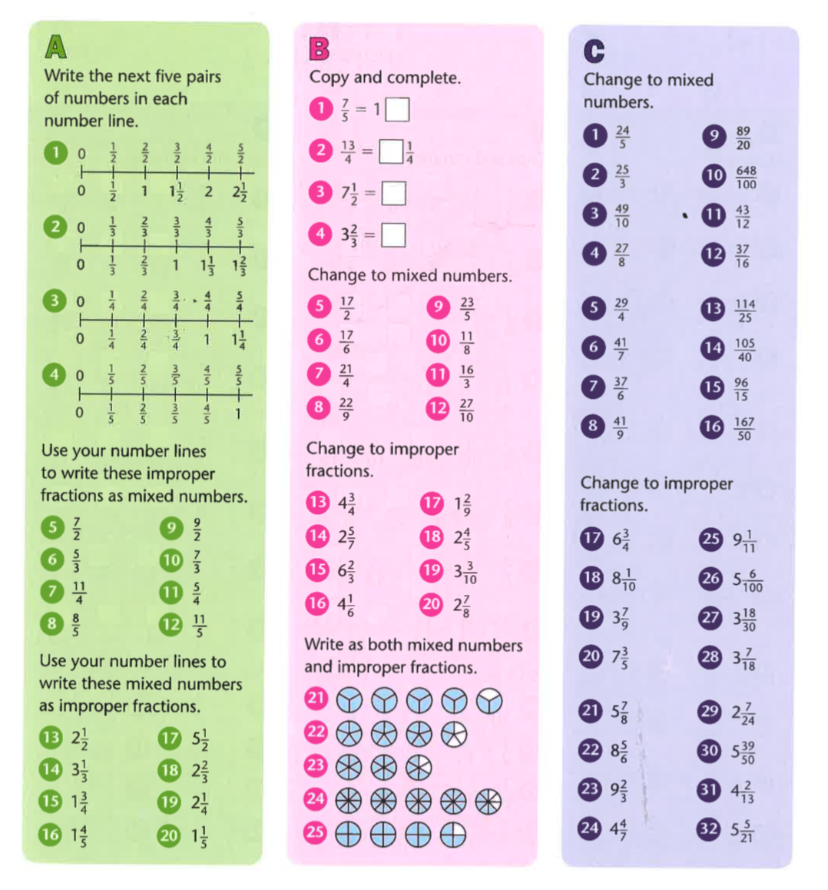

Challenge

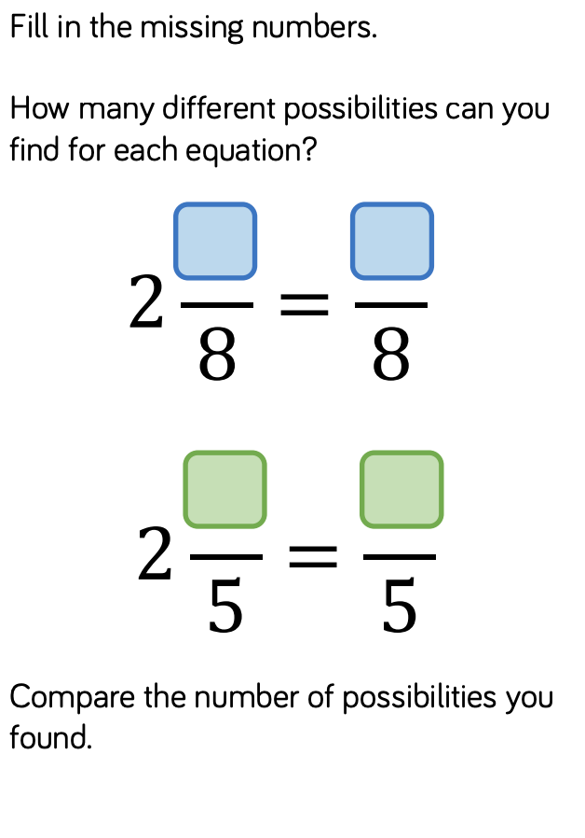
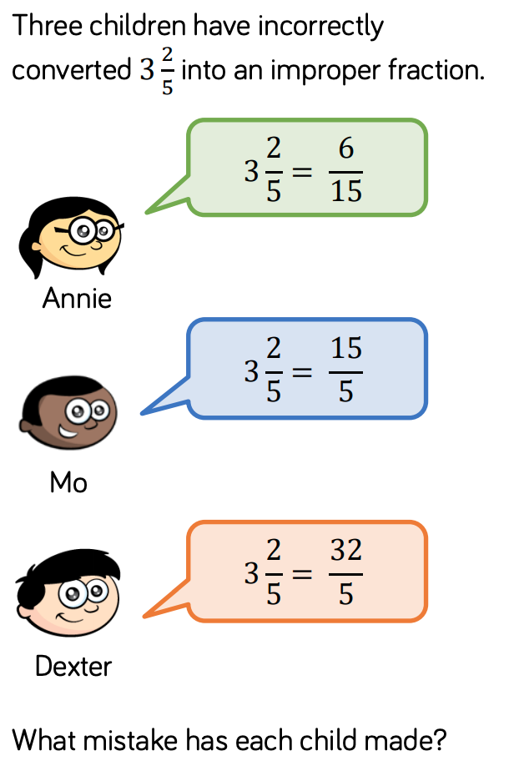

Answers
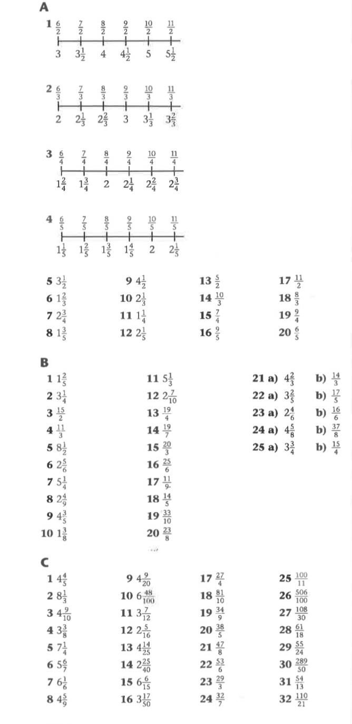

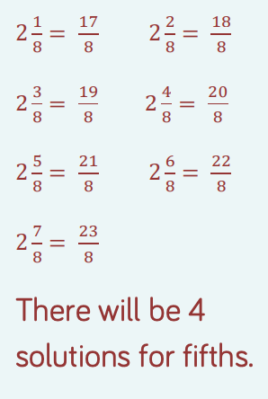
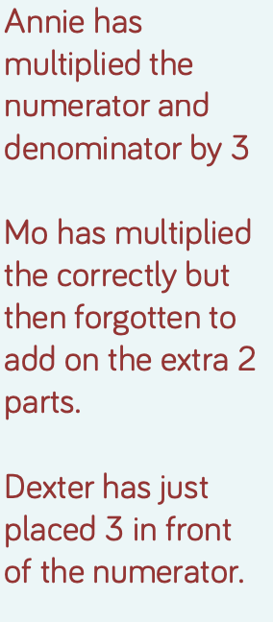
Challenge Answers

