Friday 5th February – Art

Since time began there has been a relationship between music and art. Both art forms inspiring the other.

Following the theme of expressing yourself, your task is to look at the pictures below and listen to the music. See which pieces of art go with the pieces of music. Think about how the artists were feeling when they created their art, what were they trying to express?

Artwork by Claude Monet

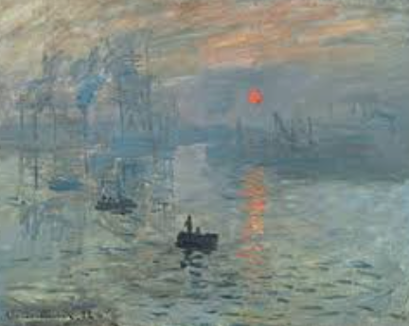
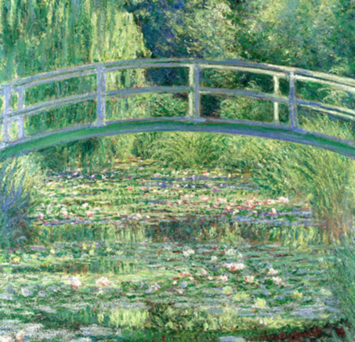

Artwork by Kandinsky

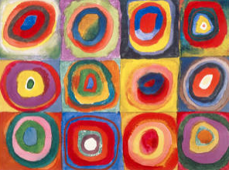
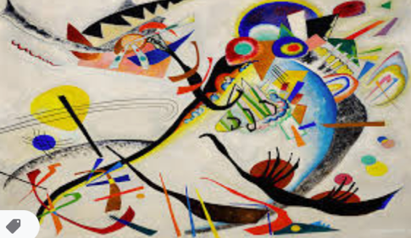
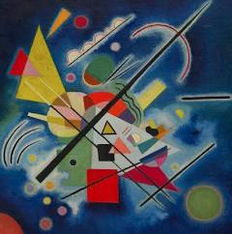

Artwork by Warhol

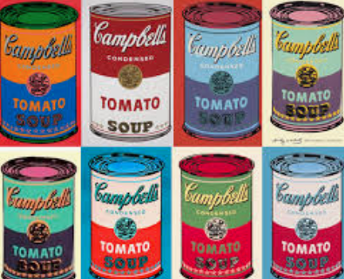
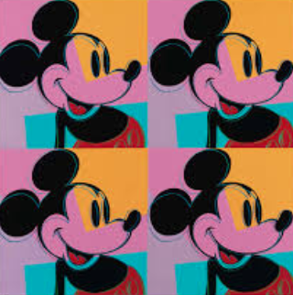

Music Links

https://www.youtube.com/watch?v=mnUAcDu3Ntc Composed by Schoenberg (listen from about 5 minutes as it takes a while to warm up!)

https://www.youtube.com/watch?v=45cYwDMibGo Composed by Lennon/McCartney (The Beatles)

https://www.youtube.com/watch?v=9Fle2CP8gR0 Composed by Debussy

Which pieces of art do you really enjoy, which are you not so keen on. Can you think of reasons why?

Your task is to find a piece of music that reflects how you feel now and to draw a picture that reflects how you feel when you listen to that music.

