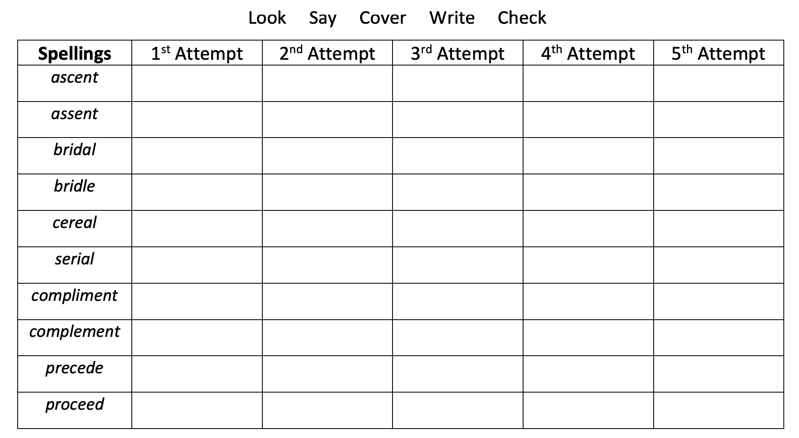

Here are your spellings for the week. Remember to look up any meanings in the dictionary.

