04/02/2021
Convert improper fractions in to mixed numbers.

Please watch the PowerPoint explaining how to be successful. We will be going through this in the Teams session at 10.10.

As usual, please choose section a, b, or c. When you can answer 5 or 6 questions confidently and you’ve checked them and they are correct then have a go at the challenge questions.

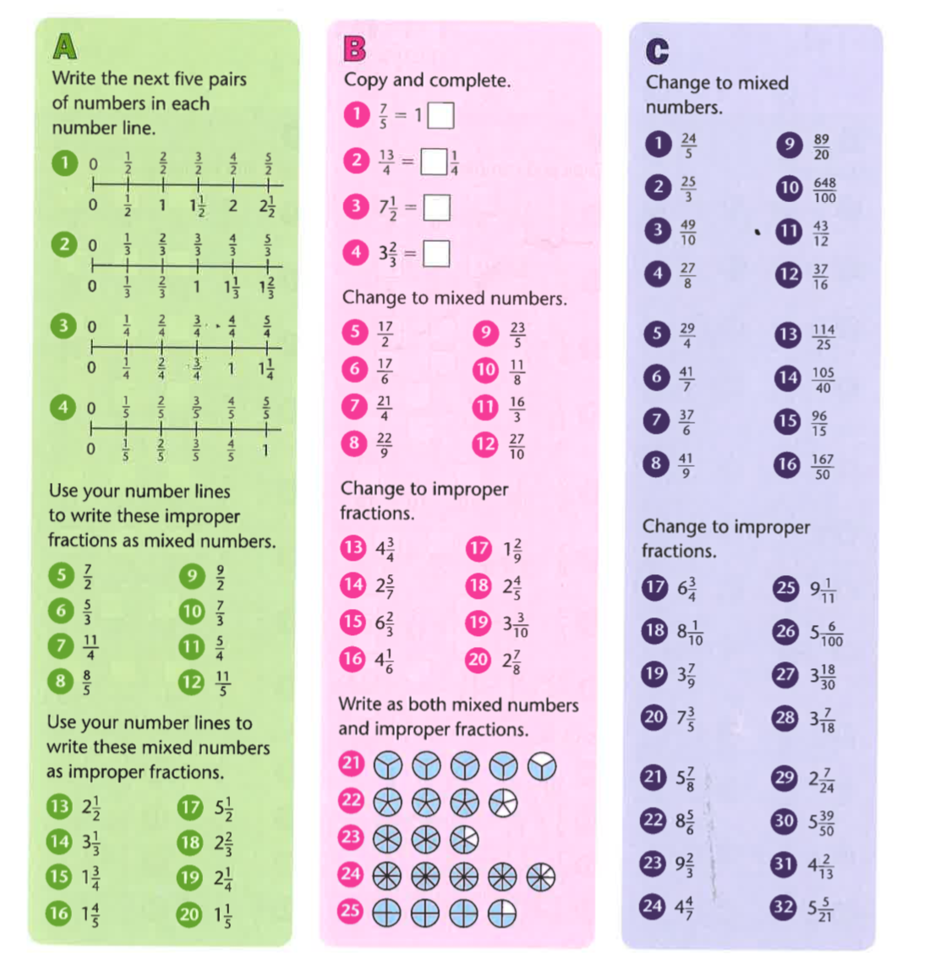

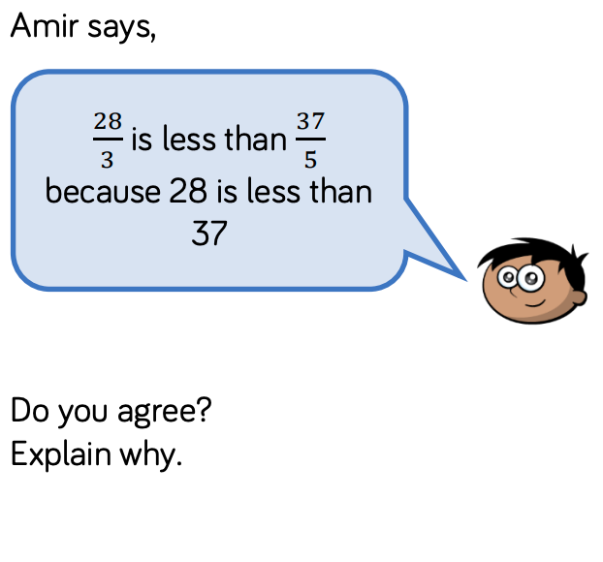
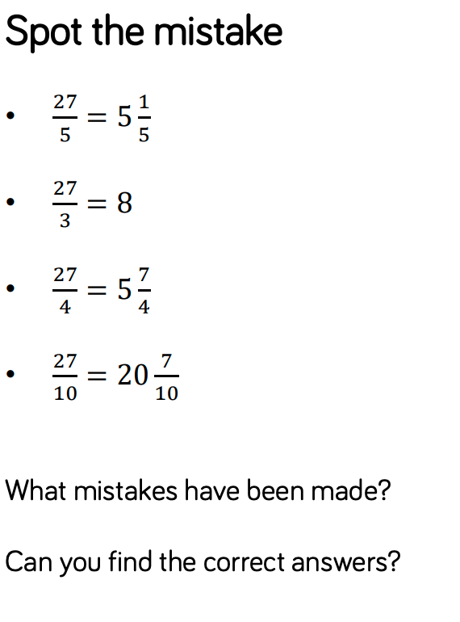

Answers

