Thursday 4th February 2021
RE – I can identify the main themes in the story of Moses and identify what characteristics Moses shows.

Throughout his story Moses shows great determination, obedience to God and faith that God will always be there for him and is showing him the right path. The themes of love, justice, faith, suffering, belief, trust and leadership occur frequently.

Have a look at the pictures below. What themes do they represent?

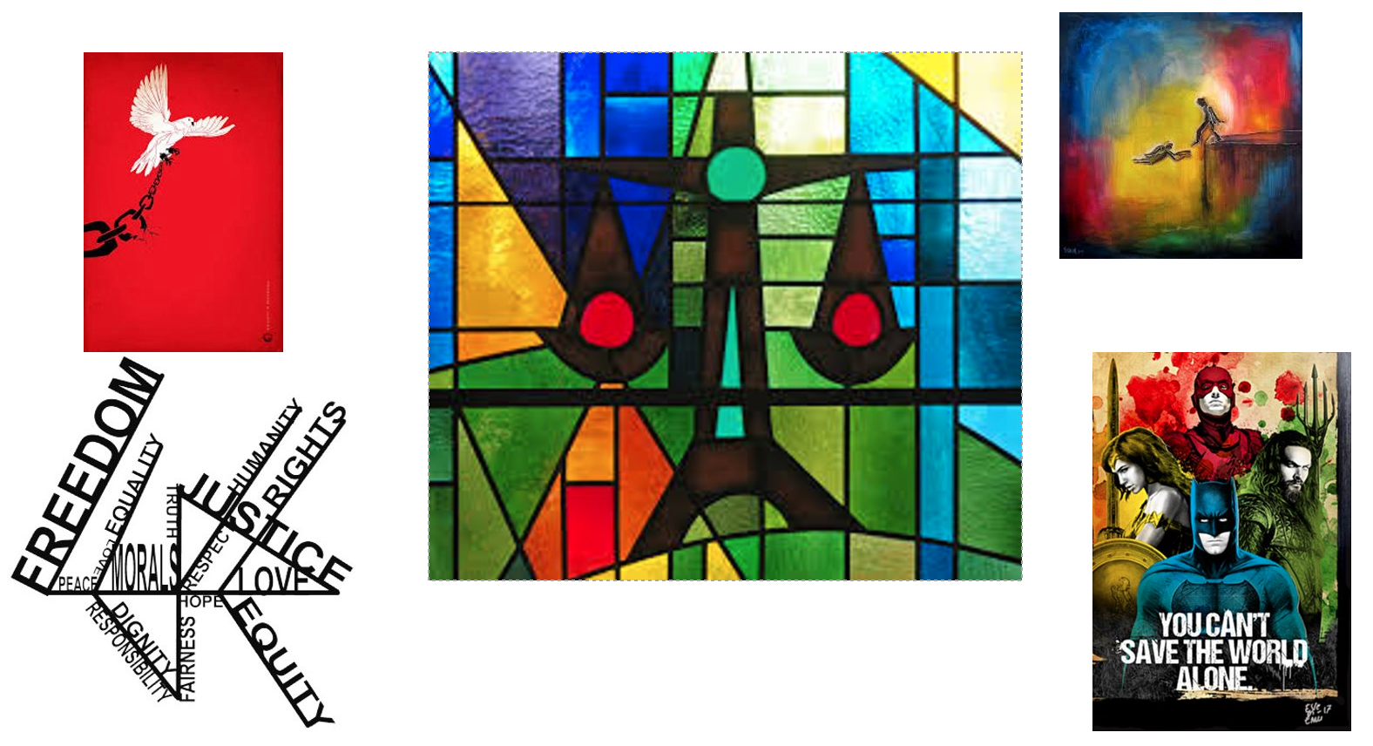

Your task for today is to research artwork that represents any of the values we can see through the journey of Moses’s life and draw your own interpretation of them. Can you compare this to a time when you have felt similar? For example: have you ever not believed in yourself, but a family member or friend has persuaded you otherwise, or ever had to keep trying to persuade someone to see things your way? Write a sentence to explain your thoughts underneath your picture.

